

**Software Requirement Specification – Manipur Property Tax Application**

**Manipur Municipality Property Tax Board**

Document History

|  |  |  |  |  |  |
| --- | --- | --- | --- | --- | --- |
| **Date** | **Version** | **Author** | **Reviewed by** | **Approved by** | **Remarks** |
|  |  |  |  |  |  |
|  |  |  |  |  |  |
|  |  |  |  |  |  |
|  |  |  |  |  |  |
|  |  |  |  |  |  |
|  |  |  |  |  |  |
|  |  |  |  |  |  |
|  |  |  |  |  |  |

Contents

1. Introduction 6

2. Project Objectives 6

3. Scope of the Project 7

4. Document Purpose 9

5. Document Structure 9

6. Overview of Manipur Property Tax Application 11

7. Overall Functionalities of Manipur Property Tax Application 11

8. New Property Registration – Process Flow 12

9. New Addition, Verification and generation of UPIN for Property 13

9.1. Use Case 1: New Property Addition 13

9.1.1 Sample User Interface 17

9.2. Use Case 2: Verification of Property Details 26

9.3. Sample User Interface 28

9.3.1. Verification of Property Details 28

9.4. Use Case 3: Field Verification of Property Details 36

9.5. Sample User Interface 38

9.5.1. Field Verification of Property Details 38

9.6. Use Case 3: Approval & Generation of UPIN 46

9.7. Sample User Interface 48

9.7.1. Approval & Generation of UPIN 48

10. Self – Assessment 58

10.1. Process Flow: 58

10.2. Use Case 1: Submission of Self-Assessment Return 59

10.3. Use Case 2: Verification of Self-Assessment Return 61

10.4. Sample User Interface 63

10.4.1. Verification of Self-Assessment Return 63

11. Payment of Property Tax Dues 67

11.1. Sample User Interface 69

11.1.1. Payment of Property Tax Dues 69

12. Modification of Property – Process Flow 73

12.1. Process Flow 1: Owner’s Request for Structural Changes 73

12.2. Process Flow 2: Notice of Transfer of Title and Mutation 74

12.3. Process Flow 3: Requesting Apportion of Annual Property Value and Assessment of Taxes 75

12.4. Process Flow 4: Requesting Amalgamation / Separation of Ownership 76

13. Modification of Property – Submission, Verification and Approval 77

13.1. Use Case 1: Modification of Property 77

13.2. Sample User Interface 82

13.2.1. Owner’s Request for Structural Changes 82

13.2.2. Notice of Transfer of Title and Mutation 85

13.2.3. Requesting Apportion of Annual Property Value and Assessment of Taxes 88

13.2.4. Notice of Transfer of Title and Mutation 91

13.3. Use Case 2: Verification of Modified Property Details 93

13.4. Use Case 3: Field Verification of Modified Property Details 94

13.5. Use Case 3: Approval & Generation of UPIN for Modified Property 95

14. Notice generation under various Rules of Manipur Municipality Property Tax Rules 2019 96

14.1. Sample User Interface 100

14.1.1. Notice for rectification of mistakes in a Defective Return 100

14.1.2. Notice for Assessment 105

14.1.3. Notice for Re-Assessment 110

14.1.4. Notice to enter Premises 115

14.1.5. Notice to file Return 123

14.1.6. Notice for Hearing under Rule 39 / 40 124

14.1.7. Notice for Imposition of Penalty 129

15. Appeal 133

15.1. Process Flow: 133

15.2. Use Case 1: Submission of Memorandum of Appeal 134

15.3. Sample User Interface 136

15.3.1. Submission of Memorandum of Appeal 136

15.4. Use Case 2: Verification of Memorandum of Appeal 141

15.5. Sample User Interface 143

15.5.1. Verification of Memorandum of Appeal 143

16. Analytics Dashboard 147

16.4. Generic Sample Layout of Analytical Dashboard for MMPTB & MAHUD 150

16.5. Key Performance Indicators (KPIs): 152

16.6. Sample Dashboard Visualization for Chairman/Secretary of MMPTB 156

﻿SCHEDULE-1 158

# Introduction

The State of Manipur has devised a Manipur Municipal Act 1994, which was primarily formed to provide for constitution and organization of municipalities in Urban areas of Manipur. Subsequently the formation of the Manipur Municipality (Property Tax) Rule, 2019 extends its outreach to whole of Manipur where municipalities has been constituted under the Manipur Municipal Act 1994, except the Hills and Cantonment area in Manipur which are governed by the Manipur (Hill Areas) District Councils Act, 1971(Act No. 76 of 1971) and Cantonments Act, 1924 (Act No. 2 of 1924) respectively.

Based on the Manipur Municipality (Property Tax) Rule 2019, the state of Manipur has decided to introduce the concept of Property Taxes in the State and a Gazette notification of the defined rules was notified on 27th October 2020. With the aim of enforcing the Manipur Municipality (Property Tax) Rules, 2019 in all the Urban Local Bodies (ULB) of Manipur, the Manipur Municipality Property Tax Board (MMPTB) was constituted under the provision of the rules.

Considering that there is no present system in place for management & collection of property taxes in the State, the Government of Manipur is desirous of implementing an IT enabled Property Tax System (PTS) and has reached out to National Institute of Urban Affairs (NIUA) who are responsible for assisting the States of India with the roll out of various modules of UPYOG Platform.

UPYOG is the national reference platform created for the delivery of municipal services online, which utilizes the National Urban Innovation Stack principle. In addition to reusable and extendable components, it also features central telemetry, data exchange, and analytics capabilities. In order to expedite adoption of Governance Platform by Manipur, the platform will be created with a minimal set of reference solutions for the priority services identified by the MMMPTB.

To further the implementation of the project, a tripartite Memorandum of Understanding (MoU) was signed between Government of Manipur, National Institute of Urban Affairs (NIUA) and Ministry of Housing and Urban affairs, Government of India for the adoption of the UPYOG Platform. Accordingly, Deloitte Touche Tomatsu India LLP has been engaged by MMPTB through NICSI to provide e-Governance professional services for the implementation of Property Tax application.

# Project Objectives

The objectives of this initiative are as below:

1. **Rollout of Manipur Municipality (Property Tax) Rules, 2019**: The project aims to enforce the Manipur Municipality (Property Tax) Rules, 2019 in all the Urban Local Bodies (ULBs) of Manipur. This will ensure uniformity in property tax regulations across the 26 ULBs of the State
2. **Implementation of IT-Enabled Property Tax System (PTS)**: The project seeks to adopt the UPYOG Platform, a national reference platform for the delivery of municipal services online. Leveraging the UPYOG it envisages implementation of an IT-enabled Property Tax System (PTS). The PTS will facilitate the management and collection of property taxes efficiently and effectively.
3. **Transparent and Accountable System**: Promote transparency and accountability in property tax collection by providing a digital platform for citizens to pay taxes and access information related to property assessment and payments.
4. **Capacity Building and Training**: The project aims to provide capacity building and training programs for relevant stakeholders, including government officials and ULB staff. This will ensure smooth implementation and operation of the IT-enabled Property Tax System.
5. **Seamless Integration with External Systems**: The project will focus on ensuring seamless integration of the IT-enabled PTS with other government systems and databases, enabling smooth data exchange and reducing redundancy.
6. **Sustainable and Scalable Solution**: The implemented IT-enabled Property Tax System will be designed to be sustainable and scalable, accommodating potential expansion and future requirements of the State's urban areas.
7. **Compliance with National Guidelines**: The project will ensure that the implemented system aligns with national guidelines and standards for property tax management and e-governance.

# Scope of the Project

The scope of work for this project is to provide certified e-Governance Manpower who will be assisting/supporting MMPTB in the below activities :

1. Project Initiation and Visioning:
   * Conduct meetings with key stakeholders, including Manipur Municipality Property Tax Board (MMPTB) and representatives from the Urban Local Bodies (ULBs) to establish a shared vision and understanding of the project objectives.
   * Reconfirm the approach and methodology proposed for the implementation of the IT-enabled Property Tax System.
   * Develop a comprehensive roadmap outlining the project's timeline, key milestones, and deliverables. This roadmap will serve as the foundation for the project's execution.
2. Review of Existing Institutional Structure and Processes:
   * Undertake a detailed review of the organizational structure and operational processes within MMPTB and each of the 26 ULBs.
   * Map existing use cases with respect to the Manipur Property Tax Rule 2019 and assess the efficiency and effectiveness of current property tax-related functions, processes, and technology.
   * Conduct a comparative study to identify best practices adopted by similar agencies in India and globally, considering factors such as terrain, weather conditions, nature of works, and challenges faced.
3. Proposed Institutional Framework and Business Process Redesign:
   * Based on the findings from the review phase, design a detailed business process for automating the Property Tax to streamline property tax-related functions within MMPTB and ULBs for improved efficiency and revenue generation.
   * Identify opportunities for technology integration to enhance the overall effectiveness of property tax management.
4. Customization and Implementation of the IT-enabled Property Tax System:
   * Customize the IT-enabled Property Tax System to suit the specific needs and requirements of Manipur's ULBs and MMPTB.
   * Ensure seamless integration of the system with existing databases, software, and infrastructure.
   * Conduct extensive testing to ensure the system's functionality, reliability, and security.
   * Roll out the system across the 26 ULBs in a phased manner, with careful planning and coordination.
5. Capacity Building and Training:
   * Identify skill gaps within MMPTB and ULBs and develop tailored capacity-building programs.
   * Conduct workshops and training sessions to familiarize stakeholders with the new processes and technology.
   * Provide ongoing support and knowledge transfer to build the capability of personnel involved in property tax implementation.
6. Statewide Rollout and Hypercare Support:
   * Oversee the statewide rollout of the IT-enabled Property Tax System and provide support during the transition period.
   * Address any issues or challenges that arise during the rollout with prompt hyper-care assistance.
   * Continuously monitor the system's performance and provide ongoing support to ensure its smooth and effective operation.
7. Reporting and Documentation:
   * Regularly update key stakeholders on project progress, achievements, and challenges.
   * Document all aspects of the project, including processes, system configurations, training materials, and best practices for future reference.
8. Knowledge Transfer and Handover:
   * Ensure a seamless knowledge transfer to the local teams, empowering them to take ownership of the implemented solution.
   * Hand over all project artifacts including documentation, training materials, and the IT-enabled Property Tax System, to the Manipur Municipality Property Tax Board (MMPTB) for long-term sustainability.

The overarching goal of this comprehensive scope of work is to establish a robust, efficient, and transparent property tax management system in Manipur.

The project scope covers providing resources to MMPTB to cover the scope of work mentioned in the Work Order. The same has been detailed out technically above in the current document. Completion of the scope within the proposed timeline and deployed resources also depends on various support required from MMPTB as mentioned in the section 6 of this document.

Any change in the current scope may impact on the proposed timeline as well as proposed man-month efforts. In case of any such occurrence of scope change will be discussed and mutually agreed with revised timeline and efforts if needed.Top of Form

# Document Purpose

This Software Requirement Specification (SRS) document intends to provide a comprehensive description of the intended business flow and detailed functionalities of the process of Property Tax Collection and Management. This application will be used by the Property Owner, Counter Users, Verifying Officer, Field Inspectors, ULP Commissioner and other Departmental staff oh MAHUD and MMPTB. The module is used for registering new properties, it verification, approval, creation of UPINs, Self-Assessment Return filing, Online Payment of Property Tax dues, Objection & Appeals. The document captures the detailed process flows, accountable actors and indicative screen captures for illustrating user interactions in the system.

This document has been prepared using the scope of work outlined in the Terms of Reference as baseline and the information collected through elaborate workshops with all relevant process owners. This document will henceforth serve as the reference for the functional scope of delivery agreed upon between MMPTB (Client) and Deloitte (Consultant) and will form the basis on which the actual system will be designed and developed. In the event of any contradiction with the functional scope highlighted in the Terms of Reference, technical proposal, the process flows described in this document will prevail.

# Document Structure

This document is deals with detailed functionality of DPR Module. We have considered below features of Manipur Property Tax Application:

* New property Registration
* Verification, Approval and UPIN generation for Properties
* Search Property
* Self-Assessment Returns
* Online Payment of Property Tax dues
* Modification of Property
* Integration with external systems
* Non-functional Requirements

Each functionality has been further sub-divided into use cases. Each use case describes the complete set of interactions between the relevant users of the e-Portal application. Each use case in the document has the following sections:

* A brief description of the use case
* Actor/user performing the transaction
* Detailed process flow
* Special Requirements
* Pre-conditions
* Post-conditions
* Sample user interface
* List of inputs fields and user actions

The underlying process within a functionality has been depicted by a set of process flow diagrams. These diagrams have prepared using the reengineered process as baseline, with relevant modifications as discussed and finalized in course of the process workshops. These diagrams are not intended to demonstrate the reengineered processes, but merely to illustrate the process flow associated with the accompanying functionality. The legend for interpreting the process flow diagrams is given below:

|  |  |
| --- | --- |
| Symbol | Explanation |
|  | * Start/Stop – This icon is used to depict the Start  or Stop of any process flow. |
|  | * Process – This icon represents a process which is a direct result of user interaction with the system. |
|  | * Sub-Process – This icon represents a sub-process which may be triggered by a process or a result of an indirect/scheduled response by the system. |
|  | * Decision – This icon occurs when a binary decision has to be taken by the system as a part of the invoked process or sub-process based on the available data. |
|  | * Data – This icon represents the information/data required by the system during the process or decision. |
|  | * Document – Process Flows that require attachment to be captured for documentation purpose is represented by this icon. |
|  | * Swim Lane – Interacting systems are represented by to be part of different lanes, which is represented by this swim lane. |

# Overview of Manipur Property Tax Application

# Overall Functionalities of Manipur Property Tax Application

# New Property Registration – Process Flow



# New Addition, Verification and generation of UPIN for Property

## Use Case 1: New Property Addition

Process Description:

|  |  |
| --- | --- |
| Description | This functionality allows Property Owner / Counter User to enter property details for registration of property as per Sub Rule 1 of Rule 4 of Manipur Municipality Property Tax Rules 2019 |
| Actor(s) | Property Owner / Counter User |
| Detailed Process Flow: | |
| 1. Property Owner / Counter User will log into the portal using the mobile number and OTP. 2. Property Owner / Counter User will need to search and select the ULB using auto suggest feature 3. The user will navigate to the Property Tax (PT) menu. 4. The user will click on the ‘Create Property’ tab. 5. The above action opens the property tax registration module for the user, where the prerequisites with list of required documents are shown to the user for registration.    1. Address Proof: Electricity Bill, Water Bill, Gas Bill, Aadhar Card, Voter Id, Driving Licence, Passport    2. Identity Proof: Aadhar Card, Voter Id, Driving Licence, Pan Card, Passport 6. Property Owner / Counter User will click on proceed button 7. A blank MMPTR form 1 will be displayed to the user 8. The MMPTR form 1 will be classified into 2 (two) section namely Property Details and Owner Details 9. Property Owner / Counter User will first have to select the ‘Property Type’ from the drop-down list 10. If the Property Owner / Counter User selects ‘Vacant Land’ / ‘Other Structure’, ‘Plot Size in Ha’ will be displayed and will be a mandatory field. 11. If the selection is other than ‘Vacant Land’ / ‘Other Structure’ rom the drop-down list, ‘Plot Size in Ha’ will not be displayed 12. If the selection is other than ‘Vacant Land’ / ‘Other Structure’ rom the drop-down list, the Property Owner / Counter User will input the following details:     1. Select ‘Floor’ from drop-down list and input the ‘Super Built-up Area in Sq.Ft.’ in the text field. This will be done for every floor that is selected     2. Property Owner / Counter User will input the ‘Unit Usage Type’, ‘Occupancy Type’, unit ‘Sub-Usage Type’. This will be done for every floor that is selected     3. If Occupancy Type selected by Property Owner / Counter User is ‘Tenant - Government / Private’ then 2 additional fields will be displayed and are mandatory:        1. No. of Tenants        2. Period of Occupation in years     4. Add more Units feature will be there to entering multiple floors / units and the list is to be displayed in a tabular form 13. Property Owner / Counter User will then enter the Pin Code, validation shall be there to check for erroneous entries 14. Property Owner / Counter User will then enter the following details in the text fields:     1. District Name     2. Town Name     3. Ward No.     4. Leikai Name     5. Property / House No. (not mandatory)     6. Village     7. Patta No.     8. Dag No.     9. Common Name of Building (not mandatory)     10. Name of Principal Road (not mandatory)     11. Name of Sub / Side Road (not mandatory)     12. Name of Landmark (not mandatory)     13. Others (not mandatory) 15. Property Owner / Counter User will have to upload the ‘’Address Proof’. For this Property Owner / Counter User will have to select the category from the drop-down list and then proceed to upload the document using the document upload feature. The file formats supported will be .jpeg, .pdf, .png and the file size supported will not be more than 5 MB 16. ‘Section 1 – Property Details’ is complete, Property Owner / Counter User will now have the following options:     1. Save & Next – Upon clicking this option, the details entered will be saved and the user will be directed to the next section     2. Save – Upon clicking this option, the details entered will be saved     3. Cancel - Upon clicking this option, the process will be terminated, and the details entered will not be saved 17. Property Owner / Counter User will now enter details for ‘Section 2 – Owner Details’ 18. Property Owner / Counter User will select the ‘Ownership Type’ from the drop-down list 19. If the selection is ‘Institutional – Private / Government’, the following fields will be displayed and input is mandatory:     1. Institution Name     2. Institution Type – Private / Government        1. If Institution Type is Private – Property Owner / Counter User will select from the following options in the drop-down list           1. Charitable Organization           2. Trust and Societies           3. Company           4. Partnership Firm           5. Others        2. If Institution Type is Government – Property Owner / Counter User will select from the following options in the drop-down list           1. Central Government           2. State Government           3. Local Government           4. Central Government UT, PSU           5. Others     3. Authorized Person details:        1. Name        2. Designation        3. Mobile No.        4. Telephone No.        5. E-Mail ID 20. If ‘Ownership Type’ selected is ‘Individual Owner’, the following fields will be displayed and input is mandatory:     1. Owner Name     2. Owner Special Category – drop-down list     3. Gender – Drop-down List     4. Father’s/ Mother’s Name     5. Age     6. No. of Members 21. If ‘Ownership Type’ selected is ‘Co-Owner’, the following fields will be displayed in addition to the fields mentioned in point no. 20 and input is mandatory:     1. Name of Co-owners     2. Add more feature is to be provided and the list will be displayed in a tabular form 22. Property Owner / Counter User will have to upload Proof of Identity. For this Property Owner / Counter User will have to select the category from the drop-down list and then proceed to upload the document using the document upload feature. The file formats supported will be .jpeg, .pdf, .png and the file size supported will not be more than 5 MB 23. ‘Section 2 – Owner Details’ is complete, Property Owner / Counter User will now have the following options:     1. Preview – Upon clicking this option, the details entered will be displayed in the format of the MMPTR Form 1. Property Owner can verify the details before final submission. Download as PDF option will be provided     2. Save – Upon clicking this option, the details entered will be saved     3. Cancel - Upon clicking this option, the process will be terminated, and the details entered will not be saved 24. Before final submission, Property Owner will click on the radio button to confirm *‘I hereby declare and affirm that the above-furnished information is true and correct and nothing has been concealed therefrom. I am also aware of the fact that in case this information is found false/incorrect, the authorities are at liberty to initiate recovery of amount / interest / penalty / fine as provided in Manipur Municipality Act 1994 or Manipur Municipality (Property Tax) Rules 2019.’* 25. Property Owner / Counter User will then click on submit button and details entered will be submitted and saved in the system 26. On successful submission of application user will have the option to download the acknowledgement as a PDF | |
| Special requirements (if any) | Not applicable |
| Pre-conditions | 1. Users should have valid login credentials 2. Property details shall be available with the user |
| Post-conditions | 1. On successful submission of the details, system will dispatch a task to the verifying officer for his/her verification. 2. System will auto generate an acknowledgement which will be sent to the user through email and or SMS 3. System will generate temporary UPIN and Application number. UPIN would be allotted by the system on the following basis: District Code: X (1 alphanumeric); Town/City Code: XX (2 alphanumeric); Ward Code: XX (2 alphanumeric); Leikai/Locality Code: XX (2 alphanumeric); Ownership Code: X (1 alphanumeric); Property Serial Number: XXXXXXXX (8 alphanumeric characters/digits) |

### 9.1.1 Sample User Interface

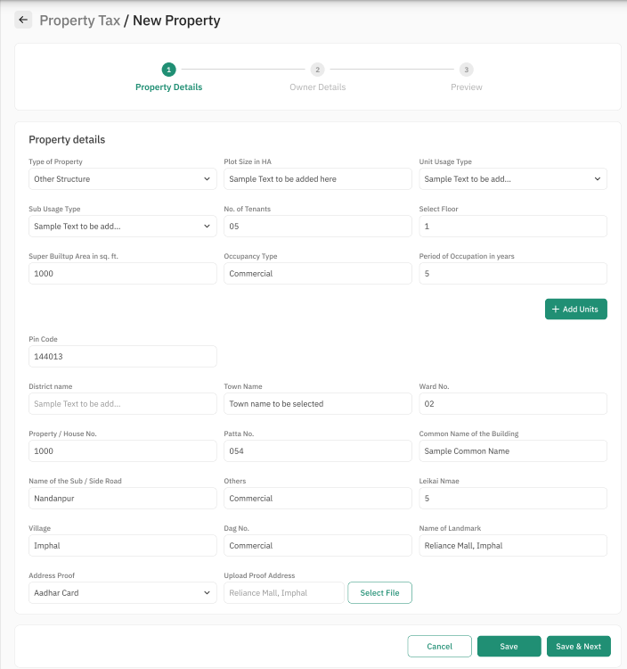

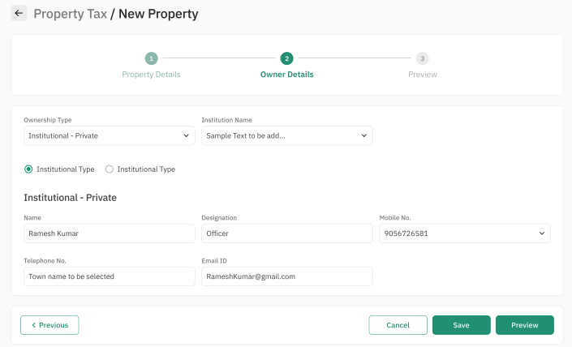

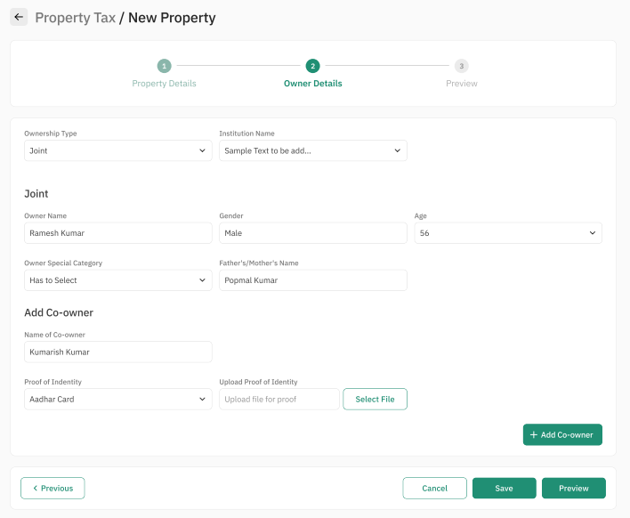

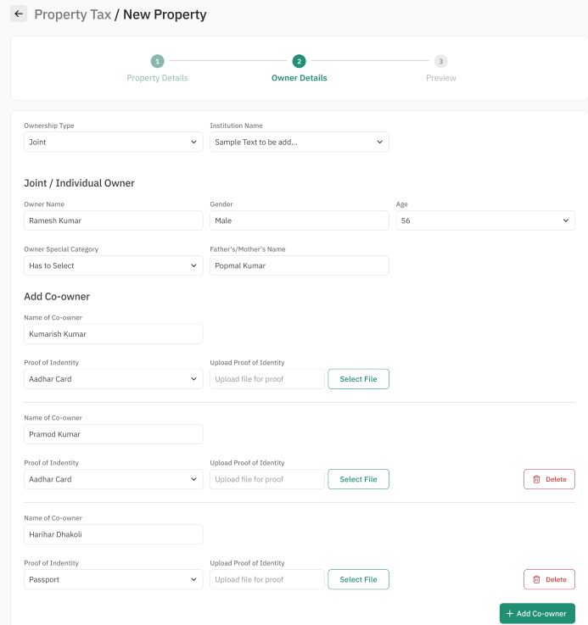

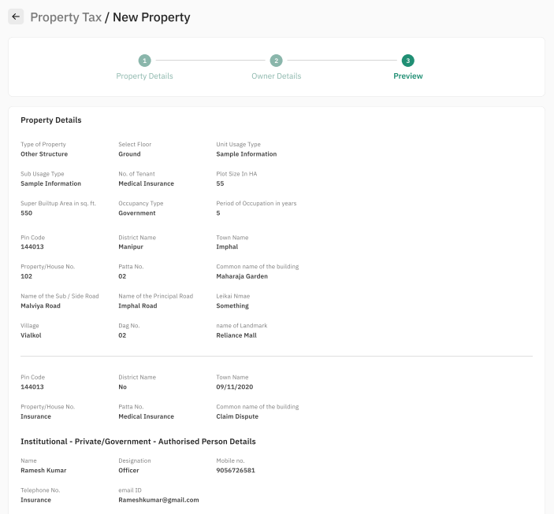

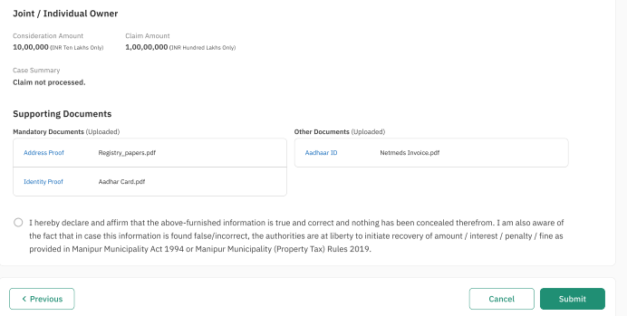

9.1.2 Property Sheet

**Property Details:**

|  |  |  |  |  |
| --- | --- | --- | --- | --- |
| Sl. No. | Attribute Name | Attribute Type | Operation Type | Remarks |
| 1 | Type of property | Varchar | Drop Down Selection | Required |
| 2 | Select Floor | Int | Write | Required |
| 3 | Unit Usage Type | Varchar | Drop Down Selection | Required |
| 4 | Sub Usage Type | Varchar | Drop Down Selection | Required |
| 5 | No. of Tenants | Int | Write | Required |
| 6. | Plot Size in HA | Varchar | Write | Required |
| 7. | Super Builtup Area in sq. ft. | Int | Write | Required |
| 8. | Occupancy Type | Varchar | Write | Required |
| 9. | Period of Occupation in years | Int | Write | Required |
| 9. | Pin Code | Int | Write | Required |
| 10. | District name | Varchar | Write | Required |
| 11. | Town Name | Varchar | Drop Down Selection | Required |
| 12. | Ward No. | Int | Write | Required |
| 13. | Property / House No. | Int | Write | Required |
| 14. | Patta No. | Int | Write | Required |
| 15. | Common Name of the Building | Varchar | Write | Required |
| 16. | Name of the Sub / Side Road | Varchar | Write | Required |
| 17. | Others | Varchar | Write | Required |
| 18. | Leikai Nmae | Int | Write | Required |
| 19. | Village | Varchar | Write | Required |
| 20. | Dag No. | Varchar | Write | Required |
| 21. | Name of Landmark | Varchar | Write | Required |
| 22. | Address Proof | Varchar | Drop Down Selection | Required |
| 23. | Upload Proof Address |  |  | Required |

**Owner Details:**

|  |  |  |  |  |
| --- | --- | --- | --- | --- |
| Sl. No. | Attribute Name | Attribute Type | Operation Type | Remarks |
| 1 | Ownership Type | Varchar | Drop Down Selection | Required |
| 2 | Institution name | Varchar | Drop Down Selection | Required |
| 3 | No. of tenants | Int | Write | Required |
| 4 | Plot size in HA | int | Write | Required |
| 5 | Name | Varchar | Write | Required |
| 6. | Designation | int | Write | Required |
| 7. | Mobile Number | Int | Write | Required |
| 8. | Telephone Number | int | Write | Required |
| 9. | eMail ID | Varchar | Write | Required |
| 9. | Owner Name | Varchar | Write | Required |
| 10. | Gender | Varchar | Write | Required |
| 11. | Age | int | Write | Required |
| 12. | Owner Special Category | Varchar | Drop Down Selection | Required |
| 13. | Father’s/Mother’s Name | Varchar | Write | Required |
| 14. | Name of Co-Owner | Varchar | Write | Required |
| 15. | Proof of Identity | Varchar | Drop Down Selection | Required |
| 16. | Upload Proof of Identity | Pdf |  | Required |

## Use Case 2: Verification of Property Details

Process Description:

|  |  |
| --- | --- |
| Description | This functionality allows users to verify the property details submitted by counter user / property owner, forward for filed inspection, revert application, reject application |
| Actor(s) | Verifying Officer |
| Detailed Process Flow: | |
| 1. Verifying officer will log into the portal using the username and password. 2. Under the property tax section verifying officer will have option to view    1. Inbox    2. Tasks nearing SLA    3. Search Property    4. Search Application 3. Verifying officer will navigate to his / her inbox where the pending tasks will be displayed to the user 4. Verifying officer will select the concerned task by clicking application number 5. The filled up MMPTR form 1 submitted by citizen / property owner will be displayed along with the documents that have been attached 6. Verifying officer will verify the details submitted under the below sections:    1. Property Details    2. Location details    3. Plot area / Built up area    4. Ownership Type    5. Unit Usage Type    6. Year of construction.    7. Property Owner / Authorized Person details 7. Verifying officer will verify the documents attached during submission by property owner / citizen 8. Verifying officer will then click on ‘Take Action’ button. The verifying officer will have 3 options:    1. Reject – verifying officer will reject the application by clicking this button and entering his / her comments along with uploading and supporting documents, if applicable. Application status will be updated as ‘Rejected’    2. Forward – Verifying Officer will select the concerned Field Inspector and clicking on the ‘Forward’ button after entering his / her comments and uploading any supporting documents, if applicable. Application status will be updated as ‘Forwarded for Field Verification’    3. Send back to Citizen – Verifying Officer will enter his / her comments and upload any supporting documents, if applicable. Verifying Officer will click on ‘Send Back to Citizen’ button. The application will be routed to the citizen and citizen will be notified through SMS/ eMail. The application will be available in the Notification section of Property Owner / Citizen / Counter User. Application status will be updated with comments of the ‘Verifying Officer’ 9. Verifying officer will have the option of uploading photographs from the site inspection. The file formats supported will be .jpeg, .pdf, .png and the file size supported will not be more than 5 MB | |
| Special requirements (if any) | Not applicable |
| Pre-conditions | 1. Verifying officer should have valid login credentials 2. Property details shall have to be submitted by the citizen / property owner 3. The task should be displayed in the inbox of Verifying Officer (User) |
| Post-conditions | 1. On successful submission of the details, system will dispatch a task to the concerned user for his/her action. 2. The task will be marked as complete and removed from the inbox 3. System will auto generate an acknowledgement which will be sent to the citizen through email and or SMS |

## Sample User Interface

### Verification of Property Details

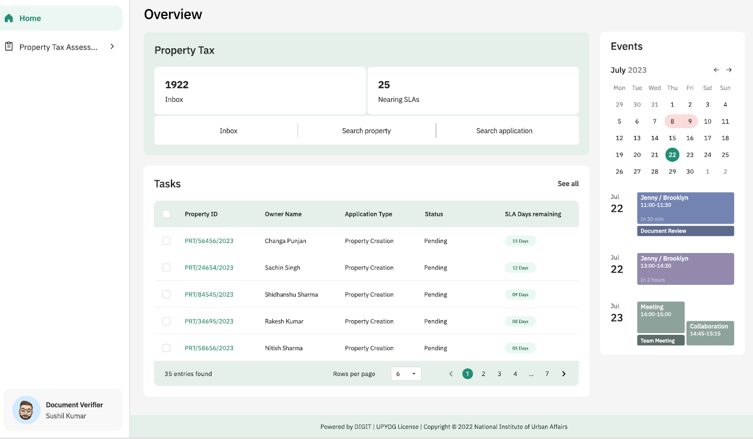

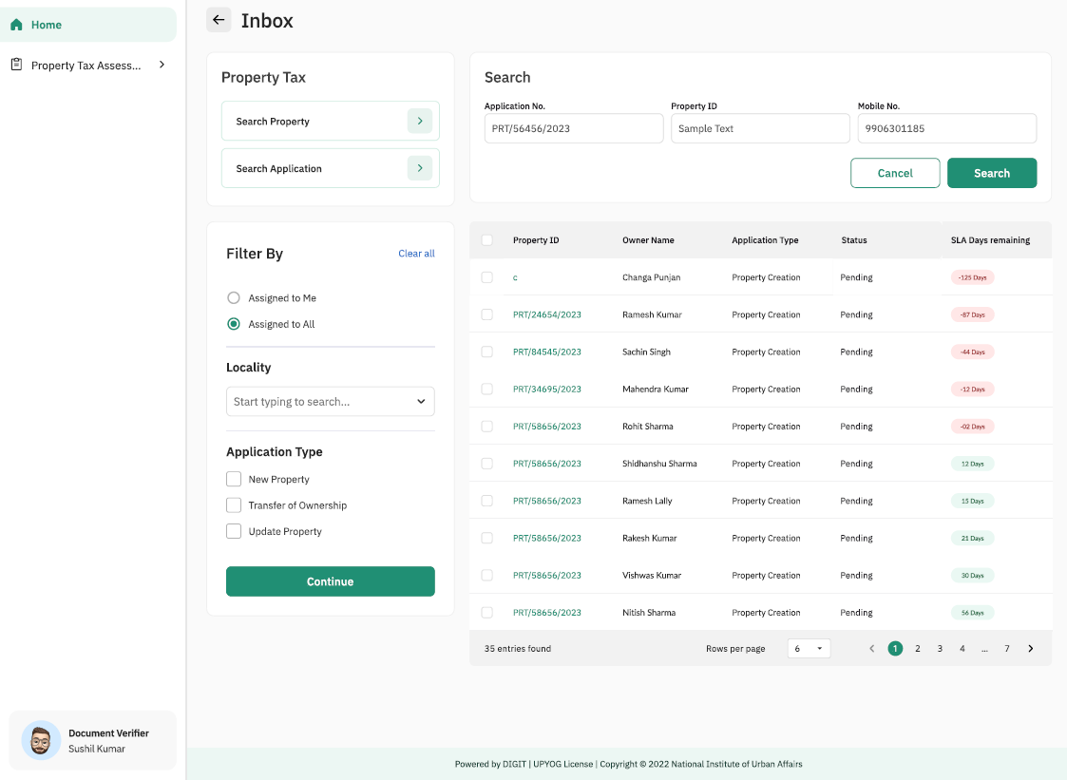

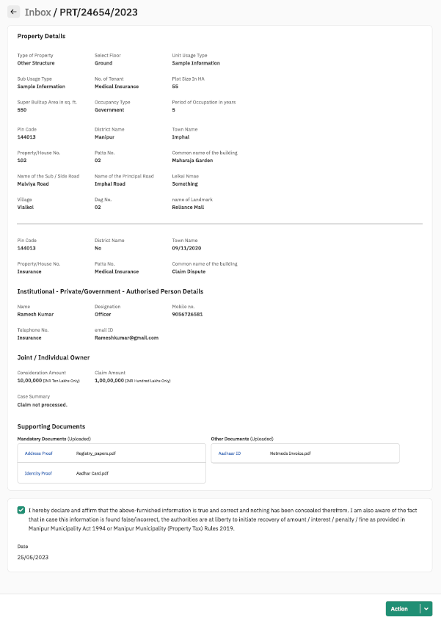

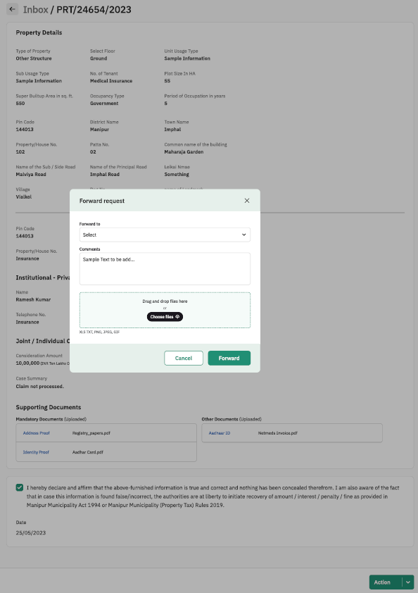y

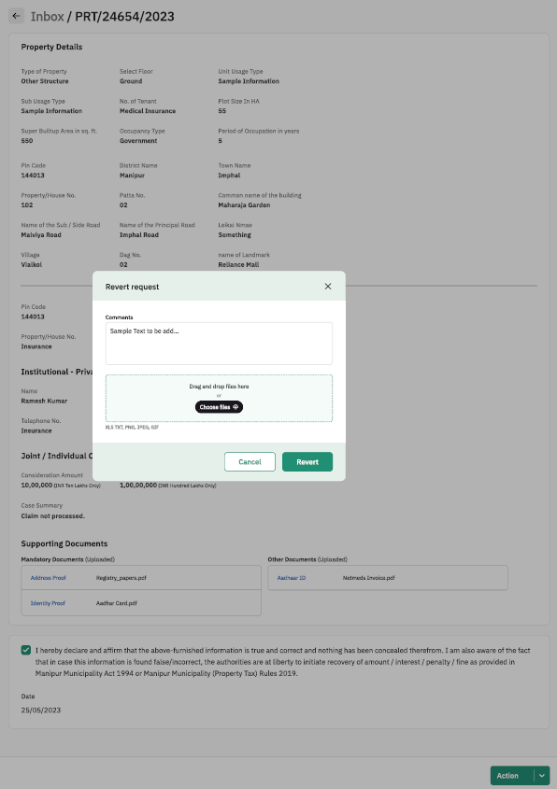

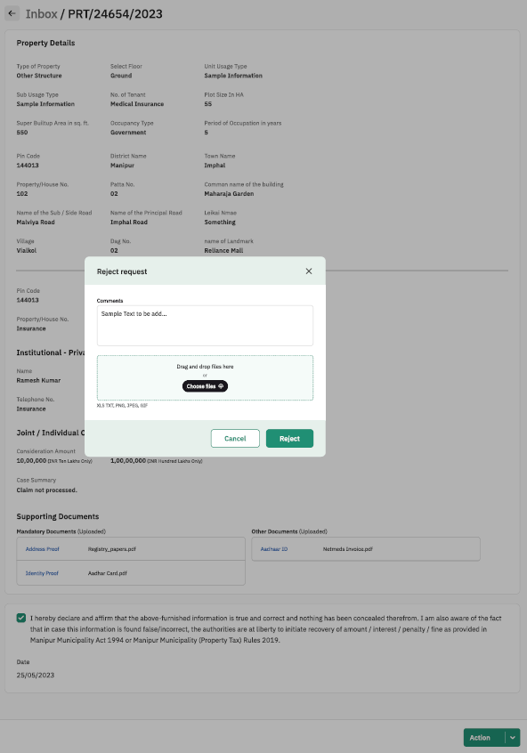

#### Property Sheet

**Action Tab**

|  |  |  |  |  |
| --- | --- | --- | --- | --- |
| Sl. No. | Attribute Name | Attribute Type | Operation Type | Remarks |
| 3 | Forward | - | Clickable | Required |
| 4 | Revert | - | Clickable | Required |
| 5 | Reject | - | Clickable | Required |

**Forward Request**

|  |  |  |  |  |
| --- | --- | --- | --- | --- |
| Sl. No. | Attribute Name | Attribute Type | Operation Type | Remarks |
| 1 | Forward to | varchar | Dropdown Selection | Required |
| 2 | Choose Files | .xls, .txt, .png, .jpeg, .gif files | Browse and select | Required |
| 3 | Forward | - | Clickable | Required |
| 4 | cancel | - | Clickable | Required |

**Revert Request**

|  |  |  |  |  |
| --- | --- | --- | --- | --- |
| Sl. No. | Attribute Name | Attribute Type | Operation Type | Remarks |
| 1 | Comments | varchar | Write | Required |
| 2 | Choose Files | .xls, .txt, .png, .jpeg, .gif files | Browse and select | Required |
| 3 | Revert | - | Clickable | Required |
| 4 | cancel | - | Clickable | Required |

**Reject Request**

|  |  |  |  |  |
| --- | --- | --- | --- | --- |
| Sl. No. | Attribute Name | Attribute Type | Operation Type | Remarks |
| 1 | Comments | varchar | Write | Required |
| 2 | Choose Files | .xls, .txt, .png, .jpeg, .gif files | Browse and select | Required |
| 3 | Reject | - | Clickable | Required |
| 4 | cancel | - | Clickable | Required |

## Use Case 3: Field Verification of Property Details

Process Description:

|  |  |
| --- | --- |
| Description | This functionality allows Field inspector to record his / her observations from field inspection of property, upload documents / photos, forward for approval, revert to verifying officer and revert to property owner |
| Actor(s) | Field Inspector |
| Detailed Process Flow: | |
| 1. Field Inspector will log into the portal using the username and password. 2. Under the property tax section verifying officer will have option to view    1. Inbox    2. Tasks nearing SLA    3. Search Property    4. Search Application 3. Field Inspector will navigate to his / her inbox where the pending tasks will be displayed to the user 4. Field Inspector will select the concerned task by clicking application number 5. The filled up MMPTR form 1 submitted by citizen / property owner will be displayed along with the documents that have been attached. Also the comments of the Verifying Officer along with supporting documents if any will be displayed 6. Field Officer will carry out field inspection of the property and click on the ‘Take Action’ button to record his / her observations in the comments box. 7. Field Inspector will have 3 options:    1. Send back to Verifying officer – Field Inspector will send back the application by clicking this button and entering his / her comments along with uploading and supporting documents, if applicable. Application status will be updated as ‘Sent Back to Verifying Officer’    2. Forward – Field Inspector will select the concerned Approver and click on the ‘Forward’ button after entering his / her comments and uploading any supporting documents, if applicable. Application status will be updated as ‘Forwarded for Approval’    3. Revert to Citizen – Field Inspector will enter his / her comments and upload any supporting documents, if applicable. Field Inspector will click on ‘Send Back to Citizen’ button. The application will be routed to the citizen and citizen will be notified through SMS/ eMail. The application will be available in the Notification section of Property Owner / Citizen / Counter User. Application status will be updated with comments of the ‘Field Inspector’ 8. Field Inspector will have the option of uploading photographs from the site inspection. The file formats supported will be .jpeg, .pdf, .png and the file size supported will not be more than 5 MB | |
| Special requirements (if any) | Not applicable |
| Pre-conditions | 1. Field Inspector should have valid login credentials 2. Property details shall have to be submitted by the citizen / property owner and verified by Verifying Officer 3. The task should be displayed in the inbox of Field Inspector (User) |
| Post-conditions | 1. On successful submission of the details, system will dispatch a task to the concerned user for his/her action. 2. The task will be marked as complete and removed from the inbox 3. System will auto generate an acknowledgement which will be sent to the citizen through email and or SMS |

## Sample User Interface

### Field Verification of Property Details

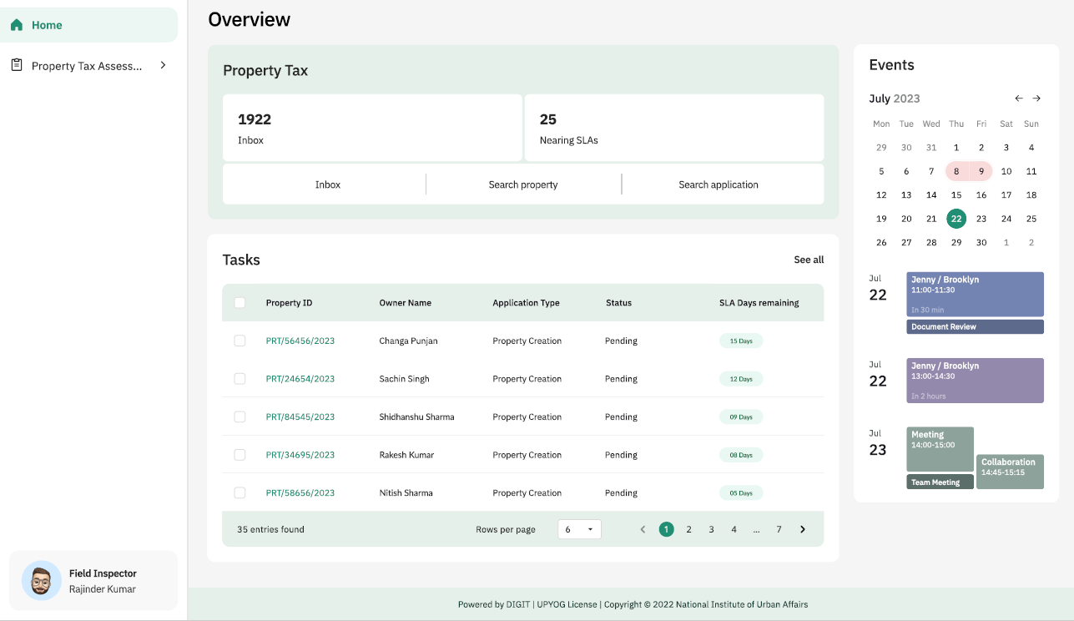

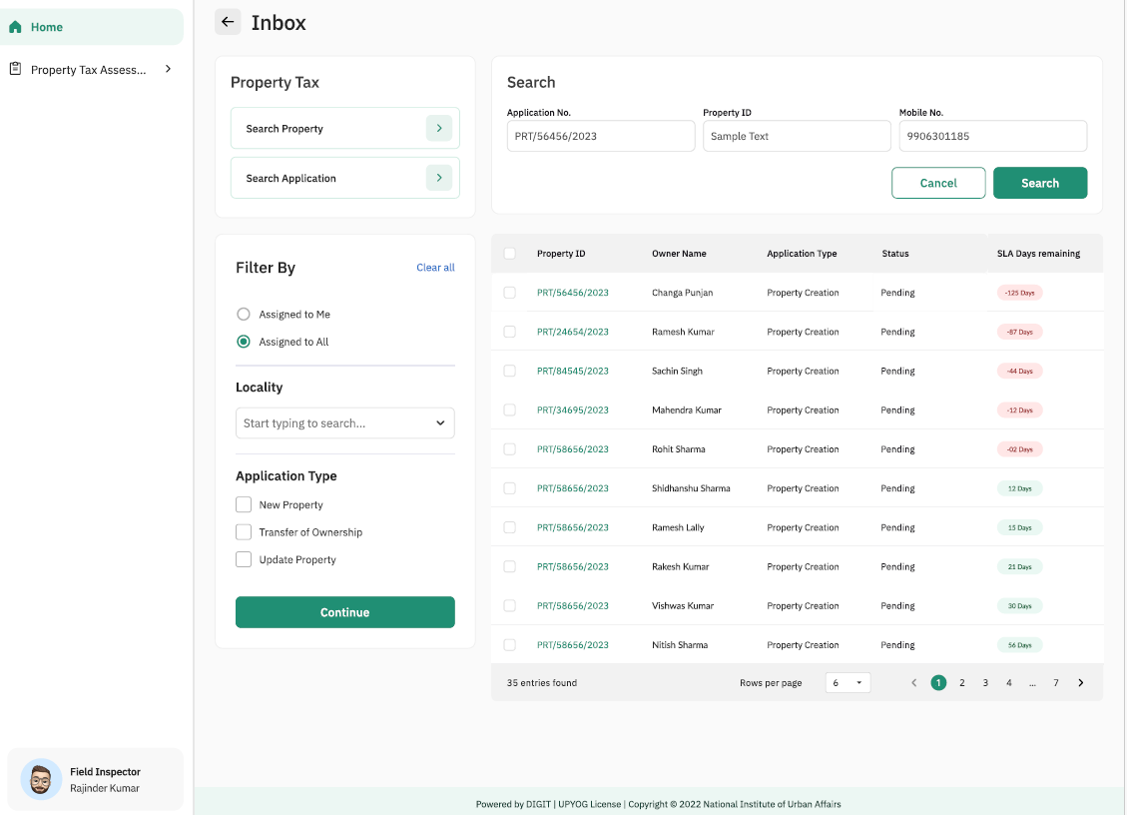

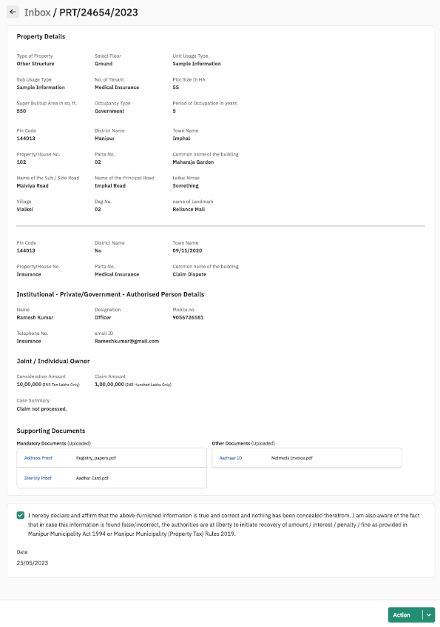

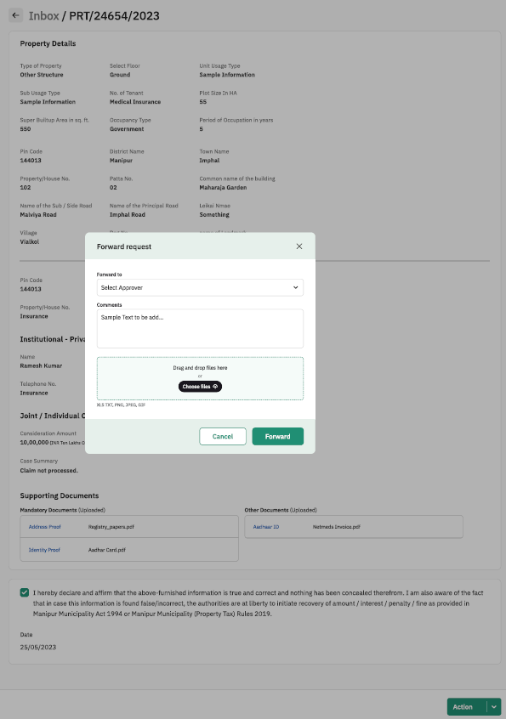

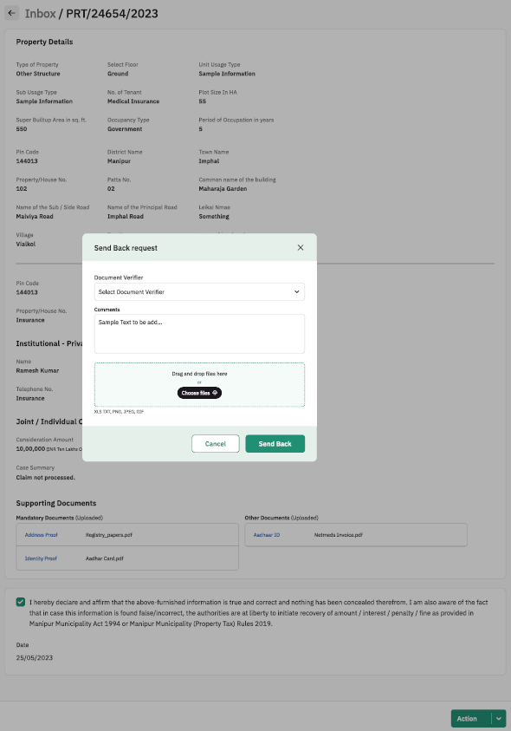

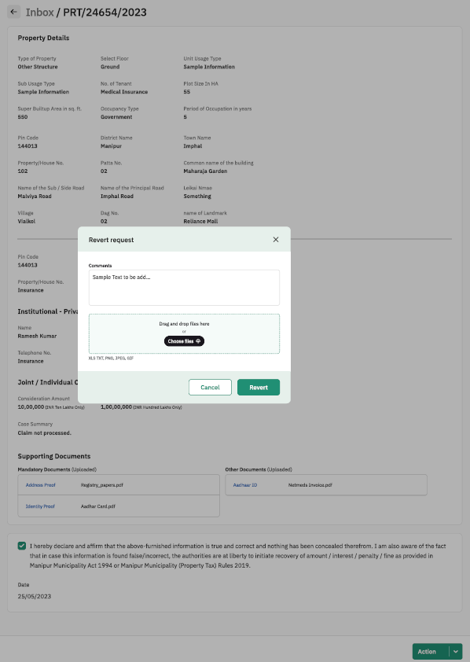

#### Property Sheet

**Action Tab**

|  |  |  |  |  |
| --- | --- | --- | --- | --- |
| Sl. No. | Attribute Name | Attribute Type | Operation Type | Remarks |
| 1 | Forward | - | Clickable | Required |
| 2 | Send Back | - | Clickable | Required |
| 3 | Revert | - | Clickable | Required |
| 4 | Reject | - | Clickable | Required |

**Forward Request**

|  |  |  |  |  |
| --- | --- | --- | --- | --- |
| Sl. No. | Attribute Name | Attribute Type | Operation Type | Remarks |
| 1 | Forward to | varchar | Dropdown Selection | Required |
| 2 | Choose Files | .xls, .txt, .png, .jpeg, .gif files | Browse and select | Required |
| 3 | Forward | - | Clickable | Required |
| 4 | cancel | - | Clickable | Required |

**Send Back Request**

|  |  |  |  |  |
| --- | --- | --- | --- | --- |
| Sl. No. | Attribute Name | Attribute Type | Operation Type | Remarks |
| 1 | Forward to | varchar | Dropdown Selection | Required |
| 2 | Choose Files | .xls, .txt, .png, .jpeg, .gif files | Browse and select | Required |
| 3 | Forward | - | Clickable | Required |
| 4 | cancel | - | Clickable | Required |

**Revert Request**

|  |  |  |  |  |
| --- | --- | --- | --- | --- |
| Sl. No. | Attribute Name | Attribute Type | Operation Type | Remarks |
| 1 | Comments | varchar | Write | Required |
| 2 | Choose Files | .xls, .txt, .png, .jpeg, .gif files | Browse and select | Required |
| 3 | Revert | - | Clickable | Required |
| 4 | cancel | - | Clickable | Required |

**Reject Request**

|  |  |  |  |  |
| --- | --- | --- | --- | --- |
| Sl. No. | Attribute Name | Attribute Type | Operation Type | Remarks |
| 1 | Comments | varchar | Write | Required |
| 2 | Choose Files | .xls, .txt, .png, .jpeg, .gif files | Browse and select | Required |
| 3 | Reject | - | Clickable | Required |
| 4 | cancel | - | Clickable | Required |

## Use Case 3: Approval & Generation of UPIN

Process Description:

|  |  |
| --- | --- |
| Description | This functionality allows Executive Officer to approve / reject the property details submitted by property owner, view observations recorded by verifying officer & field inspector and generate the UPIN for the property |
| Actor(s) | Executive Officer |
| Detailed Process Flow: | |
| 1. Executive Officer will log into the portal using the username and password. 2. Under the property tax section verifying officer will have option to view    1. Inbox    2. Tasks nearing SLA    3. Search Property    4. Search Application 3. Executive Officer will navigate to his / her inbox where the pending tasks will be displayed to the user 4. Executive Officer will select the concerned task by clicking application number 5. The filled up MMPTR form 1 submitted by citizen / property owner will be displayed along with the documents that have been attached. Also the comments of the Verifying Officer and Field Inspector along with supporting documents if any, will be displayed 6. Executive Officer will click on the ‘Take Action’ button 7. Executive Officer will have the following options:    1. Reject – Executive Officer will reject the application by clicking this button and entering his / her comments along with uploading and supporting documents, if applicable. Application status will be updated as ‘Rejected’. Citizen / Counter User / Property Owner will be notified through SMS / eMail    2. Approve - Executive Officer will approve the application by clicking this button and entering his / her comments along with uploading and supporting documents, if applicable. Application status will be updated as ‘Approved’. Citizen / Counter User / Property Owner will be notified through SMS / eMail    3. Send Back to Field Inspector – Executive Officer will send back the application by clicking on this option to seek clarification on the property creation application. Application status will be updated as ‘Reverted’. Citizen / Counter User / Property Owner will be notified through SMS / eMail 8. On approval system will generate UPIN 9. UPIN would be allotted by the system on the following basis: District Code: X (1 alphanumeric); Town/City Code: XX (2 alphanumeric); Ward Code: XX (2 alphanumeric); Leikai/Locality Code: XXX (3 alphanumeric); Ownership Code: X (1 alphanumeric); Property Serial Number: XXXXXXXX (8 alphanumeric characters/digits) | |
| Special requirements (if any) | Not applicable |
| Pre-conditions | 1. Executive Officer should have valid login credentials 2. Property details shall have to be submitted by the citizen / property owner and should be verified by verifying officer and field inspector 3. The task should be displayed in the inbox of Executive Officer |
| Post-conditions | 1. UPIN will be generated, and details will be shared with citizen / property owner through email and or SMS 2. The task will be marked as complete and removed from the inbox |

## Sample User Interface

### Approval & Generation of UPIN

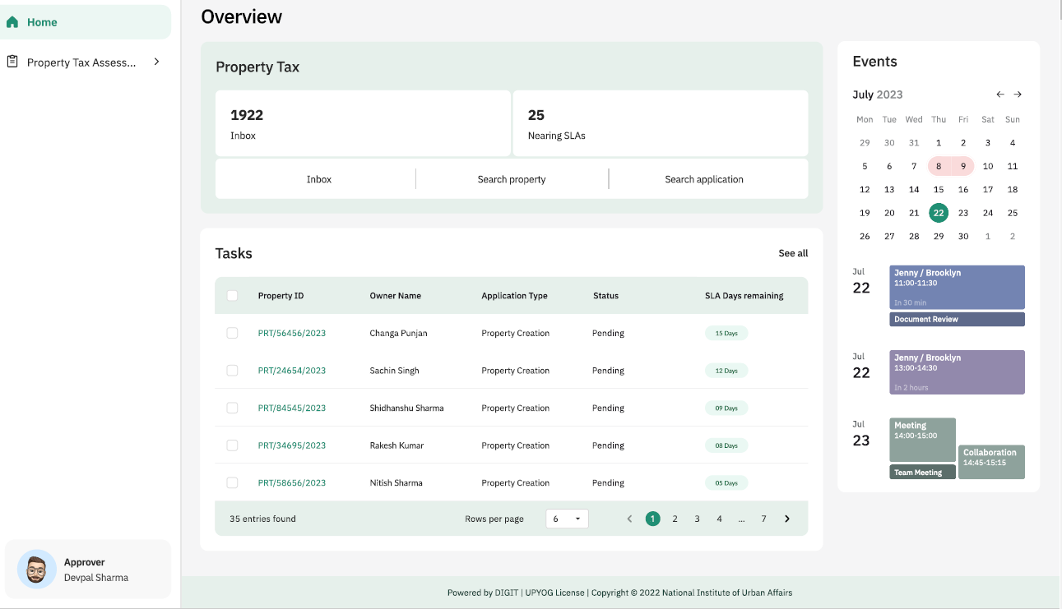

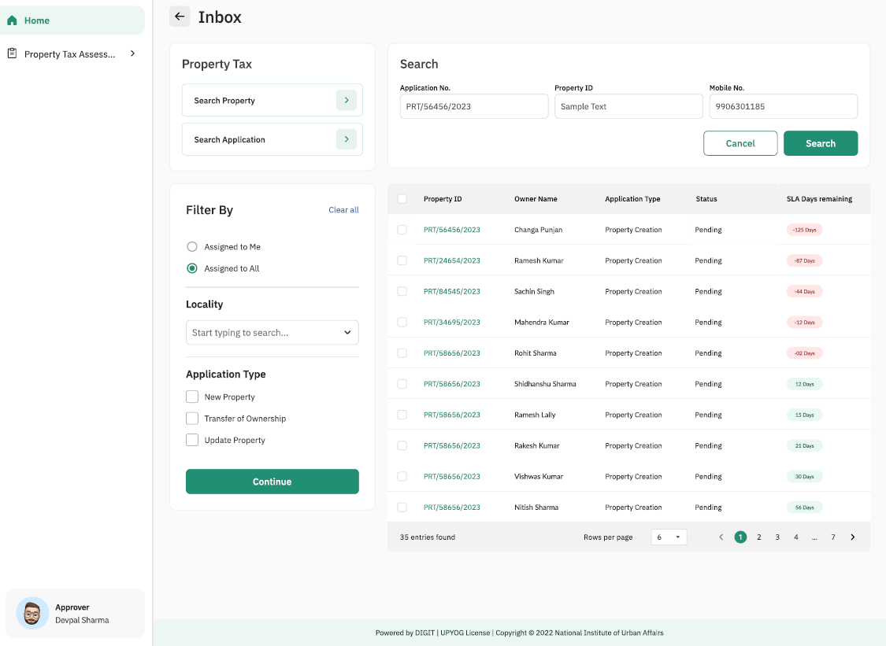.

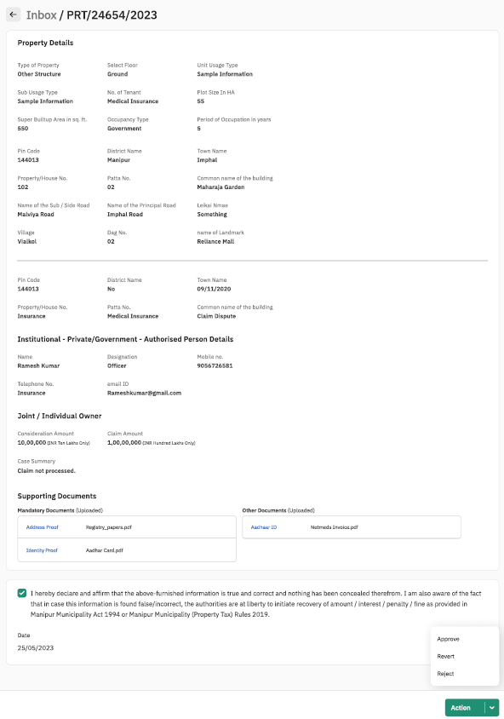

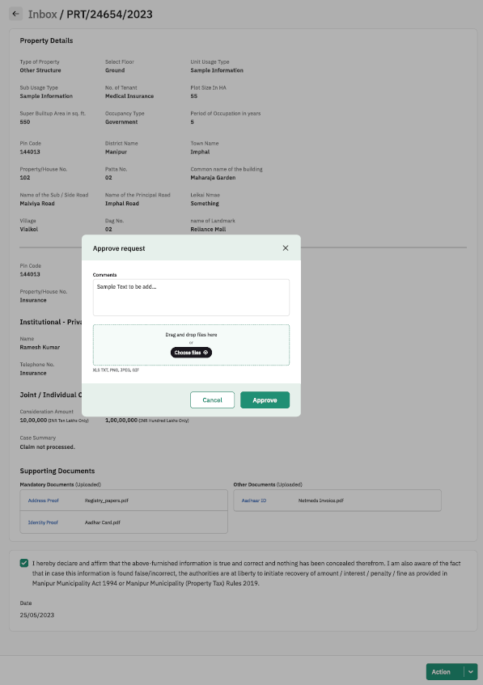

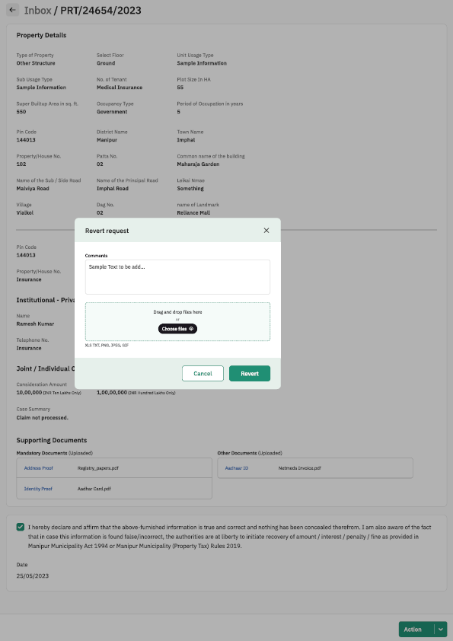

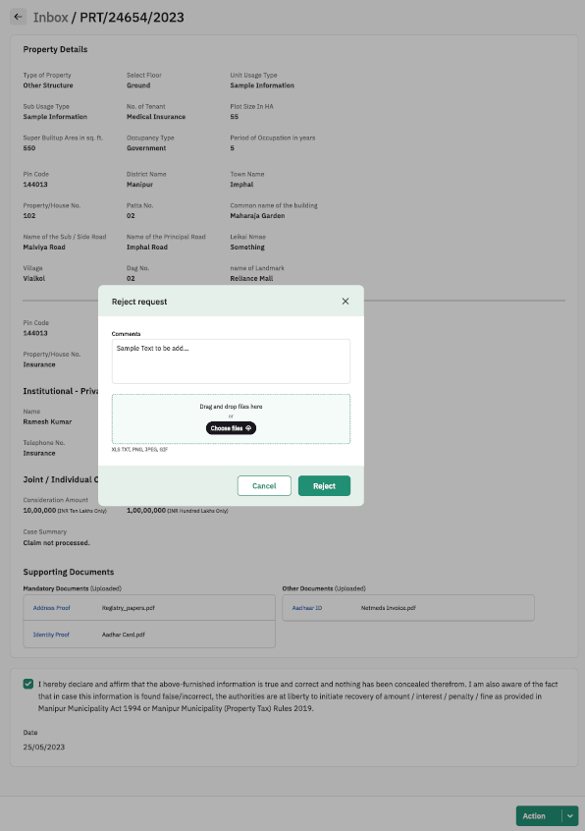

#### Property Sheet

**Appeal Details**

|  |  |  |  |  |
| --- | --- | --- | --- | --- |
| Sl. No. | Attribute Name | Attribute Type | Operation Type | Remarks |
| 1 | Tick the Checkbox | - | Clickable | Required |
| 2 | Action | - | Clickable | Required |

**Action Details**

|  |  |  |  |  |
| --- | --- | --- | --- | --- |
| Sl. No. | Attribute Name | Attribute Type | Operation Type | Remarks |
| 3 | Approve | - | Clickable | Required |
| 4 | Revert | - | Clickable | Required |
| 5 | Reject | - | Clickable | Required |

**Approve Request/Revert Request/ Reject Request**

|  |  |  |  |  |
| --- | --- | --- | --- | --- |
| Sl. No. | Attribute Name | Attribute Type | Operation Type | Remarks |
| 1 | Comments | varchar | Write | Required |
| 2 | Choose Files | .xls, .txt, .png, .jpeg, .gif files | Browse and select | Required |
| 3 | Approve/ Revert/ Reject | - | Clickable | Required |
| 4 | cancel | - | Clickable | Required |

# Self – Assessment

## Process Flow:



## Use Case 1: Submission of Self-Assessment Return

|  |  |
| --- | --- |
| Description | This functionality allows Property Owner / Counter User to submit Self-Assessment Return as per Rule 17 of Manipur Municipality Property Tax Rules 2019 |
| Actor(s) | Property Owner / Counter User |
| Detailed Process Flow: | |
| 1. Property Owner / Counter User will log into the portal using the mobile number and OTP. 2. Property Owner / Counter User will need to search and select the ULB using auto suggest feature 3. The Property Owner / Counter User will navigate to the Property Tax (PT) menu. 4. The Property Owner / Counter User will click on the ‘My Property’ tab 5. The Property Owner / Counter User will be shown property details, including details such as Property ID, Owner Name, Property Address, and Status 6. Property Owner / Counter will have to select the assessment year (Radio Button / Drop-down list) 7. The Property Owner / Counter User will click on the ‘Self Assessment’ button 8. The MMPTR Form 9 will be displayed to the Property Owner / Counter User 9. The Property Owner / Counter User will have to select from the below options (Radio Button / Drop-down list):    1. Original Return under Rule 17    2. Belated Return under Rule 18    3. Revised Return under Rule 19       1. If its Revised Return, Property Owner / Counter User will have to specify Receipt No. of Original Return and Date of Submission. Fields for the same will be displayed when this option is selected    4. Return against Notice for Defective Return under Rule 32       1. If its Defective Return, Property Owner / Counter User will have to specify Receipt No. of Original Return, Date of Submission, Notice No. and Date of Notice. Fields for the same will be displayed when this option is selected 10. The following information will be displayed to the Property Owner / Counter User in the format as per MMPTR Form 9:     1. Assesse details     2. Ownership details     3. Property details        1. Property structure        2. Usage and Age     4. Computation of Annual Property Value and Annual Tax 11. The Property Owner / Counter User will then have to enter details related to ‘Incidence of Taxation’     1. Property Owner / Counter User has to specify whether Property Owner / Counter User is claiming exemption under Section 92(1) and Section 77 of the Manipur Municipalities Act, 1994     2. If exemption is claimed, Property Owner / Counter User will have to select from the below options (Radio Button / Drop-down list):        1. Places exclusively used for public worship and either actually so used or used for no other purposes under Section 92(1)        2. Places exclusively used as public burial or burning ground under Section 92(1)        3. Any class of building exempted by government from levying property tax under Section 77 12. The Property Owner / Counter User will then have to specify the schedule of payment of annual property tax. The Property Owner / Counter User will have to select from the below option (Radio button / Drop-down list):     1. Annual Payment before 30 June of Assessment Year     2. Half yearly payment before 30 June and 31 December of the Assessment Year     3. Quarterly payment before 30 June, 30 September, 31 December, 28 February of the Assessment Year 13. After entry of the schedule of payment by Property Owner / Counter User, the system will auto generate the tax amount and the payment schedule based on the inputs of the Property Owner / Counter User and display the same in a tabular manner with all details like tax to be paid, any penalty / interest, adjustment of arrears and advance tax payments. The property tax calculator will follow the tax computation logic and the modalities as laid down in the Schedule I of this document 14. The Property Owner / Counter User will review all details related to the self-assessment return and proceed to submit 15. During submission Property Owner / Counter User will click on the radio button to confirm the declaration for return submission 16. Next Property Owner / Counter User will click on the ‘Submit’ and the self-assessment return will be submitted and saved in the system 17. On successful submission of return Property Owner / Counter User will have the option to download the acknowledgement as per MMPTR Form 10 in PDF format and also download the Challan for Payment of Property Tax Dues as per MMPTR Form 11 18. The Property Owner / Counter User will also have the option to make payment of property tax, there will be a link for payment of property tax online. On clicking this link, Property Owner / Counter User will be re-directed to the ‘My Bills’ menu | |
| Special requirements (if any) | Not applicable |
| Pre-conditions | 1. Users should have valid login credentials 2. Property should be registered in the system |
| Post-conditions | 1. On successful submission of the details, system will dispatch a task to the verifying officer for his/her verification. 2. System will auto generate an acknowledgement as per the MMPTR Form 10 and Challan for Payment of Property Tax Dues as per MMPTR Form 11, which will be sent to the user through email and or SMS |

## Use Case 2: Verification of Self-Assessment Return

|  |  |
| --- | --- |
| Description | This functionality allows Assessing Officer to verify the self-assessment return submitted by Property Owners as per rules 31,32,33 and 35 of Manipur Municipality Property Tax Rules, 2019 |
| Actor(s) | Assessment Officer |
| Detailed Process Flow: | |
| 1. Assessing officer will log into the portal using the username and password. 2. Under the property tax section verifying officer will have option to view    1. Inbox    2. Tasks nearing SLA    3. Search Property    4. Search Application 3. Assessing officer will navigate to his / her inbox where the pending tasks will be displayed to the user 4. Assessing officer will select the concerned task by clicking application number 5. The submitted self-assessment return in MMPTR form 9 submitted by counter user / property owner will be displayed along with the documents that have been attached 6. Assessing officer will verify the details submitted and documents attached during self-assessment return submission by property owner / citizen 7. Assessing officer will then click on ‘Take Action’ button. The verifying officer will have 3 options:    1. Accept – Assessing officer will click on this option if all details and documents submitted by the property owner comply. An acknowledgement to this effect will be shared with the property owner through SMS / Email    2. Generate Notice:       1. If this option is selected MMPTR Form 14 will be displayed       2. Details such as Name of Owner, Property Address, UPIN, Assessment Year, return Acknowledgement Number, Date of Submission of Annual Return will be auto populated and display only fields       3. Assessing Officer must enter the mistakes in the annual return submitted by property owner in the text field provided       4. Once the details have been entered Assessing Officer will click ‘Print’ button to generate the notice in PDF format       5. This notice in PDF must be printed signed and sealed by the Assessing Officer and shared with property owner over registered post | |
| Special requirements (if any) | Not applicable |
| Pre-conditions | 1. Users should have valid login credentials 2. Self- Assessment Return should have been submitted by Property Owner 3. The task should be available in the inbox of the user |
| Post-conditions | 1. The task will be marked as complete and removed from the inbox 2. System will auto generate an acknowledgement which will be sent to the citizen through email and or SMS |

## Sample User Interface

### Verification of Self-Assessment Return

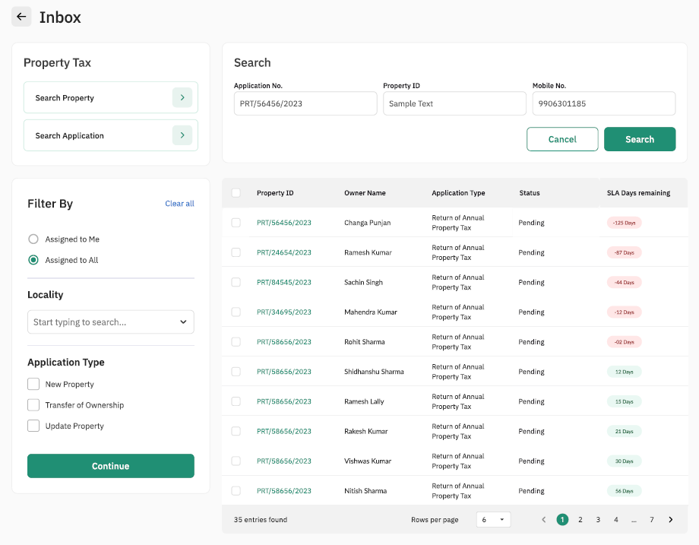

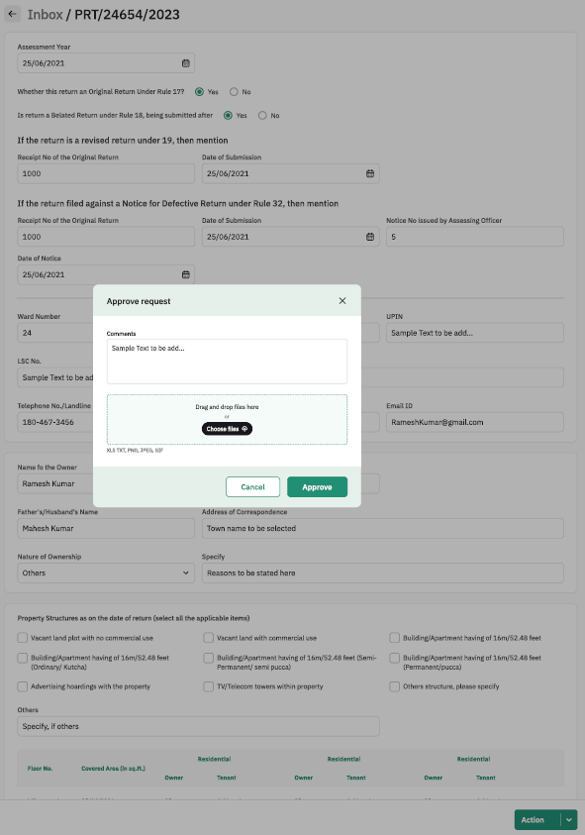

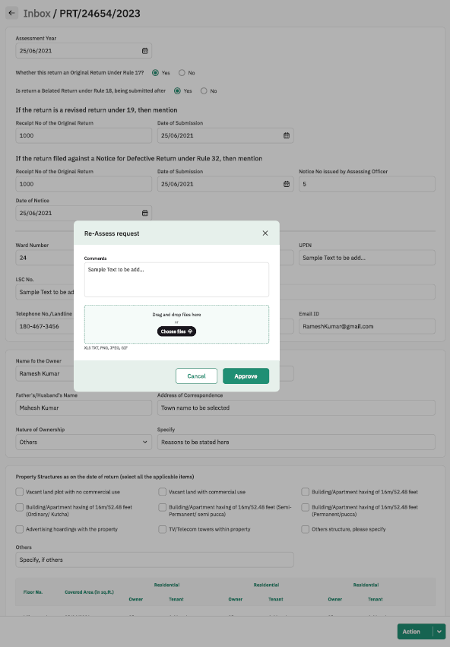

#### Property Sheet

**Action Tab**

|  |  |  |  |  |
| --- | --- | --- | --- | --- |
| Sl. No. | Attribute Name | Attribute Type | Operation Type | Remarks |
| 1 | Re-assessment | - | Clickable | Required |
| 2 | Approve | - | Clickable | Required |

**Re-Assessment Request**

|  |  |  |  |  |
| --- | --- | --- | --- | --- |
| Sl. No. | Attribute Name | Attribute Type | Operation Type | Remarks |
| 1 | Comments | varchar | Write | Required |
| 2 | Choose Files | .xls, .txt, .png, .jpeg, .gif files | Browse and select | Required |
| 3 | Approve | - | Clickable | Required |
| 4 | cancel | - | Clickable | Required |

**Approve Request**

|  |  |  |  |  |
| --- | --- | --- | --- | --- |
| Sl. No. | Attribute Name | Attribute Type | Operation Type | Remarks |
| 1 | Comments | varchar | Write | Required |
| 2 | Choose Files | .xls, .txt, .png, .jpeg, .gif files | Browse and select | Required |
| 3 | Approve | - | Clickable | Required |
| 4 | cancel | - | Clickable | Required |

# Payment of Property Tax Dues

Process Description:

|  |  |
| --- | --- |
| Description | This functionality allows Property Owner / Counter User to make payment of Property Tax Dues as per Rule 21, 22 and 23 of Manipur Municipality Property Tax Rules 2019 |
| Actor(s) | Property Owner / Counter User |
| Detailed Process Flow: | |
| 1. Property Owner / Counter User will log into the portal using the mobile number and OTP. 2. Property Owner / Counter User will need to search and select the ULB using auto suggest feature 3. The Property Owner / Counter User will navigate to the Property Tax (PT) menu. 4. The Property Owner / Counter User will click on the ‘My Property Bills’ option 5. The Property Owner / Counter User will be shown property details, including details such as Property Tax Amount Due, Property ID, Owner Name, Property Address, Billing Cycle and Due Date 6. The Property Owner / Counter User will click on the ‘View Details’ button 7. The total Property Tax Amount will be shown to Property Owner / Counter User along with breakup as follows:    1. Assessed Value    2. Rebate    3. Penalty    4. Interest    5. Special Category Exemption    6. Advance Deposit Adjustment    7. Arrear Details – Here View Arrear Details option will be there. On clicking this option, year-wise arrears will be displayed in tabular form 8. Property Owner / Counter User can verify the details and will have the following options:    1. Pay – Property owner will be directed to the payment gateway and data will be passed on to the payment gateway    2. Cancel – Process will be terminated, and no data will be saved 9. Property Owner / Counter User can also select the custom amount option to make a partial payment. Property owner will have to enter the amount of payment and click on ‘Proceed’ 10. Property Owner / Counter User can select the method of payment and pay 11. Once payment is processed Property Owner / Counter User will be re-directed to the payments page and payment status will be displayed 12. Property owner can download the receipt as per MMPTR Form 12 | |
| Special requirements (if any) | Not applicable |
| Pre-conditions | 1. Users should have valid User Identification Code and Login Password 2. Property assessment should have been completed for the concerned property 3. Users should have debit / credit cards / net banking / UPI |
| Post-conditions | 1. Payment receipt as per MMPTR Form 12 will be generated |

## Sample User Interface

### Payment of Property Tax Dues

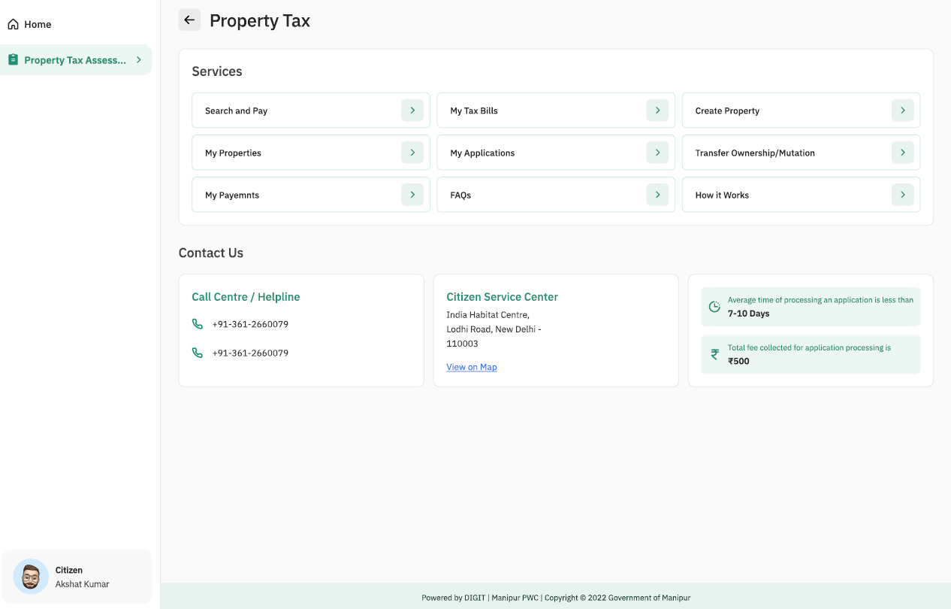

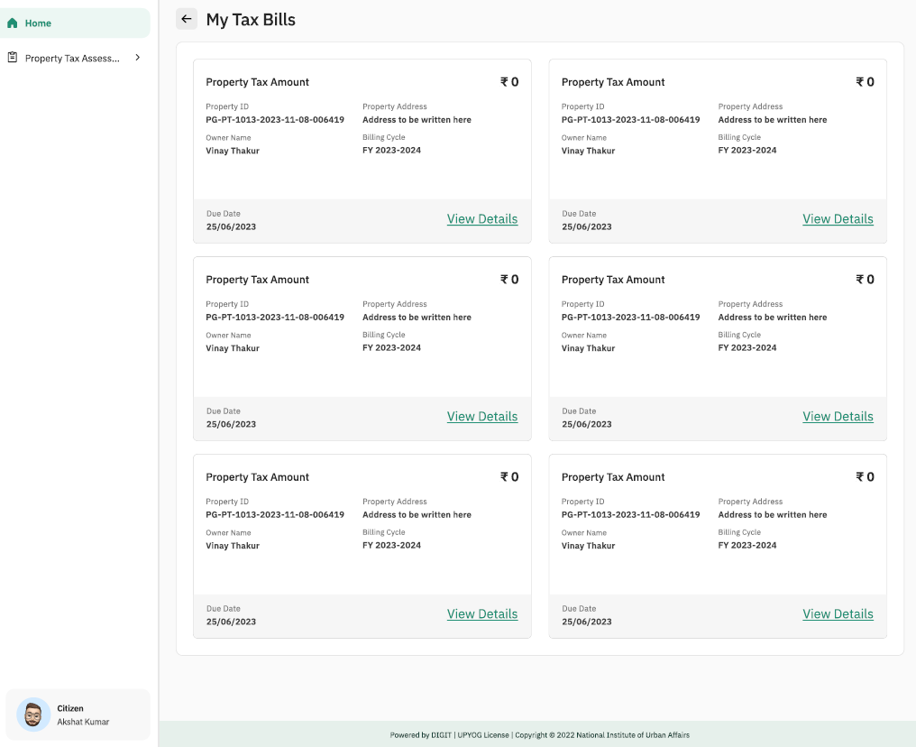

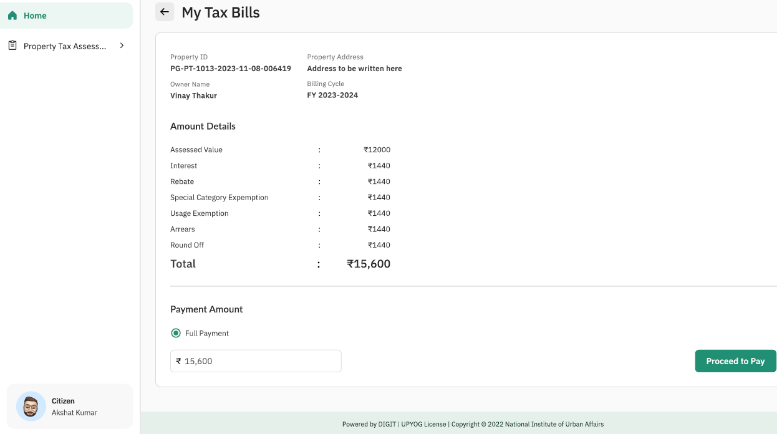

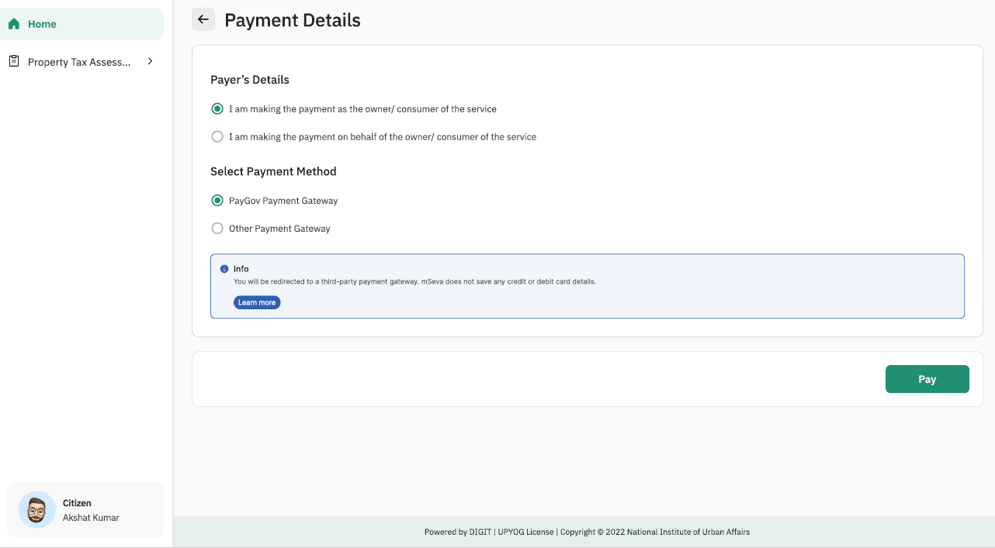

#### Property Sheet

**My Tax Bills**

|  |  |  |  |  |
| --- | --- | --- | --- | --- |
| Sl. No. | Attribute Name | Attribute Type | Operation Type | Remarks |
| 1 | View details | - | Clickable | Required |

**View Details**

|  |  |  |  |  |
| --- | --- | --- | --- | --- |
| Sl. No. | Attribute Name | Attribute Type | Operation Type | Remarks |
| 1 | Full Payement | - | Radio Button | Required |
| 2 | Proceed to Pay | - | Clickable | Required |

**Payment Details**

|  |  |  |  |  |
| --- | --- | --- | --- | --- |
| Sl. No. | Attribute Name | Attribute Type | Operation Type | Remarks |
| 3 | Payer’s Details | - | Radio Button | Required |
| 4 | Select payment method | - | Radio Button | Required |
| 5 | Pay | - | clickable | Required |

# Modification of Property – Process Flow

## Process Flow 1: Owner’s Request for Structural Changes



## Process Flow 2: Notice of Transfer of Title and Mutation



## Process Flow 3: Requesting Apportion of Annual Property Value and Assessment of Taxes



## Process Flow 4: Requesting Amalgamation / Separation of Ownership



# Modification of Property – Submission, Verification and Approval

## Use Case 1: Modification of Property

Process Description:

|  |  |
| --- | --- |
| Description | This functionality allows Property Owner / Counter User to modify the property under Rules 5, 6 and 13 of Manipur Municipality Property Tax Rules 2019 |
| Actor(s) | Property Owner / Counter User |
| Detailed Process Flow: | |
| 1. Property Owner / Counter User will log into the portal using the mobile number and OTP. 2. Property Owner / Counter User will need to search and select the ULB using auto suggest feature 3. The Property Owner / Counter User will navigate to the Property Tax (PT) menu. 4. The Property Owner / Counter User will click on the ‘Property Modification’ option 5. The Property Owner / Counter User will be shown property details, including details such as Property Tax Amount Due, Property ID, Owner Name, Property Address 6. The Property Owner / Counter User will click on the ‘Modify Property’ button 7. Property Owner / Counter User will have the following options which Property Owner / Counter User will have to select from (Radio Button / Drop-down list):    1. Notify Structural Changes under Rule 5 of the Manipur Municipality Property Tax Rules 2019    2. Notice of Transfer of Title and Mutation under Sub Rule 1 & 2 of Rule 6 of the Manipur Municipality Property Tax Rules 2019    3. Requesting Apportion of Annual Property Value and Assessment of Taxes under Sub Rule 4 of Rule 13 of the Manipur Municipality Property Tax Rules 2019    4. Requesting Amalgamation / Separation of Ownership under Sub Rule 7 of Rule 13 of the Manipur Municipality Property Tax Rules 2019   Notify Structural Changes under Rule 5 of the Manipur Municipality Property Tax Rules 2019   * + 1. If Notify Structural Changes under Rule 5 of the Manipur Municipality Property Tax Rules 2019 is selected, the MMPTR Form 3 will be displayed to the Property Owner / Counter User     2. The existing data related to the property such as UPIN, Patta No., Land Area in sq. ft., Covered Area in sq. ft., Level / Floor in numbers, Type of Structure, Usage Type will be auto populated and display on fields     3. Property Owner / Counter User will have to enter the following as per applicability:        1. Amalgamation with other Patta        2. Add / Delete Land Area in sq. ft. – System will auto-calculate the current land area in sq. ft. based on the input        3. Add / Delete Covered Area in sq. ft. – System will auto-calculate the current covered area in sq. ft. based on the input        4. Add / Delete Levels / Floors in numbers – System will auto-calculate the current level / floor numbers based on the input        5. Change in Structure Type        6. Change in Property Usage Type     4. Property Owner / Counter User will have to declare whether prior approval of MUC was obtained under relevant byelaws – ‘Yes / No’        1. If ‘Yes’ is selected, Property Owner / Counter User will have to upload a copy of the approval from MUC        2. If ‘No’ is selected, Property Owner / Counter User will have to specify the reason in the text field provided     5. Before final submission, Property Owner will click on the radio button to confirm *‘I hereby declare and affirm that the above-furnished information is true and correct and nothing has been concealed therefrom. I am also aware of the fact that in case this information is found false/incorrect, the authorities are at liberty to initiate recovery of amount / interest / penalty / fine as provided in Manipur Municipality Act 1994 or Manipur Municipality (Property Tax) Rules 2019.’*     6. Property Owner / Counter User will then click on submit button and details entered will be submitted and saved in the system     7. On successful submission of application user will have the option to download the acknowledgement as a PDF     8. On successful submission the application will be forwarded to concerned Executive Officer of the ULB for verification and approval   Notice of Transfer of Title and Mutation under Sub Rule 1 & 2 of Rule 6 of the Manipur Municipality Property Tax Rules 2019   * + 1. If Notice of Transfer of Title and Mutation under Sub Rule 1 & 2 of Rule 6 of the Manipur Municipality Property Tax Rules 2019 is selected, MMPTR Form 5 will be displayed to the Property Owner / Counter User     2. The existing data related to the property such as UPIN, Ward No., Leikai Name, Property No., Revenue Village, Patta No., Dag No. Property Address, Name of Owner/s, Father’s Name of Owner/s will be auto populated and display on fields     3. Property Owner / Counter User will have to enter the following as per applicability:        1. In case of death of Owner, ‘Date of Death’        2. Name of Transferee/s        3. Father’s Name of Transferee/s        4. Relationship with Transferor        5. Address of Transferee/s        6. Particulars of Transfer – Succession / Inheritance / Transfer by Sale / Partition / Assignment / Family Arrangement (Drop-down list or Radio Button)        7. Date of Transfer        8. Date of Execution of Transfer Documents        9. Upload Supporting Documents as per applicability (Certified Copies of Pass or Land Settlement Documents / Certified Copies of up-to-date copies of Property Tax Receipts / Sale or Purchase Deed, for sale or purchase cases / Death Certificate / Legal Heir Certificate issued by competent authority or Will duly probated by competent Civil Court / Any other Documents. The file formats supported will be .jpeg, .pdf, .png and the file size supported will not be more than 5 MB     4. Before final submission, Property Owner will click on the radio button to confirm *‘I hereby declare and affirm that the above-furnished information is true and correct and nothing has been concealed therefrom. I am also aware of the fact that in case this information is found false/incorrect, the authorities are at liberty to initiate recovery of amount / interest / penalty / fine as provided in Manipur Municipality Act 1994 or Manipur Municipality (Property Tax) Rules 2019.’*     5. Property Owner / Counter User will then click on submit button and details entered will be submitted and saved in the system     6. On successful submission of application user will have the option to download the acknowledgement as a PDF     7. On successful submission the application will be forwarded to concerned Executive Officer of the ULB for verification and approval   Requesting Apportion of Annual Property Value and Assessment of Taxes under Sub Rule 4 of Rule 13 of the Manipur Municipality Property Tax Rules 2019   * + 1. If ‘Requesting Apportion of Annual Property Value and Assessment of Taxes under Sub Rule 4 of Rule 13 of the Manipur Municipality Property Tax Rules 2019’ option is selected, MMPTR Form 7 will be displayed to Property Owner / Counter User     2. The existing data related to the property such as UPIN, Ward No., Leikai Name, Property No., Revenue Village, Patta No., Dag No. Property Address, Name of Owner/s, Father’s Name of Owner/s will be auto populated and display on fields     3. Property Owner / Counter User will have the option to add Owner by clicking on ‘Add’ button / icon     4. Property Owner / Counter User will have to assign Percentage of Ownership against each Owner / Co-owner     5. Before final submission, Property Owner will click on the radio button to confirm *‘I hereby declare and affirm that the above-furnished information is true and correct and nothing has been concealed therefrom. I am also aware of the fact that in case this information is found false/incorrect, the authorities are at liberty to initiate recovery of amount / interest / penalty / fine as provided in Manipur Municipality Act 1994 or Manipur Municipality (Property Tax) Rules 2019.’*     6. Property Owner / Counter User will then click on submit button and details entered will be submitted and saved in the system     7. On successful submission of application user will have the option to download the acknowledgement as a PDF     8. On successful submission the application will be forwarded to concerned Executive Officer of the ULB for verification and approval   Requesting Amalgamation / Separation of Ownership under Sub Rule 7 of Rule 13 of the Manipur Municipality Property Tax Rules 2019   * + 1. If ‘Requesting Amalgamation / Separation of Ownership under Sub Rule 7 of Rule 13 of the Manipur Municipality Property Tax Rules 2019’ option is selected, MMPTR Form 8 will be displayed to Property Owner / Counter User     2. Property Owner / Counter User will then have to select from the below options (Radio Button / Drop-down List):        1. Amalgamation of more than 1 (one) property into 1 (one)           1. If this option is selected, Property Owner / Counter User will have to select properties to be amalgamated by searching the properties by entering UPIN or Property No. in the search field provided           2. Property Owner / Counter User can search and ‘Add’ multiple properties by clicking on the ‘Add’ button / icon           3. The details of the selected properties such as Name of Owner, UPIN, Property Address, Ward No. Leikai Name, Patta No. will be displayed in a tabular manner           4. Once Property Owner / Counter User has selected all properties to be amalgamated into a single property, Property Owner / Counter User will click on the radio button to confirm ‘I hereby declare and affirm that the above-furnished information is true and correct and nothing has been concealed therefrom. I am also aware of the fact that in case this information is found false/incorrect, the authorities are at liberty to initiate recovery of amount / interest / penalty / fine as provided in Manipur Municipality Act 1994 or Manipur Municipality (Property Tax) Rules 2019.’           5. Property Owner / Counter User will then click on the ‘Amalgamate’ button           6. On successful submission of application user will have the option to download the acknowledgement as a PDF           7. On successful submission the application will be forwarded to concerned Executive Officer of the ULB for verification and approval        2. Separation of 1 (one) property into more than 1 (one)           1. If this option is selected, existing property details such as Name of Owner, UPIN, Property Address, Ward No. Leikai Name, Patta No. will be displayed in a tabular manner           2. Property Owner / Counter User will have to add the number owner / co-owner by clicking on ‘Add’ button / icon           3. Property Owner / Counter User will have to assign Percentage of Ownership against each Owner / Co-owner           4. Once Property Owner / Counter User has selected all owners / co-owners, Property Owner / Counter User will click on the radio button to confirm ‘I hereby declare and affirm that the above-furnished information is true and correct and nothing has been concealed therefrom. I am also aware of the fact that in case this information is found false/incorrect, the authorities are at liberty to initiate recovery of amount / interest / penalty / fine as provided in Manipur Municipality Act 1994 or Manipur Municipality (Property Tax) Rules 2019.’           5. Property Owner / Counter User will then click on the ‘Separate’ button           6. On successful submission of application user will have the option to download the acknowledgement as a PDF           7. On successful submission the application will be forwarded to concerned Executive Officer of the ULB for verification and approval | |
| Special requirements (if any) | Not applicable |
| Pre-conditions | 1. Users should have valid login credentials 2. Property details shall be available with the user |
| Post-conditions | 1. On successful submission of the details, system will dispatch a task to the verifying officer for his/her verification. 2. System will auto generate an acknowledgement which will be sent to the user through email and or SMS 3. System will generate temporary UPIN and Application number. UPIN would be allotted by the system on the following basis: District Code: X (1 alphanumeric); Town/City Code: XX (2 alphanumeric); Ward Code: XX (2 alphanumeric); Leikai/Locality Code: XX (2 alphanumeric); Ownership Code: X (1 alphanumeric); Property Serial Number: XXXXXXXX (8 alphanumeric characters/digits) |

## Sample User Interface

### Owner’s Request for Structural Changes

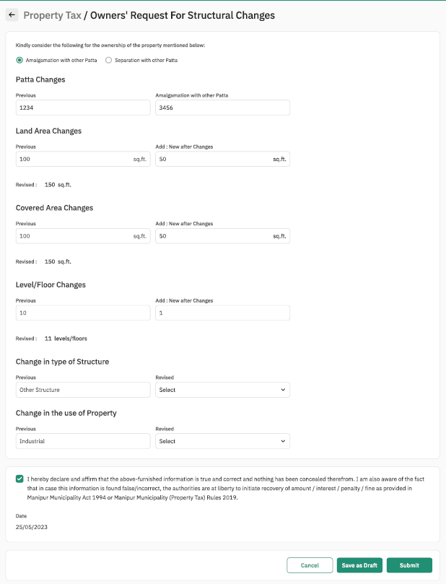

#### Property Sheet

**Patta Changes**

|  |  |  |  |  |
| --- | --- | --- | --- | --- |
| Sl. No. | Attribute Name | Attribute Type | Operation Type | Remarks |
| 1 | Previous | Int | Write | Required |
| 2 | Amalgamation with other patta | Char | Write | Required |

**Land Area Changes**

|  |  |  |  |  |
| --- | --- | --- | --- | --- |
| Sl. No. | Attribute Name | Attribute Type | Operation Type | Remarks |
| 1 | Previous | Int | Write | Required |
| 2 | Add: New after Changes | int | Write | Required |
| 3 | Revised | int | Not- clickable | Required |

**Covered area Changes**

|  |  |  |  |  |
| --- | --- | --- | --- | --- |
| Sl. No. | Attribute Name | Attribute Type | Operation Type | Remarks |
| 1 | Previous | Int | Write | Required |
| 2 | Add: New after Changes | int | Write | Required |
| 3 | Revised | int | Not- clickable | Required |

**Level/Floor Changes**

|  |  |  |  |  |
| --- | --- | --- | --- | --- |
| Sl. No. | Attribute Name | Attribute Type | Operation Type | Remarks |
| 1 | Previous | Int | Write | Required |
| 2 | Add: New after Changes | int | Write | Required |
| 3 | Revised | int | Not- clickable | Required |

**Change in Type of Structure**

|  |  |  |  |  |
| --- | --- | --- | --- | --- |
| Sl. No. | Attribute Name | Attribute Type | Operation Type | Remarks |
| 1 | Previous | varchar | Write | Required |
| 2 | Add: New after Changes | varchar | Drop down Selection | Required |

**Change in use of Property**

|  |  |  |  |  |
| --- | --- | --- | --- | --- |
| Sl. No. | Attribute Name | Attribute Type | Operation Type | Remarks |
| 1 | Previous | Varchar | Write | Required |
| 2 | Add: New after Changes | varchar | Drop down Selection | Required |

### Notice of Transfer of Title and Mutation

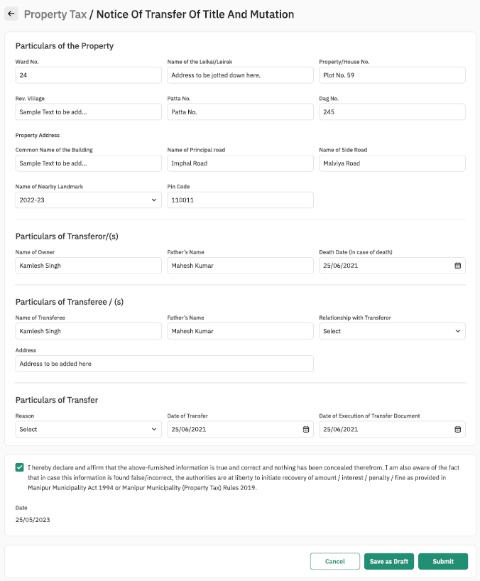

#### Property Sheet

**Particulars of The Property**

|  |  |  |  |  |
| --- | --- | --- | --- | --- |
| Sl. No. | Attribute Name | Attribute Type | Operation Type | Remarks |
| 1 | Ward No. | Int | write | Required |
| 2 | Name of Leikai/Leirak | Varchar | Write | Required |
| 3 | Property/ House No. | Varchar | Write | Required |
| 4 | Rev. Village | Varchar | Write | Required |
| 5 | Patta No. | Varchar | write | Required |
| 6 | Dag No. | Int | Write | Required |
| 7 | Common Name of the Building | Varchar | Write | Required |
| 8 | Name of the Principal Road | Varchar | Write | Required |
| 9 | Name of the Side Road | Varchar | Write | Required |
| 10 | Name of Nearby Landmark | Int | Write | Required |
| 11 | Pin Code | int | Write | Required |

**2. Particulars of Transferor/(s)**

|  |  |  |  |  |
| --- | --- | --- | --- | --- |
| Sl. No. | Attribute Name | Attribute Type | Operation Type | Remarks |
| 1 | Name of Owner | Varchar | write | Required |
| 2 | Father’s Name | Varchar | write | Required |
| 3 | Death Date (in case of death) | date | Date Selection | Required |

**Particulars of Transferee/(s)**

|  |  |  |  |  |
| --- | --- | --- | --- | --- |
| Sl. No. | Attribute Name | Attribute Type | Operation Type | Remarks |
| 1 | Name of Transferee | Varchar | write | Required |
| 2 | Father’s Name | Varchar | write | Required |
| 3 | Relationship with Transferor | Varchar | Drop Down Selection | Required |
| 4 | Address | Varchar | write | Required |

**Particulars of transfer**

|  |  |  |  |  |
| --- | --- | --- | --- | --- |
| Sl. No. | Attribute Name | Attribute Type | Operation Type | Remarks |
| 1 | Reason | Varchar | Drop Down Selection | Required |
| 2 | Date of Transfer | Int | Date Selection | Required |
| 3 | Date of Execution of Transfer Document | Varchar | Date Selection | Required |

### Requesting Apportion of Annual Property Value and Assessment of Taxes

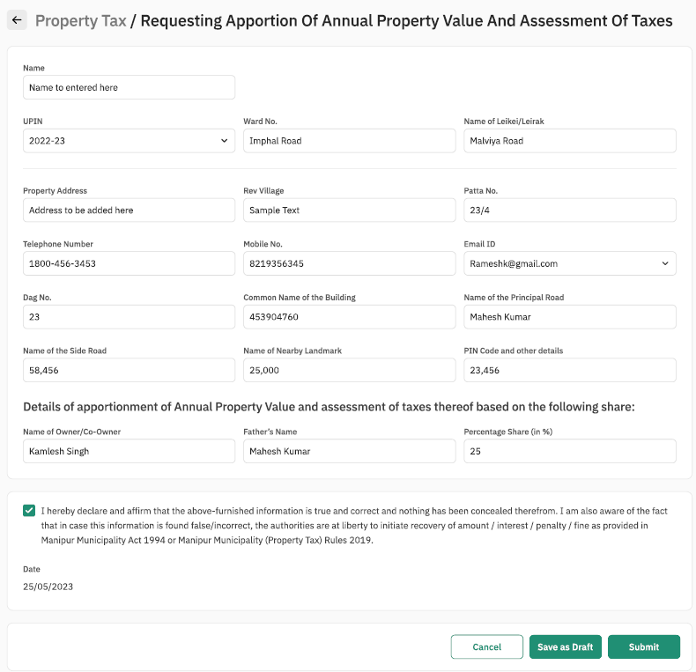

#### Property Sheet

|  |  |  |  |  |
| --- | --- | --- | --- | --- |
| Sl. No. | Attribute Name | Attribute Type | Operation Type | Remarks |
| 1 | Name | Varchar | Write | Required |
| 2 | UPIN | Int | Drop Down Selection | Required |
| 3 | Ward No. | Varchar | write | Required |
| 4 | Name of leikei/Leirak | Varchar | Write | Required |
| 5 | Property address | Varchar | Write | Required |
| 6. | Rev village | Varchar | Write | Required |
| 7. | Patta No. | Varchar | Write | Required |
| 8. | Telephone Number | int | Write | Required |
| 9. | Mobile Number | Int | Write | Required |
| 9. | Email ID | Varchar | Write | Required |
| 10. | Dag. No. | int | Write | Required |
| 11. | Common Name of the Building | Varchar | Write | Required |
| 12. | Name of Principal Road | varchar | Write | Required |
| 13. | Name of Side Road | Varchar | Write | Required |
| 14. | Name of Nearby Landmark | Varchar | Write | Required |
| 15. | PIN Code and other details | Varchar | Write | Required |

**Details of appointment of Annual Property Value and assessment of taxes thereof based on following share**

|  |  |  |  |  |
| --- | --- | --- | --- | --- |
| Sl. No. | Attribute Name | Attribute Type | Operation Type | Remarks |
| 1 | Name of Owner/ Co-Owner | Varchar | Write | Required |
| 2 | Father’s Name | varchar | Write | Required |
| 3 | Percentage Share (in %) | int | Write | Required |

### Notice of Transfer of Title and Mutation

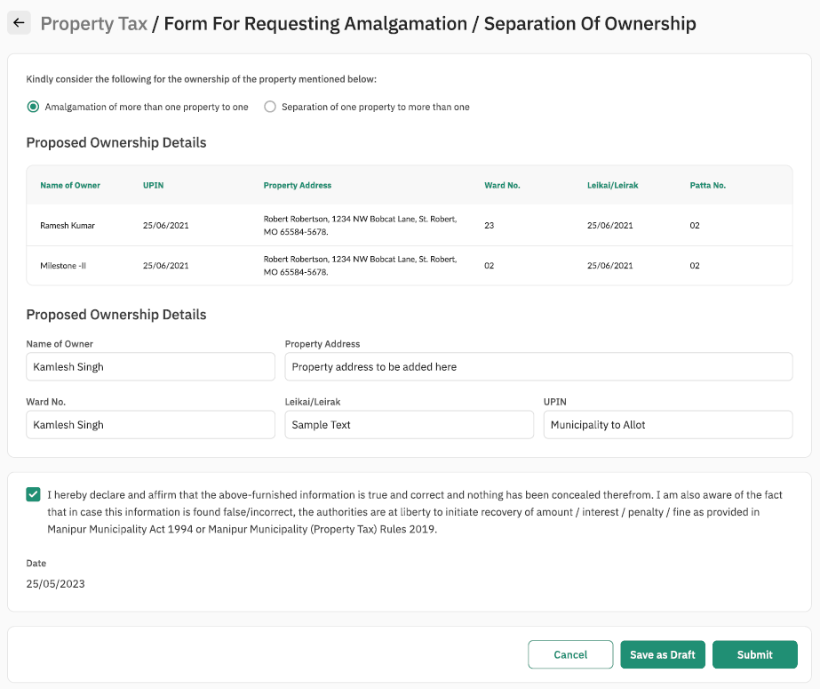

#### Property Sheet

|  |  |  |  |  |
| --- | --- | --- | --- | --- |
| Sl. No. | Attribute Name | Attribute Type | Operation Type | Remarks |
| 1 | Name of the Owner | Varchar | Clickable | Required |
| 2 | Property Address | Varchar | Clickable | Required |
| 3 | Ward No. | Varchar | Clickable | Required |
| 4 | Leikei Leirak | Varchar | Clickable | Required |
| 5 | UPIN | Varchar | Clickable | Required |

## Use Case 2: Verification of Modified Property Details

Process Description:

|  |  |
| --- | --- |
| Description | This functionality allows users to verify the modified property details submitted by counter user / property owner, forward for filed inspection, revert application, reject application |
| Actor(s) | Verifying Officer |
| Detailed Process Flow: | |
| 1. Verifying officer will log into the portal using the username and password. 2. Under the property tax section verifying officer will have option to view    1. Inbox    2. Tasks nearing SLA    3. Search Property    4. Search Application 3. Verifying officer will navigate to his / her inbox where the pending tasks will be displayed to the user 4. Verifying officer will select the concerned task by clicking application number 5. The modified property details in MMPTR form 3 / 5 / 7 / 8 submitted by counter user / property owner will be displayed along with the documents that have been attached 6. Verifying officer will verify the documents attached during submission by property owner / citizen 7. Verifying officer will then click on ‘Take Action’ button. The verifying officer will have 3 options:    1. Reject – verifying officer will reject the application by clicking this button and entering his / her comments along with uploading and supporting documents, if applicable. Application status will be updated as ‘Rejected’    2. Forward – Verifying Officer will select the concerned Field Inspector and clicking on the ‘Forward’ button after entering his / her comments and uploading any supporting documents, if applicable. Application status will be updated as ‘Forwarded for Field Verification’    3. Send back to Citizen – Verifying Officer will enter his / her comments and upload any supporting documents, if applicable. Verifying Officer will click on ‘Send Back to Citizen’ button. The application will be routed to the citizen and citizen will be notified through SMS/ eMail. The application will be available in the Notification section of Property Owner / Citizen / Counter User. Application status will be updated with comments of the ‘Verifying Officer’ 8. Verifying officer will have the option of uploading supporting documents. The file formats supported will be .jpeg, .pdf, .png and the file size supported will not be more than 5 MB | |
| Special requirements (if any) | Not applicable |
| Pre-conditions | 1. Verifying officer should have valid login credentials 2. Modified property details shall have to be submitted by the counter user / property owner 3. The task should be displayed in the inbox of Verifying Officer (User) |
| Post-conditions | 1. On successful submission of the details, system will dispatch a task to the concerned user for his/her action. 2. The task will be marked as complete and removed from the inbox 3. System will auto generate an acknowledgement which will be sent to the citizen through email and or SMS |

## Use Case 3: Field Verification of Modified Property Details

Process Description:

|  |  |
| --- | --- |
| Description | This functionality allows Field inspector to record his / her observations from field inspection of property, upload documents / photos, forward for approval, revert to verifying officer and revert to property owner |
| Actor(s) | Field Inspector |
| Detailed Process Flow: | |
| 1. Field Inspector will log into the portal using the username and password. 2. Under the property tax section verifying officer will have option to view    1. Inbox    2. Tasks nearing SLA    3. Search Property    4. Search Application 3. Field Inspector will navigate to his / her inbox where the pending tasks will be displayed to the user 4. Field Inspector will select the concerned task by clicking application number 5. The modified property details in MMPTR form 3 / 5 / 7 / 8 submitted by counter user / property owner will be displayed along with the documents that have been attached. Also the comments of the Verifying Officer along with supporting documents if any will be displayed 6. Field Officer will carry out field inspection of the property and click on the ‘Take Action’ button to record his / her observations in the comments box. 7. Field Inspector will have 3 options:    1. Send back to Verifying officer – Field Inspector will send back the application by clicking this button and entering his / her comments along with uploading and supporting documents, if applicable. Application status will be updated as ‘Sent Back to Verifying Officer’    2. Forward – Field Inspector will select the concerned Approver and click on the ‘Forward’ button after entering his / her comments and uploading any supporting documents, if applicable. Application status will be updated as ‘Forwarded for Approval’    3. Send back to Citizen – Field Inspector will enter his / her comments and upload any supporting documents, if applicable. Field Inspector will click on ‘Send Back to Citizen’ button. The application will be routed to the citizen and citizen will be notified through SMS/ eMail. The application will be available in the Notification section of Property Owner / Citizen / Counter User. Application status will be updated with comments of the ‘Field Inspector’ 8. Field Inspector will have the option of uploading photographs from the site inspection. The file formats supported will be .jpeg, .pdf, .png and the file size supported will not be more than 5 MB | |
| Special requirements (if any) | Not applicable |
| Pre-conditions | 1. Field Inspector should have valid login credentials 2. Property details shall have to be submitted by the citizen / property owner and verified by Verifying Officer 3. The task should be displayed in the inbox of Field Inspector (User) |
| Post-conditions | 1. On successful submission of the details, system will dispatch a task to the concerned user for his/her action. 2. The task will be marked as complete and removed from the inbox 3. System will auto generate an acknowledgement which will be sent to the citizen through email and or SMS |

## Use Case 3: Approval & Generation of UPIN for Modified Property

Process Description:

|  |  |
| --- | --- |
| Description | This functionality allows Executive Officer to approve / reject the modified property details submitted by property owner / counter user, view observations recorded by verifying officer & field inspector and generate the UPIN for the property |
| Actor(s) | Executive Officer |
| Detailed Process Flow: | |
| 1. Executive Officer will log into the portal using the username and password. 2. Under the property tax section verifying officer will have option to view    1. Inbox    2. Tasks nearing SLA    3. Search Property    4. Search Application 3. Executive Officer will navigate to his / her inbox where the pending tasks will be displayed to the user 4. Executive Officer will select the concerned task by clicking application number 5. The modified property details in MMPTR form 3 / 5 / 7 / 8 submitted by citizen / property owner will be displayed along with the documents that have been attached. Also the comments of the Verifying Officer and Field Inspector along with supporting documents if any, will be displayed 6. Executive Officer will click on the ‘Take Action’ button 7. Executive Officer will have the following options:    1. Reject – Executive Officer will reject the application by clicking this button and entering his / her comments along with uploading and supporting documents, if applicable. Application status will be updated as ‘Rejected’. Citizen / Counter User / Property Owner will be notified through SMS / eMail    2. Approve - Executive Officer will approve the application by clicking this button and entering his / her comments along with uploading and supporting documents, if applicable. Application status will be updated as ‘Approved’. Citizen / Counter User / Property Owner will be notified through SMS / eMail 8. On approval system will generate UPIN 9. UPIN would be allotted by the system on the following basis: District Code: X (1 alphanumeric); Town/City Code: XX (2 alphanumeric); Ward Code: XX (2 alphanumeric); Leikai/Locality Code: XX (2 alphanumeric); Ownership Code: X (1 alphanumeric); Property Serial Number: XXXXXXXX (8 alphanumeric characters/digits) | |
| Special requirements (if any) | Not applicable |
| Pre-conditions | 1. Executive Officer should have valid login credentials 2. Modified property details shall have to be submitted by the citizen / property owner and should be verified by verifying officer and field inspector 3. The task should be displayed in the inbox of Executive Officer |
| Post-conditions | 1. UPIN will be generated, and details will be shared with citizen / property owner through email and or SMS 2. The task will be marked as complete and removed from the inbox |

# Notice generation under various Rules of Manipur Municipality Property Tax Rules 2019

Process Description:

|  |  |
| --- | --- |
| Description | This functionality allows ULB officials to generate and dispatch notices under various Rules of Manipur Municipality Property Tax Rules 2019 |
| Actor(s) | Assessing Officer / Designated Officer of the Board |
| Detailed Process Flow: | |
| 1. Assessing Officer / Designated Officer of the Board will log into the portal using the username and password. 2. Under the property tax section verifying officer will have option to view    1. Inbox    2. Tasks nearing SLA    3. Search Property    4. Search Application 3. Assessing Officer / Designated Officer of the Board will click on the ‘Search’ option 4. Assessing Officer / Designated Officer of the Board will be able to search property/s with the below search criteria or its combination:    1. UPIN    2. Owner Name & Mobile Number    3. Locality & Property ID 5. Assessing Officer / Designated Officer of the Board will then select the concerned property and property details, including details such as UPIN, Property ID, Owner Name, Property Address will be displayed 6. Assessing Officer / Designated Officer of the Board will then proceed for notice generation and click on ‘Generate Notice’ button 7. Assessing Officer / Designated Officer of the Board will have to select the required notice to be generated from the following options (drop-down list / Radio Button):    1. Notice for rectification of mistakes in a Defective Return       1. If this option is selected MMPTR Form 14 will be displayed       2. Details such as Name of Owner, Property Address, UPIN, Assessment Year, return Acknowledgement Number, Date of Submission of Annual Return will be auto populated and display only fields       3. Assessing Officer must enter the mistakes in the annual return submitted by property owner in the text field provided       4. Once the details have been entered Assessing Officer will click ‘Print’ button to generate the notice in PDF format       5. This notice in PDF must be printed signed and sealed by the Assessing Officer and shared with property owner over registered post       6. Notices generated will be accessible in the Notification Section of the Property Owner’s login account    2. Notice for Assessment       1. If this option is selected MMPTR Form 15 will be displayed       2. Details such as Name of Owner, Property Address, UPIN, Assessment Year, return Acknowledgement Number, Date of Submission of Annual Return will be auto populated and display only fields       3. Assessing Officer must enter the particulars as per the format provided       4. Once the details have been entered Assessing Officer will click ‘Print’ button to generate the notice in PDF format       5. This notice in PDF must be printed signed and sealed by the Assessing Officer and shared with property owner over registered post       6. Notices generated will be accessible in the Notification Section of the Property Owner’s login account    3. Notice for Re-Assessment       1. If this option is selected MMPTR Form 16 will be displayed       2. Details such as Name of Owner, Property Address, UPIN, Assessment Year, return Acknowledgement Number, Date of Submission of Annual Return will be auto populated and display only fields       3. Assessing Officer must enter the particulars in the text field provided       4. Once the details have been entered Assessing Officer will click ‘Print’ button to generate the notice in PDF format       5. This notice in PDF must be printed signed and sealed by the Assessing Officer and shared with property owner over registered post       6. Notices generated will be accessible in the Notification Section of the Property Owner’s login account    4. Notice to enter Premises       1. If this option is selected MMPTR Form 17 will be displayed       2. Details such as Name of Owner, Property Address, UPIN, Assessment Year, will be auto populated and display only fields       3. Assessing Officer must enter the name and designation of the authorized official in the text field provided       4. Assessing Officer must enter the date and time of the authorized official’s visit in the text field provided       5. Assessing Officer must enter the mobile number of the authorized official in the text field provided       6. Once the details have been entered Assessing Officer will click ‘Print’ button to generate the notice in PDF format       7. This notice in PDF must be printed signed and sealed by the Assessing Officer and shared with property owner over registered post       8. Notices generated will be accessible in the Notification Section of the Property Owner’s login account    5. Notice to file Return       1. If this option is selected a notice in MMPTR Form 19 with details such as Name of Owner, Property Address, UPIN, Assessment Year, will be auto generated       2. Assessing Officer will click ‘Print’ button to generate the notice in PDF format       3. This notice in PDF must be printed signed and sealed by the Assessing Officer and shared with property owner over registered post       4. Notices generated will be accessible in the Notification Section of the Property Owner’s login account    6. Notice for Hearing under Rule 39 / 40       1. If this option is selected MMPTR Form 22 will be displayed       2. Details such as Name of Owner, Property Address, UPIN, Assessment Year, will be auto populated and display only fields       3. Designated Officer of the Board must enter the Appeal Application Number and Date of Filing in the text field provided       4. Designated Officer of the Board must enter the date and time of the Hearing in the text field provided       5. Once the details have been entered Assessing Officer will click ‘Print’ button to generate the notice in PDF format       6. This notice in PDF must be printed signed and sealed by the Designated Officer of the Board and shared with property owner over registered post       7. Notices generated will be accessible in the Notification Section of the Property Owner’s login account    7. Notice for Imposition of Penalty       1. If this option is selected a notice in MMPTR Form 25 with details such as Name of Owner, Property Address, UPIN, Assessment Year, will be auto generated       2. Assessing Officer will click ‘Print’ button to generate the notice in PDF format       3. This notice in PDF must be printed signed and sealed by the Assessing Officer and shared with property owner over registered post       4. Notices generated will be accessible in the Notification Section of the Property Owner’s login account | |
| Special requirements (if any) | Not applicable |
| Pre-conditions | 1. Assessing Officer / Designated Officer of the Board should have valid login credentials |
| Post-conditions | 1. Notices generated will be accessible in the Notification Section of the Property Owner’s login account |

## Sample User Interface

### Notice for rectification of mistakes in a Defective Return

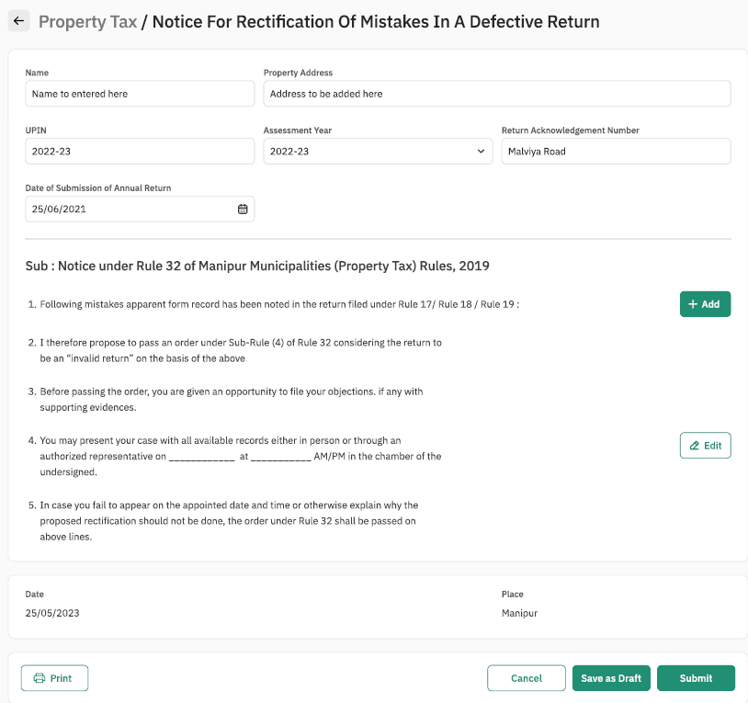

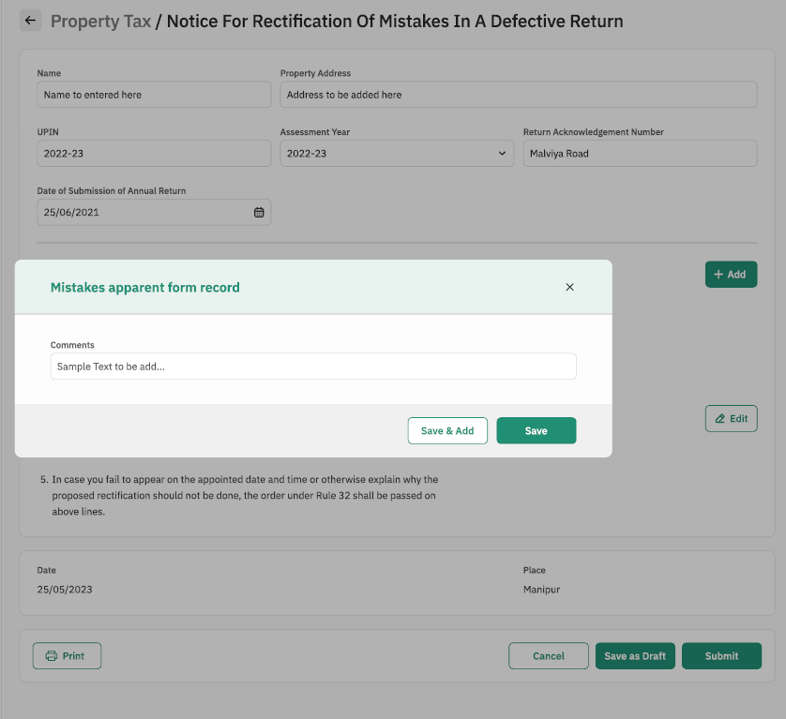

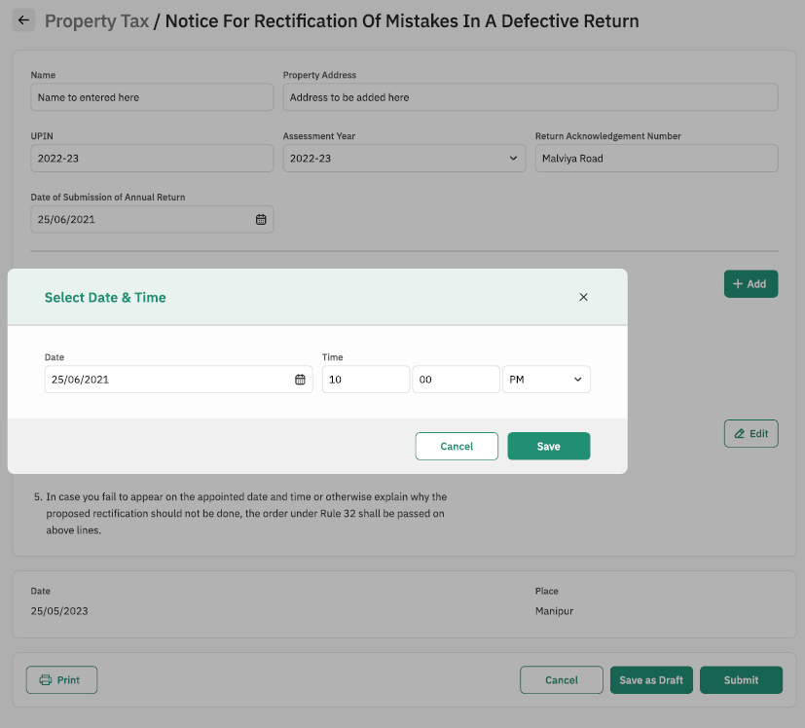

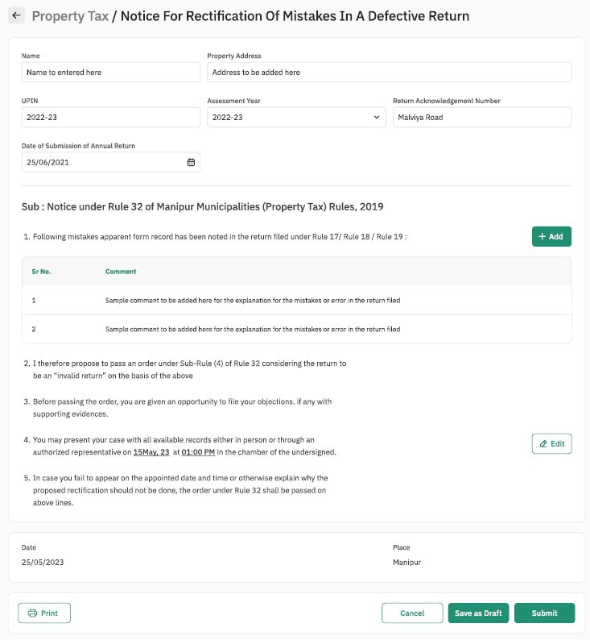

#### Property Sheet

**Notice under Rule 32 of Manipur Municipalities (Property Tax) Rules, 2019**

|  |  |  |  |  |
| --- | --- | --- | --- | --- |
| Sl. No. | Attribute Name | Attribute Type | Operation Type | Remarks |
| 1 | Add | - | Clickable | Required |
| 2 | Edit | - | Clickable | Required |

**Mistakes apparent form Record**

|  |  |  |  |  |
| --- | --- | --- | --- | --- |
| Sl. No. | Attribute Name | Attribute Type | Operation Type | Remarks |
| 1 | comments | Varchar | Write | Required |
| 2 | Save and add | - | Clickable | Required |
| 3 | Save | - | Clickable | Required |

**Select Date and Time**

|  |  |  |  |  |
| --- | --- | --- | --- | --- |
| Sl. No. | Attribute Name | Attribute Type | Operation Type | Remarks |
| 1 | Date | Varchar | Date Selection | Required |
| 2 | Time | int | Write | Required |
| 3 | Time | int | Write | Required |
| 4 | AM/PM | Varchar | Drop Down Selection | Required |
| 5 | Save | - | Clickable | Required |
| 6 | Cancel | - | Clickable | Required |

### Notice for Assessment

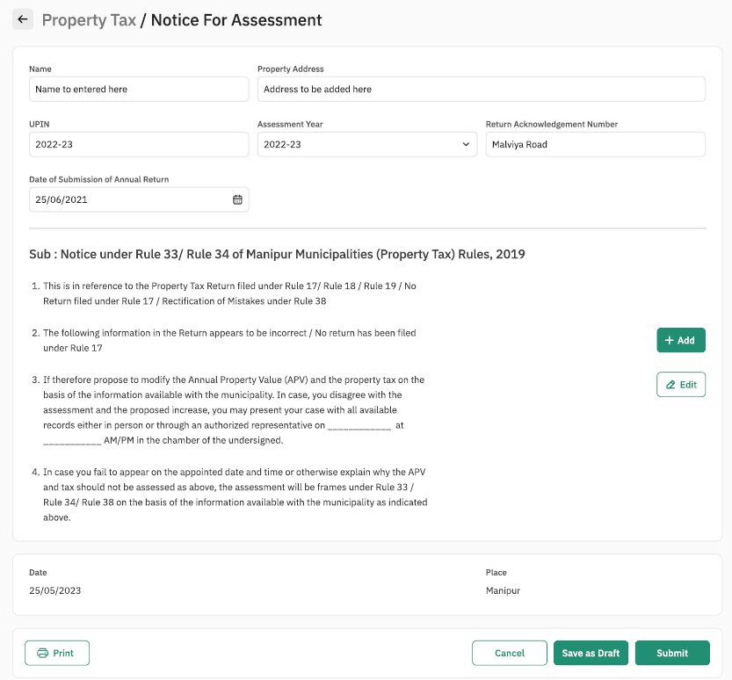

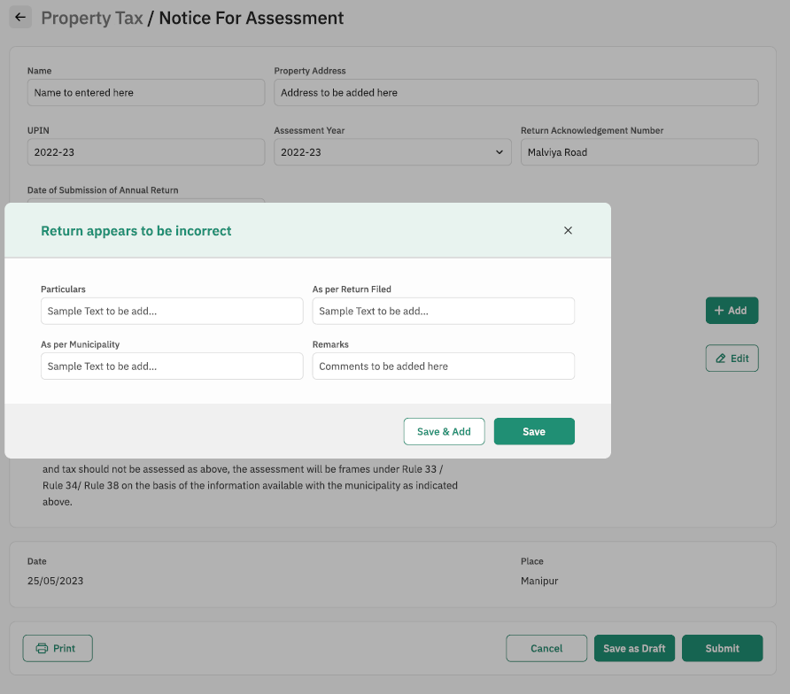

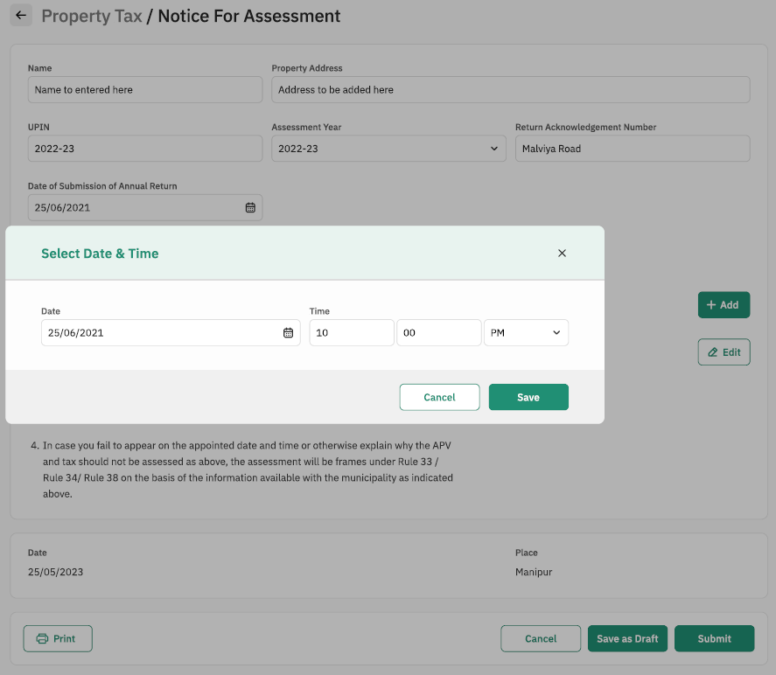

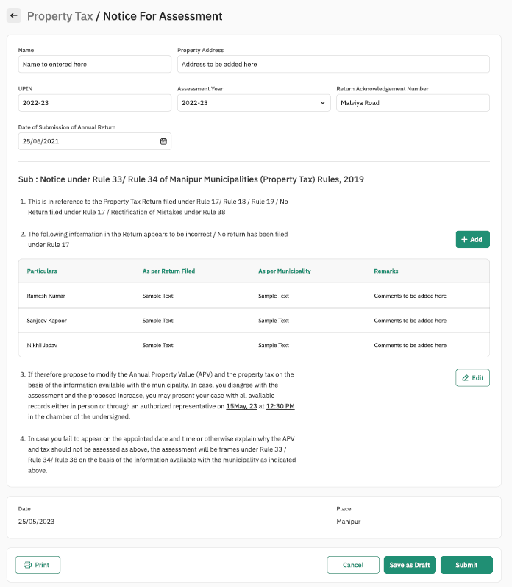

#### Property Sheet

**Notice under Rule 33/34 of Manipur (Property Tax) Rules, 2019**

|  |  |  |  |  |
| --- | --- | --- | --- | --- |
| Sl. No. | Attribute Name | Attribute Type | Operation Type | Remarks |
| 1 | Add | - | Clickable | Required |
| 2 | Edit | - | Clickable | Required |

**Return Correction**

|  |  |  |  |  |
| --- | --- | --- | --- | --- |
| Sl. No. | Attribute Name | Attribute Type | Operation Type | Remarks |
| 1 | As per return filed | Varchar | Write | Required |
| 2 | As per Municipality | Varchar | Write | Required |
| 3 | Remarks | Varchar | Write | Required |
| 4 | Save and add | - | Clickable | Required |
| 5 | Save | - | Clickable | Required |

**Select Date and Time**

|  |  |  |  |  |
| --- | --- | --- | --- | --- |
| Sl. No. | Attribute Name | Attribute Type | Operation Type | Remarks |
| 1 | Date | Varchar | Date Selection | Required |
| 2 | Time | int | Write | Required |
| 3 | Time | int | Write | Required |
| 4 | AM/PM | Varchar | Drop Down Selection | Required |
| 5 | Save | - | Clickable | Required |
| 6 | Cancel | - | Clickable | Required |

### Notice for Re-Assessment

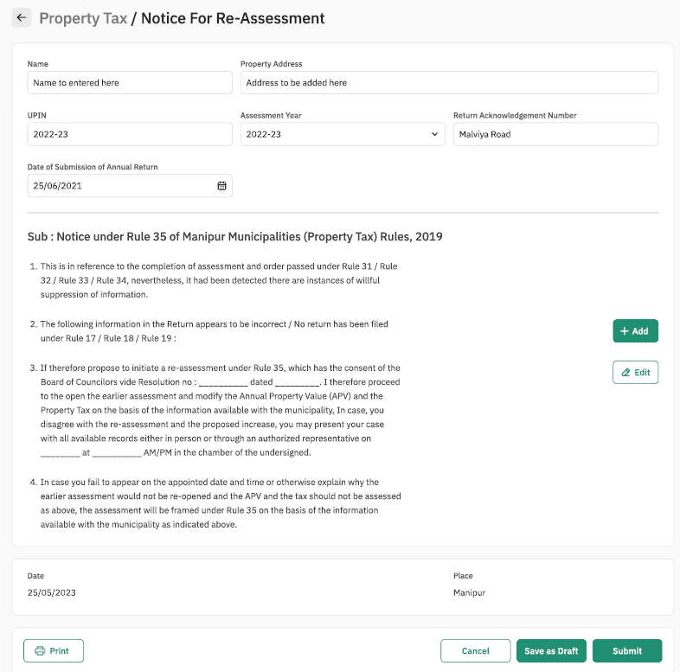

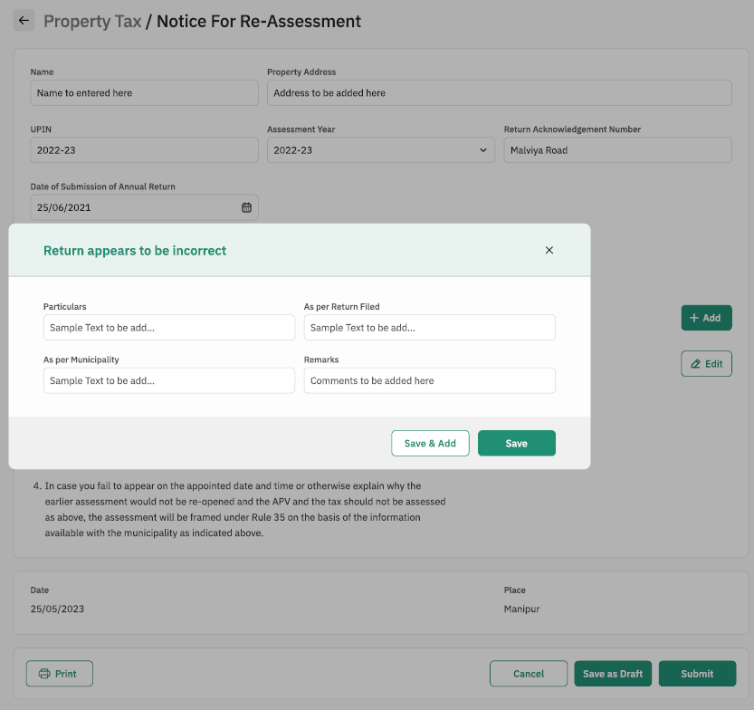

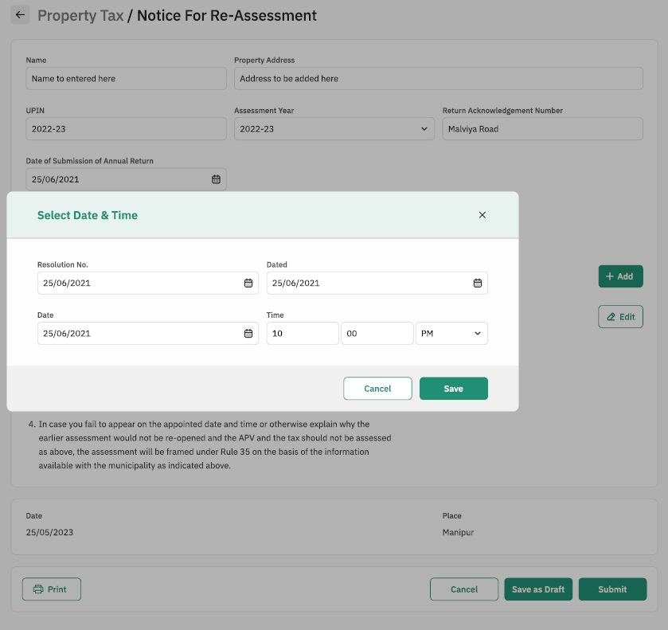

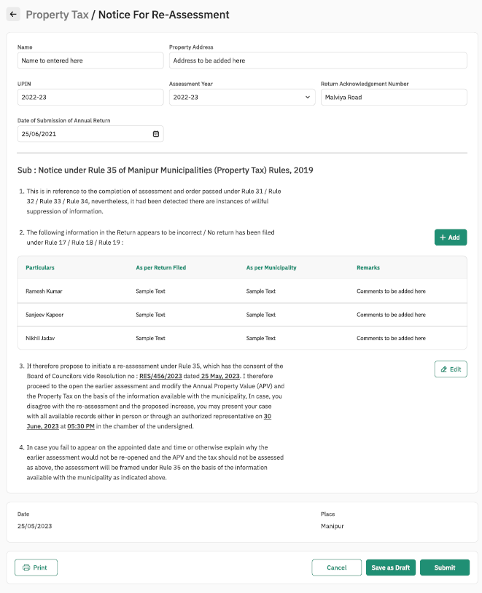

#### Property Sheet

**Notice under Rule 33/34 of Manipur (Property Tax) Rules, 2019**

|  |  |  |  |  |
| --- | --- | --- | --- | --- |
| Sl. No. | Attribute Name | Attribute Type | Operation Type | Remarks |
| 1 | Add | - | Clickable | Required |
| 2 | Edit | - | Clickable | Required |

**Return Correction**

|  |  |  |  |  |
| --- | --- | --- | --- | --- |
| Sl. No. | Attribute Name | Attribute Type | Operation Type | Remarks |
| 1 | As per return filed | Varchar | Write | Required |
| 2 | As per Municipality | Varchar | Write | Required |
| 3 | Remarks | Varchar | Write | Required |
| 4 | Save and add | - | Clickable | Required |
| 5 | Save | - | Clickable | Required |

**Select Date and Time**

|  |  |  |  |  |
| --- | --- | --- | --- | --- |
| Sl. No. | Attribute Name | Attribute Type | Operation Type | Remarks |
| 1 | Date | Varchar | Date Selection | Required |
| 2 | Time | int | Write | Required |
| 3 | Time | int | Write | Required |
| 4 | AM/PM | Varchar | Drop Down Selection | Required |
| 5 | Save | - | Clickable | Required |
| 6 | Cancel | - | Clickable | Required |

### **Notice to enter Premises**

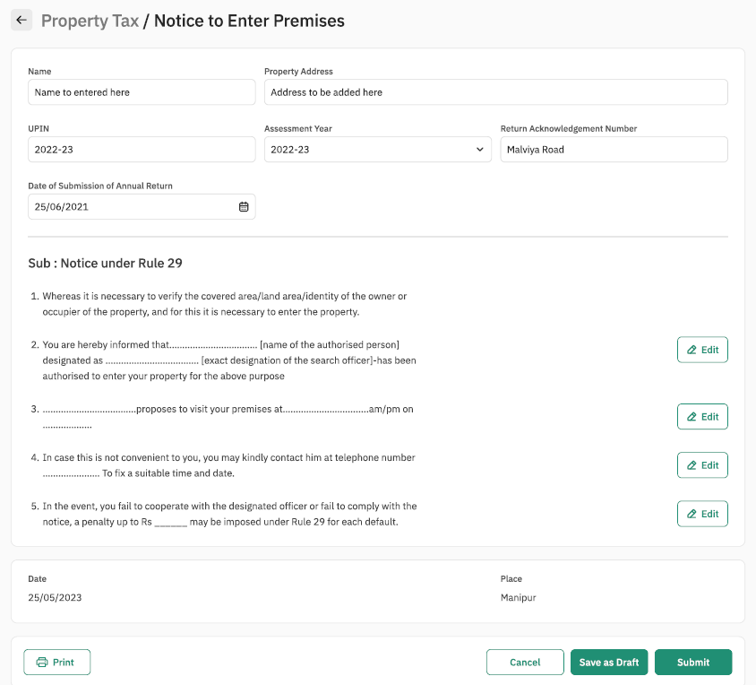

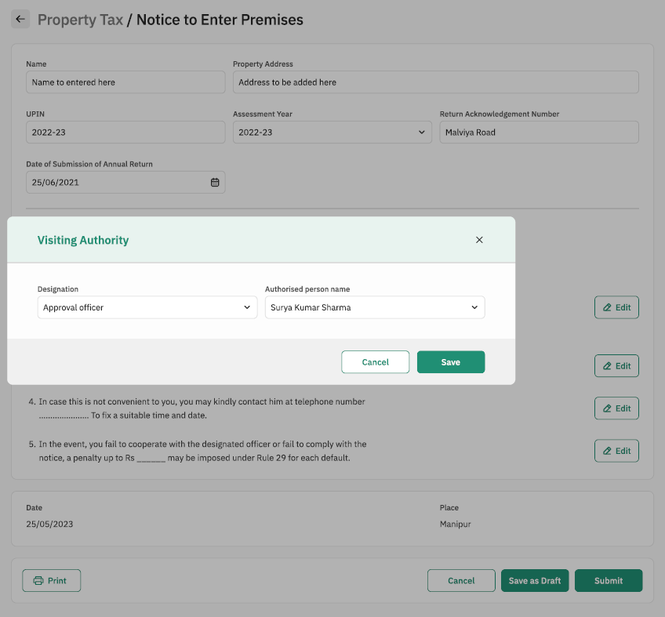

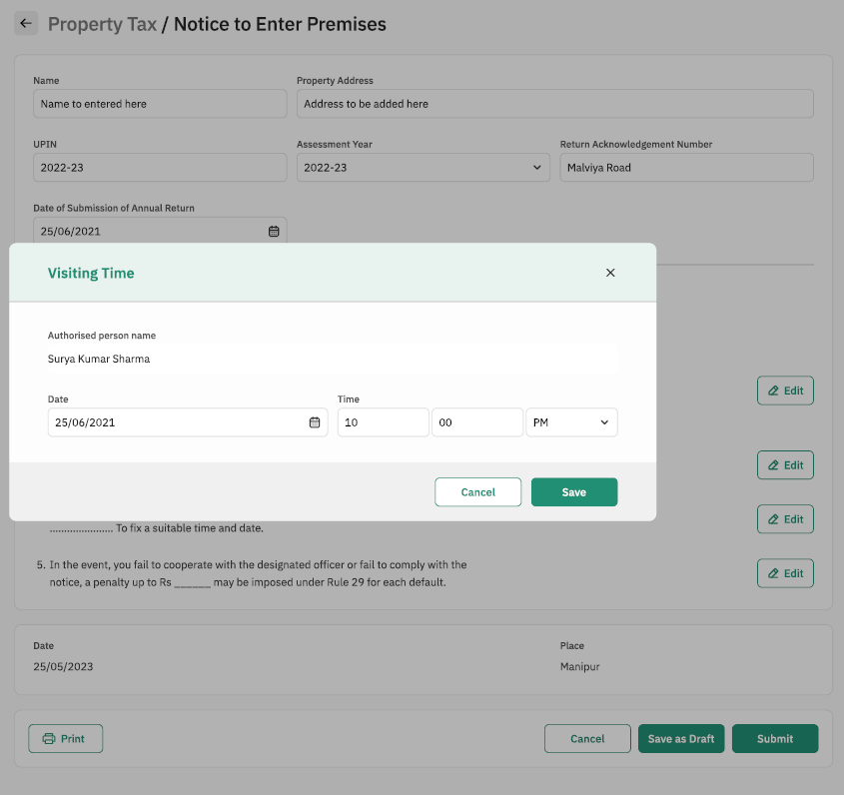

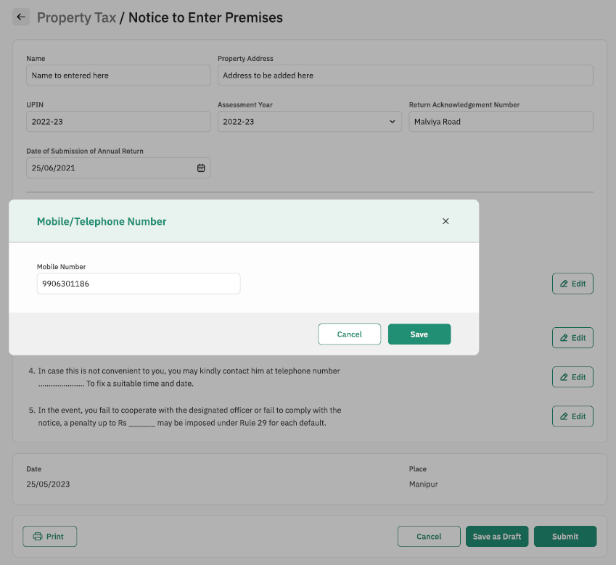

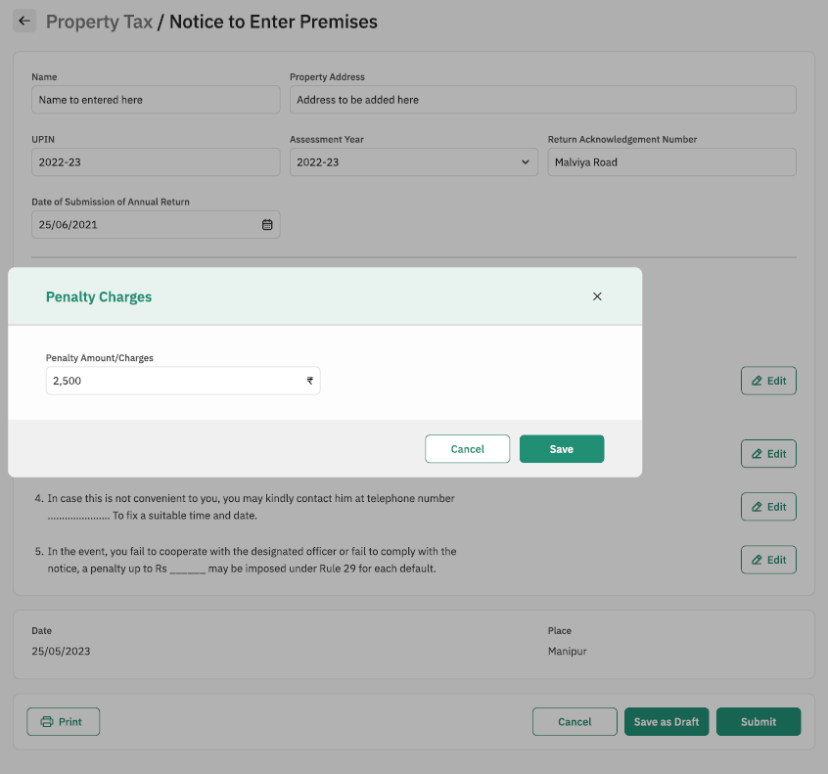

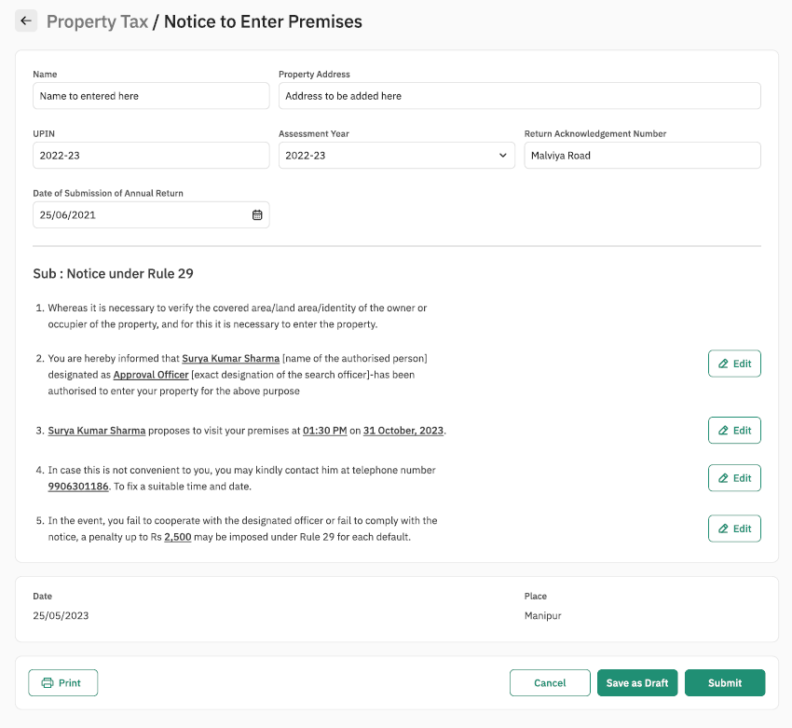

*14.1.4.1 Property Sheet*

**Notice under Rule 29**

|  |  |  |  |  |
| --- | --- | --- | --- | --- |
| Sl. No. | Attribute Name | Attribute Type | Operation Type | Remarks |
| 1 | Edit | - | Clickable | Required |
| 2 | Edit | - | Clickable | Required |
| 3 | Edit | - | Clickable | Required |
| 4 | Edit | - | Clickable | Required |

**Visiting Authority**

|  |  |  |  |  |
| --- | --- | --- | --- | --- |
| Sl. No. | Attribute Name | Attribute Type | Operation Type | Remarks |
| 1 | Designation | Varchar | Drop Down Selection | Required |
| 2 | Authorized Person name | Varchar | Drop Down Selection | Required |
| 3 | Save and add | - | Clickable | Required |
| 4 | Save | - | Clickable | Required |

**Visiting Date and time**

|  |  |  |  |  |
| --- | --- | --- | --- | --- |
| Sl. No. | Attribute Name | Attribute Type | Operation Type | Remarks |
| 1 | Date | Varchar | Date Selection | Required |
| 2 | Time | int | Write | Required |
| 3 | Time | int | Write | Required |
| 4 | AM/PM | Varchar | Drop Down Selection | Required |
| 5 | Save | - | Clickable | Required |
| 6 | Cancel | - | Clickable | Required |

**Mobile/Telephone Number**

|  |  |  |  |  |
| --- | --- | --- | --- | --- |
| Sl. No. | Attribute Name | Attribute Type | Operation Type | Remarks |
| 1 | Mobile Number | int | write | Required |
| 2 | Cancel | - | Clickable | Required |
| 3 | Save | - | Clickable | Required |

**Penalty Charges**

|  |  |  |  |  |
| --- | --- | --- | --- | --- |
| Sl. No. | Attribute Name | Attribute Type | Operation Type | Remarks |
| 1 | Penalty Amount/ Charges | int | write | Required |
| 2 | cancel | - | Clickable | Required |
| 3 | Save | - | Clickable | Required |

### **Notice to file Return**

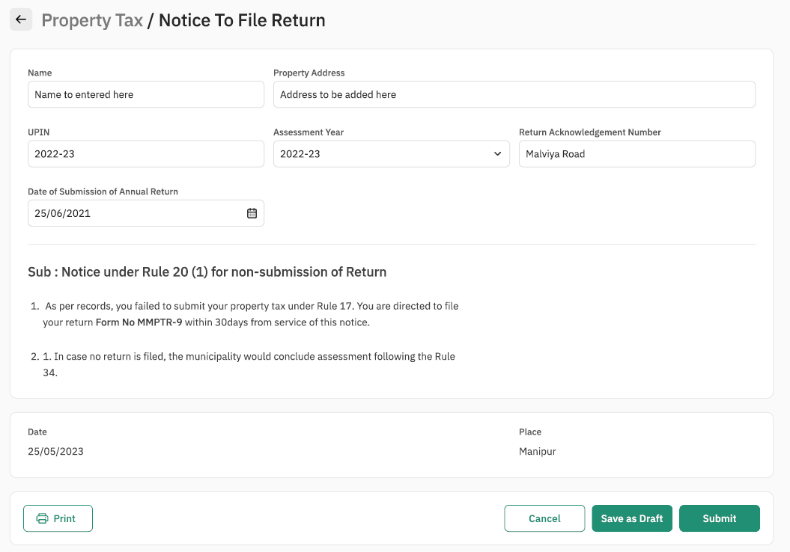

#### Property Sheet

Not Applicable

### **Notice for Hearing under Rule 39 / 40**

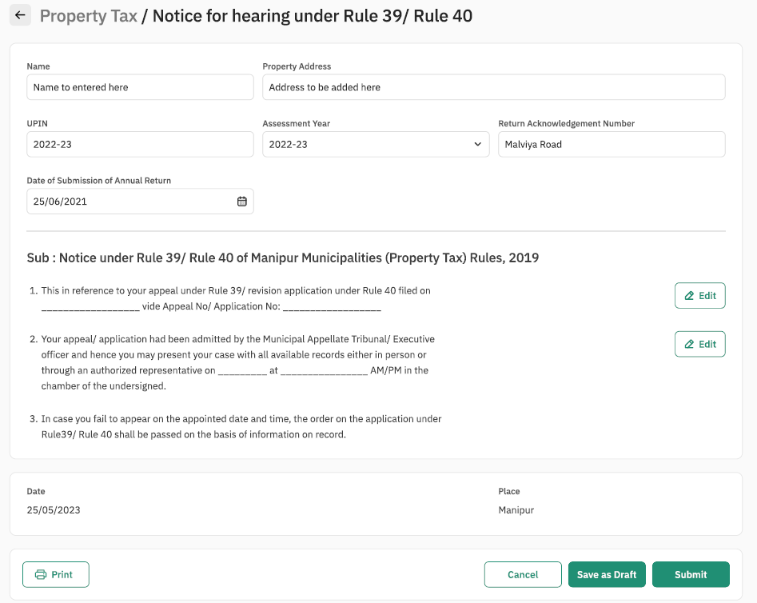

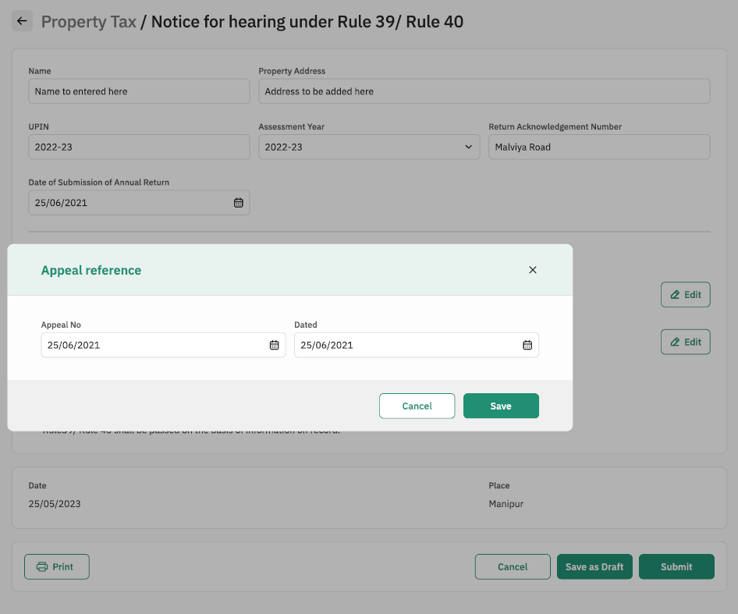

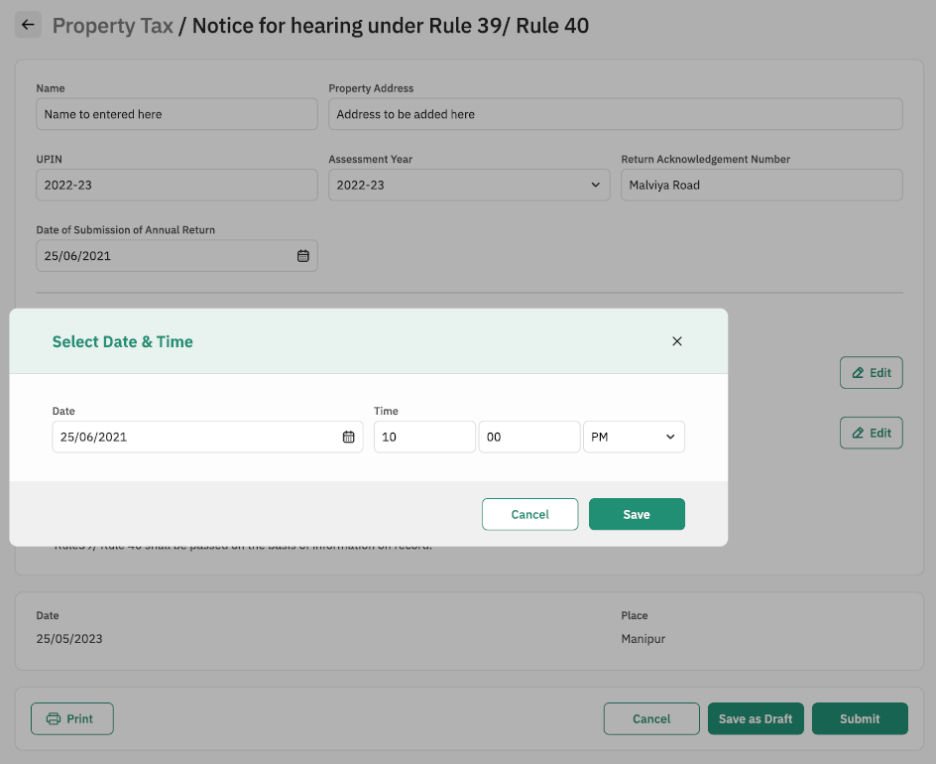

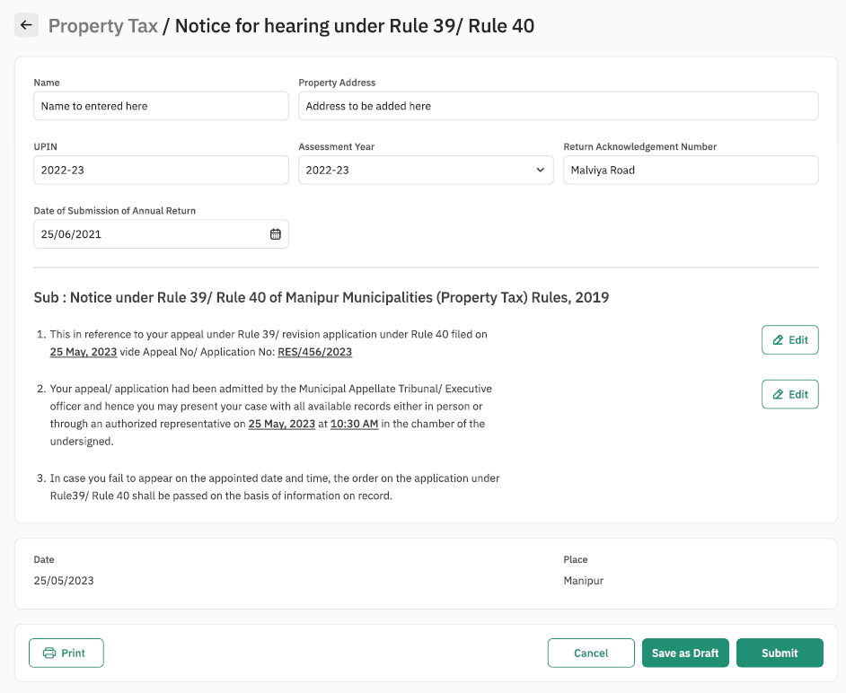

#### Property Sheet

**Notice under Rule 39/ Rule 40 of Manipur Municipalities (Property Tax) Rules, 2019**

|  |  |  |  |  |
| --- | --- | --- | --- | --- |
| Sl. No. | Attribute Name | Attribute Type | Operation Type | Remarks |
| 1 | Edit | - | Clickable | Required |
| 2 | Edit | - | Clickable | Required |

**Appeal Reference**

|  |  |  |  |  |
| --- | --- | --- | --- | --- |
| Sl. No. | Attribute Name | Attribute Type | Operation Type | Remarks |
| 1 | Appeal No. | Varchar | Date Selection | Required |
| 2 | Dated | Varchar | Date Selection | Required |
| 3 | Cancel | - | Clickable | Required |
| 4 | Save | - | Clickable | Required |

**Select Date and Time**

|  |  |  |  |  |
| --- | --- | --- | --- | --- |
| Sl. No. | Attribute Name | Attribute Type | Operation Type | Remarks |
| 1 | Date | Varchar | Date Selection | Required |
| 2 | Time | int | Write | Required |
| 3 | Time | int | Write | Required |
| 4 | AM/PM | Varchar | Drop Down Selection | Required |
| 5 | Save | - | Clickable | Required |
| 6 | Cancel | - | Clickable | Required |

### **Notice for Imposition of Penalty**

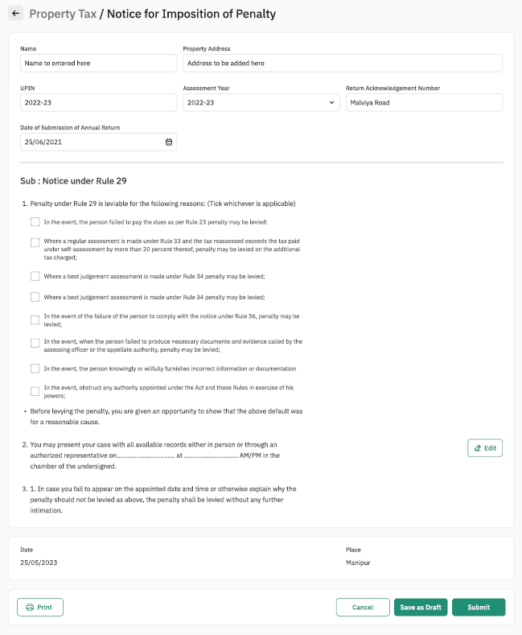

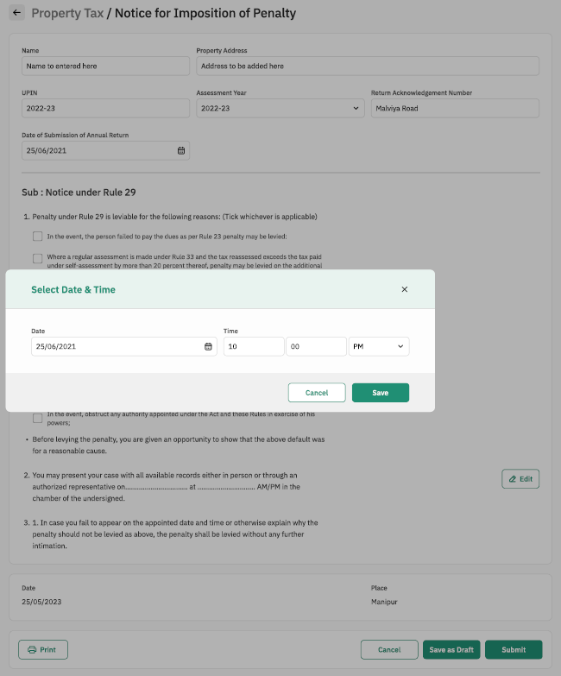

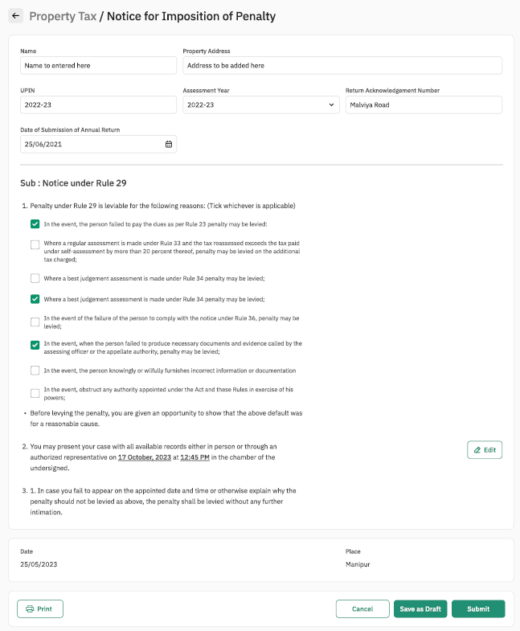

#### Property Sheet

**Notice under Rule 29**

|  |  |  |  |  |
| --- | --- | --- | --- | --- |
| Sl. No. | Attribute Name | Attribute Type | Operation Type | Remarks |
| 1 | Tick the check box | - | checkbox | Required |
| 2 | Tick the check box | - | Checkbox | Required |
| 3 | Tick the check box | - | Checkbox | Required |
| 4 | Tick the check box | - | Checkbox | Required |
| 5 | Tick the check box | - | Checkbox | Required |
| 6 | Tick the check box | - | checkbox | Required |
| 7 | Tick the check box | - | checkbox | Required |
| 8 | Tick the check box | - | checkbox | Required |
| 9 | Edit | - | Clickable | Required |

**Select Date and Time**

|  |  |  |  |  |
| --- | --- | --- | --- | --- |
| Sl. No. | Attribute Name | Attribute Type | Operation Type | Remarks |
| 1 | Date | Varchar | Date Selection | Required |
| 2 | Time | int | Write | Required |
| 3 | Time | int | Write | Required |
| 4 | AM/PM | Varchar | Drop Down Selection | Required |
| 5 | Save | - | Clickable | Required |
| 6 | Cancel | - | Clickable | Required |

# Appeal

## Process Flow:



## Use Case 1: Submission of Memorandum of Appeal

Process Description

|  |  |
| --- | --- |
| Description | This functionality allows Property Owner to submit Memorandum of Appeal in MMPTR Form 20 as per Rule 39 of the Manipur Municipality Property Tax Rules, 2019. This also allows MMPTB to receive appeals, reject or accept the appeals submitted. |
| Actor(s) | Property Owner, MMPTB |
| Detailed Process Flow: | |
| 1. Property Owner / Counter User will log into the portal using the mobile number and OTP. 2. Property Owner / Counter User will need to search and select the ULB using auto suggest feature 3. The Property Owner / Counter User will navigate to the Property Tax (PT) menu. 4. The Property Owner / Counter User will click on the ‘My Property’ tab 5. The Property Owner / Counter User will be shown property details, including details such as UPIN, Owner Name, Property Address 6. Property Owner / Counter will have to select the assessment year (Radio Button / Drop-down list) 7. The Property Owner / Counter User will click on the ‘Appeal’ button 8. The MMPTR Form 20 will be displayed to the Property Owner / Counter User with following details which will be auto populated:    1. Name of Owner    2. Property Address    3. UPIN    4. Financial Year of the Appeal 9. Property Owner will then have to enter the following details in the concerned text fields provided:    1. Name and Designation of the Assessing Officer passing the Order appealed against    2. Rule under which the Order was passed    3. Date of the Order    4. Date of Service of the Order    5. Admitted Tax Liability    6. Address for sending Notice to Appellant    7. Relief claimed in Appeal    8. Statement of Fact    9. Grounds for Appeal    10. List of Supporting Documents 10. Property Owner will then upload the necessary supporting documents 11. Before final submission, Property Owner will click on the radio button to confirm *‘I hereby declare and affirm that the above-furnished information is true and correct and nothing has been concealed therefrom. I am also aware of the fact that in case this information is found false/incorrect, the authorities are at liberty to initiate recovery of amount / interest / penalty / fine as provided in Manipur Municipality Act 1994 or Manipur Municipality (Property Tax) Rules 2019.’* 12. Property Owner / Counter User will then click on submit button and details entered will be submitted and saved in the system 13. On successful submission of application user will have the option to download the acknowledgement as a PDF | |
| Special requirements (if any) | Not applicable |
| Pre-conditions | 1. Users should have valid login credentials 2. Previous Order details shall be available with the user 3. There should be no pending dues against the said property e.g. tax dues, arrears, penalties, interest |
| Post-conditions | 1. On successful submission of the details, system will dispatch a task to the Designated Officer of the Board for his/her action. 2. System will auto generate an acknowledgement which will be sent to the user through email and or SMS |

## Sample User Interface

### **Submission of Memorandum of Appeal**

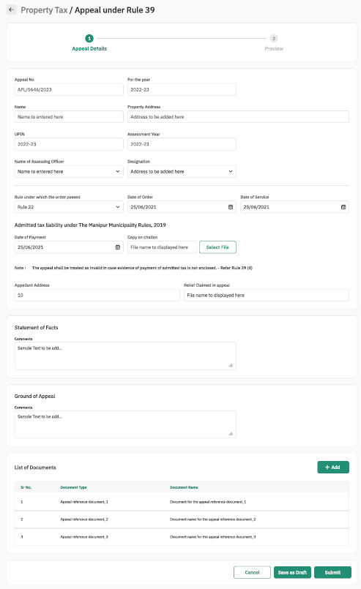

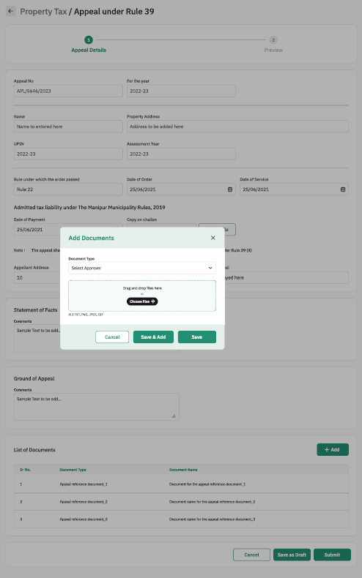

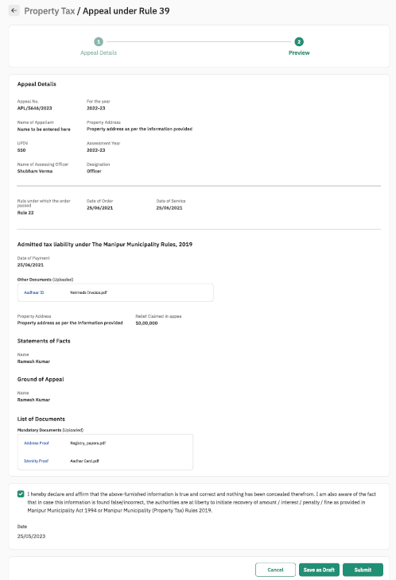

#### Property Sheet

**Appeal Details**

|  |  |  |  |  |
| --- | --- | --- | --- | --- |
| Sl. No. | Attribute Name | Attribute Type | Operation Type | Remarks |
| 1 | Date of Payment | Date Selection | write | Required |
| 2 | Copy of challan (select file) | .xls, .txt, .png, .jpeg, .gif files | Clickable | Required |
| 3 | Appellant address | varchar | Write | Required |
| 4 | Relief claimed in appeal | carchar | Write | Required |
| 5 | Statement of facts | varchar | Write | Required |
| 6 | Comments | varchar | Write | Required |
| 7 | Add | - | Clickable | Required |

**Add Documents**

|  |  |  |  |  |
| --- | --- | --- | --- | --- |
| Sl. No. | Attribute Name | Attribute Type | Operation Type | Remarks |
| 1 | Document type | varchar | Drop Down Selection | Required |
| 2 | Choose files | .xls, .txt, .png, .jpeg, .gif files | Browse and select | Required |
| 3 | Cancel | - | Clickable | Required |
| 4 | Save and Add | - | Clickable | Required |
| 5 | Save | - | Clickable | Required |

**Preview**

|  |  |  |  |  |
| --- | --- | --- | --- | --- |
| Sl. No. | Attribute Name | Attribute Type | Operation Type | Remarks |
| 1 | Tick the checkbox | - | Clickable | Required |
| 2 | Cancel | - | Clickable | Required |
| 3 | Save as Draft | - | Clickable | Required |
| 4 | Save | - | Clickable | Required |

## Use Case 2: Verification of Memorandum of Appeal

Process Description

|  |  |
| --- | --- |
| Description | This functionality allows Property Owner to submit Memorandum of Appeal in MMPTR Form 20 as per Rule 39 of the Manipur Municipality Property Tax Rules, 2019. This also allows MMPTB to receive appeals, reject or accept the appeals submitted. |
| Actor(s) | Property Owner, MMPTB |
| Detailed Process Flow: | |
| 1. Designated Officer of the Board will log into the portal using the username and password. 2. Under the property tax section verifying officer will have option to view    1. Inbox    2. Tasks nearing SLA    3. Search Property    4. Search Application 3. Designated Officer of the Board will navigate to his / her inbox where the pending appeals will be displayed to the user 4. Designated Officer of the Board will select the concerned Appeal by clicking application number 5. The appeal details in MMPTR form 20 submitted by counter user / property owner will be displayed along with the documents that have been attached 6. Designated Officer of the Board will verify the documents attached during submission by property owner 7. Designated Officer of the Board will then click on ‘Take Action’ button. The verifying officer will have 3 options:    1. Reject – Designated Officer of the Board will reject the application by clicking this button and entering his / her comments along with uploading and supporting documents, if applicable. Appeal status will be updated as ‘Rejected’    2. Notice for Hearing under Rule 39 / 40       1. If this option is selected MMPTR Form 22 will be displayed       2. Details such as Name of Owner, Property Address, UPIN, Assessment Year, will be auto populated and display only fields       3. Designated Officer of the Board must enter the Appeal Application Number and Date of Filing in the text field provided       4. Designated Officer of the Board must enter the date and time of the Hearing in the text field provided       5. Once the details have been entered Assessing Officer will click ‘Print’ button to generate the notice in PDF format       6. This notice in PDF must be printed signed and sealed by the Designated Officer of the Board and shared with property owner over registered post | |
| Special requirements (if any) | Not applicable |
| Pre-conditions | 1. Users should have valid login credentials 2. Previous Order details shall be available with the user 3. There should be no pending dues against the said property e.g. tax dues, arrears, penalties, interest |
| Post-conditions | 1. On successful submission of the details, system will dispatch a task to the Designated Officer of the Board for his/her action. 2. System will auto generate an acknowledgement which will be sent to the user through email and or SMS |

## Sample User Interface

### **Verification of Memorandum of Appeal**

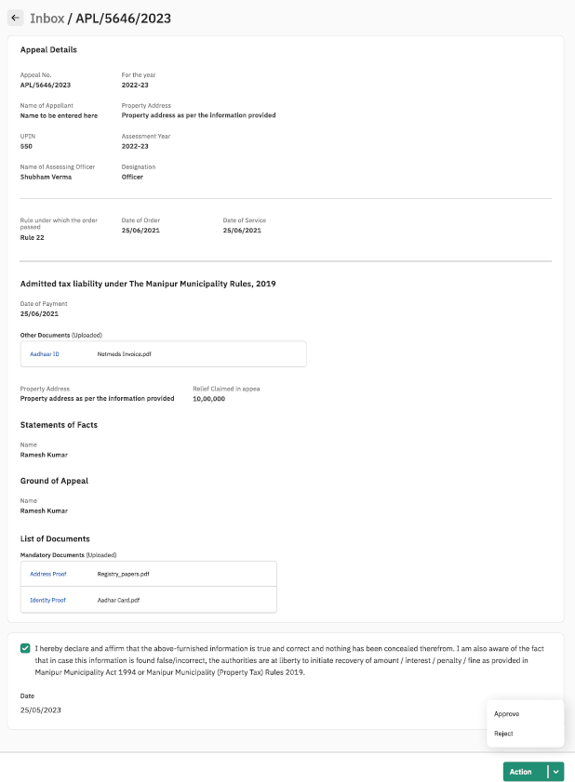

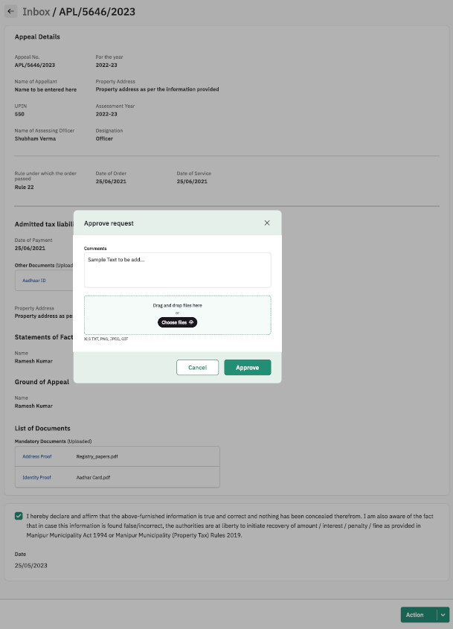

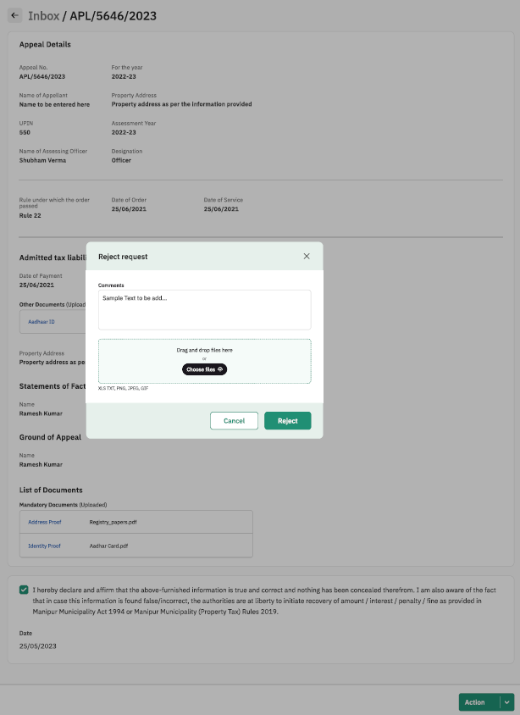

#### Property Sheet

**Action Tab**

|  |  |  |  |  |
| --- | --- | --- | --- | --- |
| Sl. No. | Attribute Name | Attribute Type | Operation Type | Remarks |
| 1 | Approve | - | Clickable | Required |
| 2 | Reject | - | Clickable | Required |

**Approve Request**

|  |  |  |  |  |
| --- | --- | --- | --- | --- |
| Sl. No. | Attribute Name | Attribute Type | Operation Type | Remarks |
| 1 | Comments | varchar | Write | Required |
| 2 | Choose Files | .xls, .txt, .png, .jpeg, .gif files | Browse and select | Required |
| 3 | Approve | - | Clickable | Required |
| 4 | cancel | - | Clickable | Required |

**Reject Request**

|  |  |  |  |  |
| --- | --- | --- | --- | --- |
| Sl. No. | Attribute Name | Attribute Type | Operation Type | Remarks |
| 1 | Comments | varchar | Write | Required |
| 2 | Choose Files | .xls, .txt, .png, .jpeg, .gif files | Browse and select | Required |
| 3 | Reject | - | Clickable | Required |
| 4 | cancel | - | Clickable | Required |

# Analytics Dashboard

|  |  |
| --- | --- |
| Description | The analytical dashboard for MAHUD & MMPTB officials would be rolled out on the UPYOG platform to provide real-time insights and analytics related to property tax collection in the State of Manipur. It aims to assist ULB Commissioner, Verifying Officers, Field Inspectors, & other departmental staff at MAHUD & MMPTB in effectively monitoring and managing tax collection process.  The system integrates with IT enabled Property Tax System (PTS) to fetch relevant data, which is then processed and visualized in a user-friendly dashboard interface. The dashboard offers a range of features & functionalities to enable efficient analysis and reporting of property tax collection metrics. |
| User Interface | The system will have two primary interfaces:  1.**Admin Dashboard**: Accessible to system administrators for configuration, user management, and data source integration.  2.**Analytical Dashboard**: Accessible to authorized users (MMPTB Chairman, ULB Commissioners etc.) to view property tax collection metrics, reports, and visualizations. |
| System Requirements | 1.**Data Sources**: The system will integrate with sources such as IT enabled Property Tax System (PTS).  2.**Data Transformation**: Implement data processing and transformation mechanisms to normalize, clean, and aggregate data for dashboard presentation.  3.**Data Security**: Ensure all data transmissions and storage meet security standards and compliance regulations.  4.**Visualization Tools**: Include various types of charts, graphs, and tables to represent property tax collection data.  5.**Customization**: Allow users to personalize dashboard views and create custom reports.  6.**Drill-Down Capability**: Enable users to delve deeper into specific data points for detailed analysis.  7. **Alerts and Notifications**:  Implement an alert system to notify relevant stakeholders about important updates, such as delinquent properties or upcoming payment deadlines.  8.**Real-Time Updates**: Provide real-time or near-real-time updates of data.  9.**User Management**: Authentication & Authorization:   1. The system is able to authenticate users with unique credentials. 2. Different user roles are defined such as Commissioner, Verifying Officers, Field Officers etc. each with specific permissions and functionalities in the analytical dashboard ensuring confidentiality and user privilege management.   10. **Performance**:   1. Responsiveness: The system should respond quickly to user interactions and data queries. 2. **Scalability**: The system should handle an increasing volume of data and users without compromising performance.   11. **Security**:   1. 1.Data Encryption: All sensitive data must be encrypted during transmission and storage. 2. 2.Authentication Mechanisms: Implement secure authentication measures such as multi-factor authentication.   12.**Compatibility**:   1. 1.Cross-Platform Compatibility: The dashboard should be accessible across various devices and web browsers. 2. 2.API Integration: Ability to integrate with external APIs for additional data sources.   3. **Integration and Compatibility**:   1. Ensure compatibility with the existing infrastructure and systems used by the Manipur Municipality Property Tax Board. 2. Enable integration with other relevant systems, such as financial management or reporting tools.   4. **System Constraints**:   1. The system must comply with local and national data protection and privacy laws. 2. Data acquisition may be subject to limitations based on data availability. |
| Key Performance Indicators (KPIs) | 1. **Total Tax Revenue:** This KPI measures the overall revenue generated from property tax collection. It provides an overview of the financial performance of the property tax collection board.  2. **Collection Rate**: This KPI calculates the percentage of property taxes collected out of the total taxes assessed. It helps assess the effectiveness of the tax collection efforts and indicates the level of compliance among property owners.  3. **Delinquency Rate**: This KPI measures the percentage of property owners who have not paid their taxes within the specified timeframe. Tracking the delinquency rate helps identify areas where enforcement or outreach efforts should be focused to improve tax compliance.  4. **Average Time to Process Payments**: This KPI measures the average time taken to process property tax payments, from the moment of submission to the actual posting of the payment. It helps evaluate the efficiency of the payment processing system and identify any bottlenecks that may need attention.  5. **Collection Efficiency Ratio**: This KPI compares the total amount of taxes collected with the total amount of taxes billed. It provides insights into the effectiveness of the tax collection process and highlights any gaps or discrepancies in the billing system.  6.**Property Verification Rate**: This KPI evaluates how many properties have been verified post MMPTR FORM 5 submission on the portal.  7. **Field Inspection Rate**: This KPI evaluates how many properties have been inspected over the total verified properties in a particular ULB.  8. **No. of Property Modifications**: This KPI evaluates how many properties have been modified with a geographical heatmap wherein darker colors depict higher number of property modifications with a specific ULB.  9. **Average time for Verification & Field Inspection Processing**: This KPI evaluates the average time for and between Verification & Field Inspection to map the lags, if there are any, subsequently impacting the tax collection process in a specific ULB.  10.**Objections & Appeals Grievance Addressal Rate**: This KPI evaluates the rate at which the appeals and objections are resolved at a specific ULB.  11. **Property Tax Collection Trends**: The dashboard will provide visual representations of the historical property tax collection data over time. Users can have line charts, bar graphs, or area charts to highlight the trends. This will help the users to identify patterns, seasonal variations, and overall progress in property tax collection. Enable filters to view trends based on different periods, such as monthly, quarterly, or yearly.  12. **Geographic Analysis**:   1. Geographic filtering to analyse property tax collection trends based on different regions within Manipur. 2. Display maps or heatmaps to visualize property tax collection performance across different areas. |

## Generic Sample Layout of Analytical Dashboard for MMPTB & MAHUD

1. **Overview Section:**

This section provides a high-level summary of property tax collection performance.

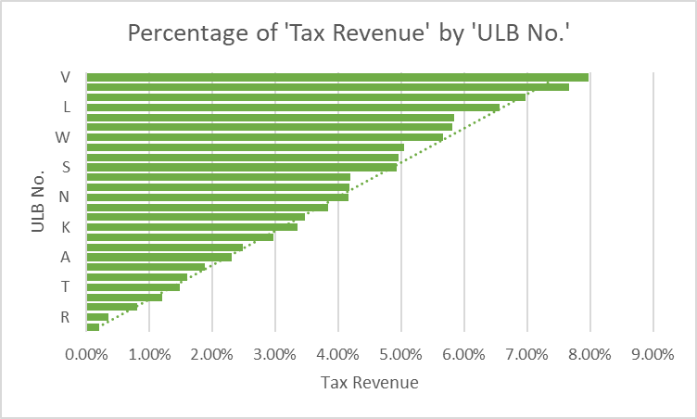

1. **Total Tax Revenue**: A summary number showing the total revenue collected from property taxes.
2. **Tax Collection Trends**: A line chart showing the trends in tax collections over time, month-by-month, or year-by-year.
3. **Property Tax Distribution**: A pie or bar chart displaying the proportion of taxes collected from various property types (residential, commercial, industrial, etc.).
4. **Delinquency and Arrears Section:**

This area focuses on delinquent or overdue payments.

1. **Delinquent Tax Summary**: A bar chart or table showing the amount of delinquent taxes and the number of properties with overdue payments.
2. **Delinquency Trends**: A trend line graph illustrating the change in delinquency rates over time.
3. **Property Valuation and Assessment Section:**

This section gives insights into property values and assessments.

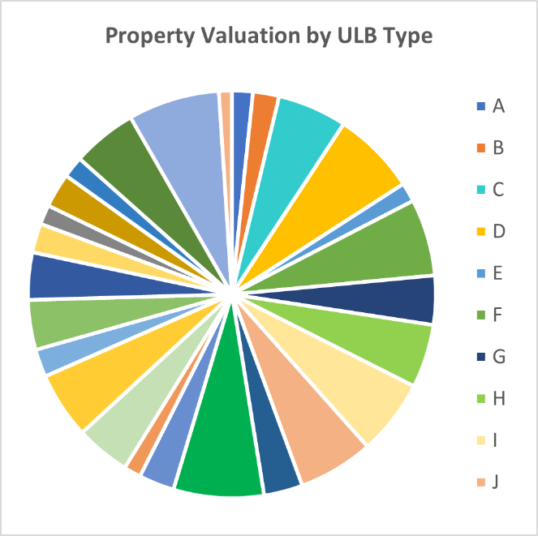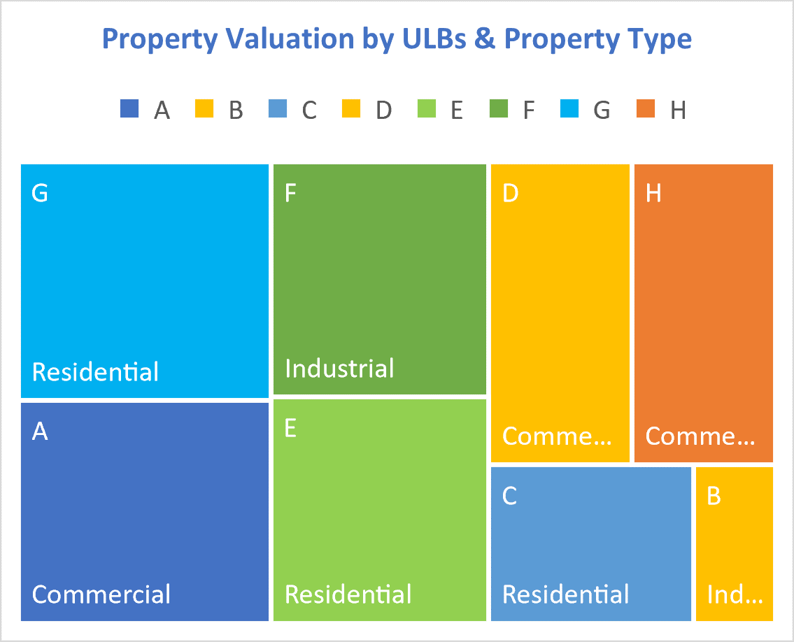

1. **Property Valuation Heatmap**: A geographical heatmap showing property valuations across different regions. Higher valuations could be represented with warmer colors.
2. **Valuation Changes**: A bar or line chart indicating changes in property valuations over time.
3. **Geographic Distribution Section:**

This area provides a spatial representation of tax data.

**Geographical Map**: A map highlighting tax collection data by region or district. Different shades or colors could represent tax collection levels in different areas.

## Key Performance Indicators (KPIs):

1. **Total Tax Collected**: A KPI displaying the total tax collected.

1. **Collection Rate**: A KPI showing the percentage of taxes collected against the total outstanding amount.

1. **Top Non-Paying Areas**: A list or chart highlighting regions or property types with the highest outstanding taxes.

1. **Customizable Filters and Interactivity**:
2. Users will have the ability to filter data by date range, property types, regions, and more.
3. Interactive features like drill-down options, where users can click on charts or graphs to see more detailed data.

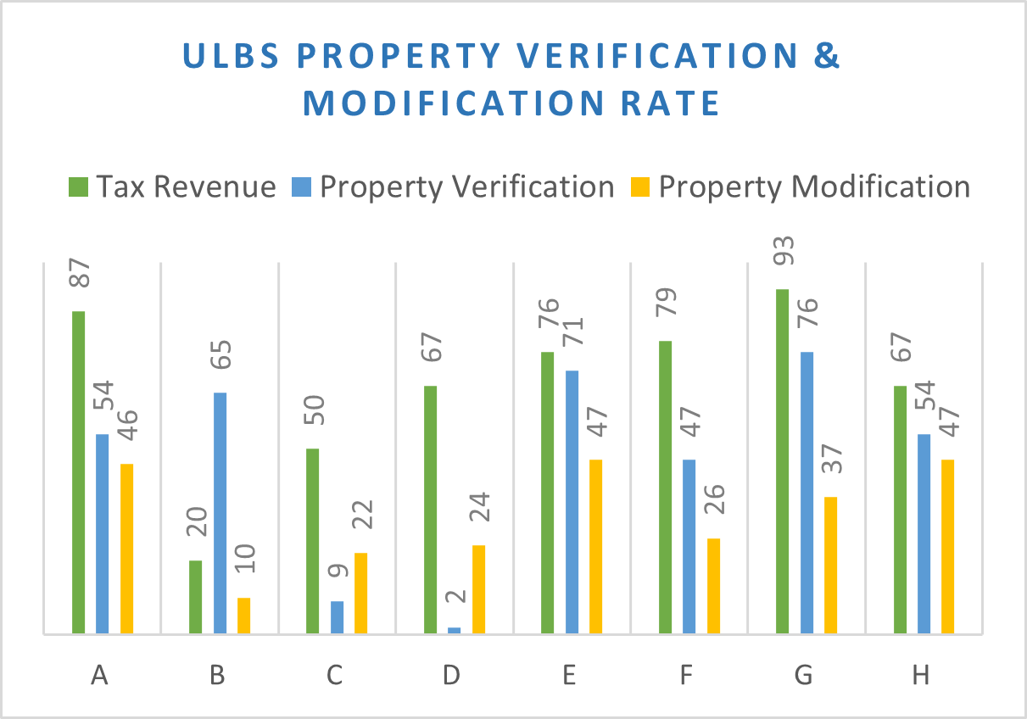

Key Performance Indicators (KPIs) that can be utilized to evaluate the performance of individual Urban Local Bodies (ULBs) within the Manipur Municipality Property Tax Collection Board:

**1. Tax Collection Rate**: This KPI measures the percentage of property tax revenue collected compared to the total tax demand. It reflects the efficiency of ULBs in collecting taxes and achieving compliance.

**2. Delinquency Rate**: This KPI assesses the percentage of outstanding property taxes that have not been paid within the specified timeframe. It indicates the effectiveness of ULBs in managing delinquent tax accounts and implementing necessary measures for recovery.

**3. Assessment Accuracy**: This KPI evaluates the accuracy of property assessments conducted by ULBs. It measures the variance between the assessed property values and the actual market values. Higher accuracy leads to fair and uniform tax distribution.

**4. Taxpayer Satisfaction**: This KPI gauges the satisfaction level of taxpayers with the services provided by the ULBs in relation to property tax collection. It can be measured through surveys, feedback mechanisms, or complaint resolution metrics.

**5. Timeliness of Tax Processing**: This KPI tracks the average time taken by ULBs to process property tax payments, issue tax bills, and update tax records. It ensures efficiency in operations and minimizes delays for taxpayers.

**6. Revenue Growth**: This KPI measures the increase in property tax revenue collected by ULBs over time. It indicates the effectiveness of strategies implemented to improve tax collection, such as awareness campaigns, digitalization efforts, or enforcement actions.

**7. Cost of Tax Collection**: This KPI assesses the cost-effectiveness of tax collection operations. It measures the cost incurred by ULBs to collect each unit of property tax revenue, considering factors such as staff salaries, infrastructure, and technology investments.

**8. Compliance Rate**: This KPI evaluates the compliance level of property owners in paying their taxes on time. It indicates the effectiveness of ULBs in promoting tax compliance and reducing the number of defaulters.

**9.Property Verification Rate**: This KPI evaluates how many properties have been verified post MMPTR FORM 5 submission on the portal.

**10. Field Inspection Rate**: This KPI evaluates how many properties have been inspected over the total verified properties in a particular ULB.

**11. No. of Property Modifications**: This KPI evaluates how many properties have been modified with a geographical heatmap wherein darker colors depict higher number of property modifications with a specific ULB.

**12. Average time for Verification & Field Inspection Processing**: This KPI evaluates the average time for and between Verification & Field Inspection to map the lags, if there are any, subsequently impacting the tax collection process in a specific ULB.

**13.Objections & Appeals Grievance Addressal Rate**: This KPI evaluates the rate at which the appeals and objections are resolved at a specific ULB.

## Sample Dashboard Visualization for Chairman/Secretary of MMPTB

Key performance indicators (KPIs) that can be utilized to evaluate the performance of Officers in ULBs & gain insights about Property Tax Collection in the State by Manipur Property Tax Collection Board Secretary/Chairman:

**1. Tax Collection Revenue**: This KPI measures the total revenue collected by the Property Tax Collection Board during a specific period. It reflects the overall effectiveness of the Secretary in managing and increasing tax collection.

**2. Collection Efficiency**: This KPI assesses the efficiency of the tax collection process. It measures the percentage of taxes collected compared to the total tax demand, taking into account any exemptions or discounts provided.

**3. Compliance Rate**: This KPI evaluates the level of compliance among property owners in paying their taxes on time. It reflects the Secretary's efforts in enforcing tax regulations, promoting awareness, and minimizing tax evasion.

**4. Delinquency Rate**: This KPI measures the percentage of outstanding property taxes that have not been paid within the specified timeframe. A lower delinquency rate indicates the Secretary's effectiveness in managing delinquent tax accounts and implementing necessary measures for recovery.

**5. Timeliness of Tax Processing**: This KPI tracks the average time taken to process property tax payments, issue tax bills, and update tax records. It ensures efficient operations and minimizes delays for taxpayers.

**6. Stakeholder Satisfaction**: This KPI evaluates the satisfaction level of stakeholders, including property owners, taxpayers, and other relevant entities, with the services provided by the Secretary's office. It can be assessed through surveys, feedback mechanisms, or complaint resolution metrics.

**7. Compliance with Regulations**: This KPI assesses the Secretary's adherence to relevant tax regulations, guidelines, and legal requirements. It ensures that tax collection practices are in line with the established rules and procedures.

**8. Technology Adoption and Innovation:** This KPI measures the Secretary's efforts in leveraging technology and implementing innovative solutions to enhance tax collection efficiency. It includes factors such as digitalization of processes, implementation of online payment systems, and integration of data management tools.

**9.Property Verification Rate**: This KPI evaluates how many properties have been verified post MMPTR FORM 5 submission on the portal across all 26 ULBs under MMPTB.

**10. Field Inspection Rate**: This KPI evaluates how many properties have been inspected over the total verified properties across all 26 ULBs under MMPTB.

**11. No. of Property Modifications**: This KPI evaluates how many properties have been modified with a geographical heatmap wherein darker colors depict higher number of property modifications across all 26 ULBs under MMPTB.

**12. Average time for Verification & Field Inspection Processing**: This KPI evaluates the average time for and between Verification & Field Inspection to map the lags, if there are any, subsequently impacting the tax collection process across all 26 ULBs under MMPTB.

**13.Objections & Appeals Grievance Addressal Rate**: This KPI evaluates the rate at which the appeals and objections are resolved across all 26 ULBs under MMPTB.

**14. Geographical Trends**: A geographic heatmap would depict tax collection rate, property distribution, property valuations etc. across all ULBs to detect any trends or anomalies.

Monitoring these KPIs will help evaluate the performance of the Manipur Property Tax Collection Board Secretary/Chairman, ensure effective property tax collection management, and drive continuous improvement in property tax administration processes.

# ﻿SCHEDULE-1

The rate for determination of property tax value payable by the owner of a property situated in the jurisdiction of Imphal Municipal Corporation for the financial year 2023-24 are as follows:

1. **Rate of Property Tax:**

Rate for calculation of property tax = 8% of equivalent Annual Property Value (APV) of the property.

Where,

8% include the following components

Tax for general purpose on land and building = 5%

Tax for street lighting =1%

Tax for conservancy =2%

1. **Annual Property Value (APV):**

Annual Property Value (APV) = APV of vacant land/land appurtenant to building + APV of covered area [i.e., the annual property value of a property is equivalent to the sum of the APV of Vacant Land/Land appurtenant to building and APV of Covered area]

Where,

**APV of vacant land/land appurtenant to building** = Area x Unit Area Value x Location Factor x Ownership/User Factor x Age Factor.

**APV of Covered Area** = Area x Unit Area Value x Location Factor x Structural Factor x Ownership/User Factor x Age Factor

1. **Area:**

Here, Area is the area covered by vacant land/ land appurtenant to building or the area covered in each floor or area covered in the unit of building. It is measured in sq. ft.

1. **Unit Area Value (UAV):**

Unit Area value is the unit value measured in rupees per sq. ft of a property situated in a particular area/category within the municipality. The UAV for different categories of municipal areas shall be taken as 3% of the MGV of the area for the case of covered area and .20% of the MGV of the area for the case of vacant land. The following are the UAVs to be applied in the determination of Annual Property Value (APV):

**A. Value per unit area of structural covered area:**

|  |  |
| --- | --- |
| **Classified Category** | **UAV for covered Area**  **(Rs. per sq. ft.)** |
| A | 36 |
| B | 30 |
| C | 15 |
| D | 14.7 |
| E | 9 |
| F | 5.85 |
| G | 3 |

﻿

**B. Value per unit area of vacant land/land appurtenant to building:**

|  |  |
| --- | --- |
| **Classified Category** | **UAV for covered Area**  **(Rs. per sq. ft.)** |
| A | 2.4 |
| B | 2 |
| C | 1 |
| D | 0.98 |
| E | 0.6 |
| F | 0.39 |
| G | 0.2 |

1. **Classified Categories of Municipal Areas:**

Based on different factors/criteria provided under Rule No. 10 of the Manipur Municipalities (Property Tax) Rules 2019 and the Minimum Guidance Value (MGV) fixed by the Government of Manipur and published in the Manipur Gazette No. 830 dated 22nd March 2012 for different categories of land in the State on the basis of location with similar values and usage, commercial/market value etc., 27 wards of Imphal Municipal Corporation (IMC) have been divided into (7) seven categories namely A, B, C, D, E, F and G.

|  |  |  |
| --- | --- | --- |
| **Category** | **Ward No.** | **Name of Leikai/Locality** |
| A | 24 | Kakhulong, Paona Bazar, Raj Bhavan |
| A | 25 | Thangal Bazar, Major Khul |
| B | 24 | Jail Compound, Old Lambulane, Bapupara, Sanjenthong Officers Colony, Electricity Colony, First Battalion Manipur Rifles |
| B | 26 | Second Battalion Manipur Rifles |
| C | 23 | Khurai Thangjam Leikai, Khurai Ahongei Leikai, Khurai Thoudam Leikai, Khurai Tellipati |
| C | 25 | D.M. College Compound |
| C | 26 | Zomi Villa, Canan Villa, Kekru Villa, Ragailong, Namdunlong, Deulahland, Gaipuinam, Khuman Lampak Sports Complex, Chingmeirong East |
| D | 1 | Thangmeiband Sinam Leikai, Thangmeiband Yumnam Leikai, Thangmeiband Lairenhanjaba Leikai, Meisnam Leikai, Thangmeiband Hijam Leikai, Thangmeiband Dimdaijang, Thangmeiband Koireng Khul, Muchikhul/Namthalong |
| D | 2 | Thangmeiband Kabrambam Leikai, Thangmeiband Polem Leikai, Thngmeiband Khondram Selungba Leikai, Thangmeiband Lourungpurel Leikai, Thangmeiband Hijam Dewan Leikai, Thangmeiband Hijam Leikai, Thangmeiband Koireng Khul |
| D | 3 | Lalambung Ningthoujam Leikai, Lalambung Makhong Naosekpam Leikai, Lalambung Makhong Khoirom Leikai, Lalambung Makhong Takhellambam Leikai Nagamapal Phougeisangbam Leikai, Nagamapal Soram Leirak, Nagamapal Kangjabi Leirak Thangmeiband Thingel Leikai, Thangmeiband Polem Leikai, Thangmeiband Meinam Leikai, Lamabam Leikai |
| D | 4 | Nagamapal Paonam Leikai, Lalambung Singjubung Leirak, Khwaibrahmapur, RIMS Nityainanda Leirak, Uripok Tourangbam Leikai, Uripok Haobam Dewan Leikai, Sorbon Thingel Haorungbam Leikai, Sorbon Thingel Kabrabam Leikai, Lalambung Makhong Laishram Kollup, Sorbon Thingel Leirak (BOC) |
| D | 5 | Uripok Bachaspati Leikai, Uripok Bachaspati Maning Leikai, Uripok Bachaspati Mamang Leikai, Uripok Yambem Leikai, Uripok Haobam Dewan Leikai, Uripok Mayai Leikai, Uripok Khumanthem Leikai, Uripok Takhellambam Leikai, Uripok Sorbon Thingel Maning Leikai, Uripok Sinam Leikai |
| D | 6 | Uripok Ahanthem Leikai, Uripok Takhellambam Leikai, Uripok Panchai Maning, Uripok Khaidem Leikai, Uripok Polem Leikai, Uripok Khoisnam Leikai, Uripok Laikhurembi Leikai, Uripok Achom Leikai, Uripok Ningthoujam Leikai, Uripok Huidrom Leikai, Uripok Laishram Leikai |
| D | 7 | Sagolband Moirang Leirak, Bijoygovinda Mamang Leikai, Bijoygovinda Maning Leikai, Sagolband Mabudhou Mantri Leikai, Sagolband Nepra Menjor Leikai, Sagolband Thangjam Leikai, Sagolband Ingudam Leikai, Sagolband Tera Amudon Akham Leikai |
| D | 8 | Keishampat Kangabam Leikai, Keishampat Thokchom Leikai, Sagolband Salam Leikai, Sagolband Maisnam Leikai, Sagolband Maisnam Nongthombam Leikai, Wahengbam Leikai |
| D | 9 | Maisnam Nongthombam Leikai, Konjeng Hazari Leikai, Keishampat Leimajam Leikai, Keishampat Keisham Leikai, Keishampat Thiyam Leikai, Keishampat Kangabam Leikai, Keishampat Mutum Leikai, Sega Road Khwairakpam Leikai, Nepra Menjor Leikai, Sagolband Meino Leirak, Sagolband Khwairakpam Leikai |
| D | 10 | Sega Road Takhellambam Leikai, Sega Road Khwairakpam Leikai, Kwakeithel Thounaojam Leikai, Kwakeithel Akham Leikai, Kwakeithel Bazar/Nganu Lampak, Kwakeithel Thiyam Leikai Kha, Sayang Kurao Makhong, Sagolband Sayang Pukhri Mapal, Sayang Kwai Ningthou/Bori Leirak, Kwakeithel Thingom Leikai, Kwakeithel Soibam Leikai, Kwakeithel Awang Thiyam Leikai, Mayaikoibi Thounaojam Leikai, Sagolband Nepra Menjor Leikai, Kwakeithel Leimakhujam Leikai, Kwakeithel Thiyam Leikai Awang |
| D | 11 | Keishampat Aheibam Leikai, Keishampat Laishom Leirak, Keishampat Moirangningthou Leirak, Keishamthong Top Leirak, Keishamthong Hodam Leirak, Keishamthong Longjam Leirak, Elangbam Leikai Leirak Macha, Keishamthong Maning Longjam Leikai, Thouda Bhabok Leikai, Elangbam Leikai Leirak Achouba |
| D | 12 | Keishamthong Elangbam Leikai, Keishamthong Ahanthem Leikai, Keishamthong Thangjam Leirak, Khagempalli Panthak, Keishamthong Irom Pukhri Mapal, Thouda Bhabok Leikai, Kwakeithel Nganapithong Mapal, Kwakeithel Thokchom Leikai |
| D | 13 | Khagempalli Pankha, Khagempalli Huidrom Leikai, Pishum Ningom Leirak, Pishum Oinam Leikai, Nongthombam Leirak, Haobam Marak Kangjam Leikai, Haobam Marak Ngangom Leikai, Khagempalli Ningom Leikai, Khagempalli Nganapithong Mapal, Kwakeithel Moirang Purel Leikai, Kwakeithel Laishram Leikai, Kwakeithel Akham Leikai, Huidrom Leikai |
| D | 14 | Yaiskul Hiruhanba Nambul Mapal, Mongjam Leirak Sougaijam, Yaiskul Hiruhanba West, Yaiskul Hiruhanba Police Lane, Yaiskul Jamasthan, Loklaobung Bokulmakhong, Loklaobung, Yaiskul Hiruhanba East, Yumnam Leikai Awang, Yaiskul Police Lane, Moirangkhom Kabui Khul, Yaiskul Chingakham |
| D | 15 | Singjamei Leishangthem Leikai, Ngakraba Leirak, Singjamei Sapam Leikai, Singjamei Chirom Leikai, Singjamei Mathak Chongtham Leikai, Singjamei Mathak Thokchom Leikai, Singjamei Yumnam Leikai, Chinga Mathak Nameirakpam Leikai, Yumnam Leikai Lairembi Maning, Yumnam Leikai Nambul Mapal |
| D | 17 | Singjamei Ningthoujam Leikai, Singjamei Thongam Leikai, Singjamei Thongam Top Leikai, Singjamei Sougrakpam Leikai, Singjamei Mayengbam Leikai, Singjamei Oinam Thingel, Singjamei Waikhom Leikai, Singjamei Leishangthem Leikai, Singjamei Okram Leikai |
| D | 18 | Singjamei Wangma Bheigyabati Leikai, Mangjil Mamang Leikai, Aribam Leikai, Nahabam Leikai, Laljilatpa Leikai, Thangjam Leikai, Mange Makhong Leikai, Sangaipat, Wangkhei Koijam Leikai, Wangkhei Tokpam Leikai, Kongba Bazar, Maning Pat |
| D | 19 | Thangapat Mapal, Guru Aribam Leikai, Brahmapur Nahabam Leikai, Wangkhei Konsam Leikai, Wangkhei Koijam Leikai, Wangkhei Yumlembam Leikai, Konung Mamang Leikai, Haokip Veng, Mahabali Kabui Khul, Laljilatpa Leikai, Palace Compound |
| D | 20 | Thangjam Leikai, Ningthem Pukhri Mapal Awang Leirak, Ningthem Pukhri Mapal Kha Leirak, Balwadi Leirak, Ningthem Pukhri Mapal Sabi Leirak, Wangkhei Lourembam Leikai, Hijam Leirak, Laishram Leikai, Wangkhei Yonglan Leirak, Wangkheimayum Leirak, Laishram Leikai, Wangkhei Keithel Ashangbi |
| D | 21 | Nongmeibung, Ningthem Pukhri Mapal, Nongmeibung Khanglabung Leikai, Purana Rajbari I, Purana Rajbari II, Old Checkon, Angom Leikai, Tribal Colony, Hijam Kollup, Nongpok Ingkhol South, Nongpok Ingkhol North, Chassad Avenue, MariLane, Dimdailong, Mission Lane, Namthanpung, Officer Colony, Nongmeibung Wangkheirakpam Leikai |
| D | 22 | Hatta Golapati, Hatta Mana Ingkhol, Minuthong Hafiz Hatta, Hatta Makha Leikai, New Checkon, New Checkon Chingnang Leikai, Khurai Soibam Leikai AT Line, Soibam Leikai Meri Leirak, Soibam Leikai Khanglabung Leirak, Soibam Leikai Ahongei Leirak, Soibam Leikai Old Checkon, Wangkhei Khunou Konjeng Poila Leikai, Wangkhei Khunou, New Lambulane 1/2/3 Street, K.R. Lane |
| D | 24 | Police lane, Keishamthong Kabui Khul |
| D | 26 | Chingmeirong West, Paomei Colony, Chingmeirong Kabui Khul, Lei Ingkhol, Mantripukhri East, Mantripukhri West, Mantripukhri Bengali Colony, Mantripukhri Muslim Colony |
| E | 16 | Chingamakha Maisnam Leikai, Chingamakha Kshetri Leikai, Chingamakha Phuramakhong, Chingamakha Yanglem Leikai, Maisnam Leikai, Chingamakha Ningthoujam Leikai, Chanam Pukhri Mapal, Kongkham Leikai, Chingamakha Oinam Leikai, Irom Leirak, Chingamakha Yengkhom Leirak |
| F | 1 | Sanakeithel |
| F | 5 | Lamphel Sanakeithel |
| G | 1 | Thangmeiband Tarung, Neikanlong, Thangmeiband Tharon, Guigailong |
| G | 5 | CP Colony, Nurse Colony, Lamphel Khunou, Langol Lairembi, Game Village, Langol Warok, Langol Wangrel/Wangdei Leikai, Langol Punshi Leikai, Langol Yumjao Manbi, Langol Aying Leikai, Langol Leima Khullen, Langol Ningthou Leikai, Langol Laimanai, Langol Pheipijang, Lanthungching, Neikanlong, Guiganlong |
| G | 27 | Iroishemba Maning Leikai, Iroishemba Mamang Leikai, Yaipha Leikai, Lamboikhongnangkhong, Laishram Leikai, Khullem Leikai, Shamushang Chorus Theatre Leirak, Iroishemba Moirangthong |
| Any change/ inclusion/deletion/modification in this regard shall be examined and notified accordingly | | |

1. ﻿**Multiplicative Factors pf Municipal Areas under IMC:**

The Multiplicative Factors are assigned to account for the wide heterogeneity among types of properties within a classified municipal area. It shall be used in the determination of Annual Property Value (APV) and to ensure equity of taxation of properties lying within the same classified municipal area. The different multiplicative factors for determination of Annual Property Value shall be applied as given below:

**6.1: Multiplication Factors to be used in calculation of APV for a structural covered area:**

**a. LOCATION FACTOR (LF):**

|  |  |  |
| --- | --- | --- |
| **Sl. No.** | **LOCATION FACTOR** | **Multiplicative Factors** |
| 1 | National Highway with Right of Way is 25-45 meters or State Highways with Right of Way is 15-30 meters | **1** |
| 2 | Major District Roads (MDR) would include roads with Right of Way is 7-15 meters | **0.9** |
| 3 | Other District Roads (ODR) would include all other roads not listed above with Right of Way is 4 - 12 meters | **0.75** |
| 4 | Any roads other than above would include village roads, having Right of Way less than 4 meters | **0.5** |

Where the property is adjacent to two or more roads, the road with higher value of Multiplicative Factor shall be taken into account.

**b. STRUCTURE FACTOR (SF):**

|  |  |  |
| --- | --- | --- |
| **SL. No.** | **STRUCTURE FACTOR** | **Multiplicative Factors** |
| 1 | Building / Apartment having a height of 16 m/ 52.48 ft or above with or without appurtenant open space, | 1.2 |
| 2 | Building / Apartment having a height of 9m/29.5 ft upto 16 m/52.48 ft with or without appurtenant open space | 1.1 |
| 3 | Building/Apartment having a height of below 9 m / 29.5 ft with or without appurtenant open space, and further classified as - |  |
|  | (i) Ordinary (kutcha) Building | 0.50 |
| (ii) Semi-permanent (semi pucca) Building | 0.75 |
| (iii) Permanent (pucca) Building | 1 |

**c. OWNERSHIP AND USER FACTOR (O/UF):**

|  |  |  |
| --- | --- | --- |
| **Sl. No.** | **OWNERSHIP AND USER FACTOR** | **Multiplicative Factors** |
| 1 | Owners' Residential Use only | 1 |
| 2 | Owners' Commercial Use only, | 1.8 |
| 3 | Owners' Mix Use, | 1.4 |
| 4 | Tenants' Residential Use only, | 1.2 |
| 5 | Tenants' Commercial Use only, | 2 |
| 6 | Tenants' Mix Use, | 1.6 |
| 7 | Use by the State Govt./Public Sector Undertaking/ Local Government owned for offices and any other purpose (including residential quarters), | 1 |
| 8 | Use by the Departments of the Central Government | 1 |
| 9 | Additional Structure for outhouse (Sangoi), garage etc. | 0.30 |

**d. AGE FACTOR (AF):**

|  |  |  |
| --- | --- | --- |
| **Sl. No.** | **AGE FACTOR** | **Multiplicative Factors** |
| 1 | Less than 10 years before | 1 |
| 2 | Between 10 and 25 years before | 0.85 |
| 3 | Between 25 and 50 years before | 0.75 |
| 4 | More than 50 years before | 0.5 |
| 5 | Declared Heritage Property by any authority like Government of India, Government of Manipur, or by organizations like the UNESCO; | 0 |

**6.2: Multiplication Factors to be used in calculation of APV for a vacant land/Land appurtenant to building:**

**a. LOCATION FACTOR (LF):**

|  |  |  |
| --- | --- | --- |
| **Sl. No.** | **LOCATION FACTOR** | **Multiplicative Factors** |
| 1 | National Highway with Right of Way is 25-45 meters or State Highways with Right of Way is 15-30 meters | **1** |
| 2 | Major District Roads (MDR) would include roads with Right of Way is 7-15 meters | **0.9** |
| 3 | Other District Roads (ODR) would include all other roads not listed above with Right of Way is 4 - 12 meters | **0.75** |
| 4 | Any roads other than above would include village roads, having Right of Way less than 4 meters | **0.5** |

**b. OWNERSHIP AND USER FACTOR (/UF):**

|  |  |  |
| --- | --- | --- |
| **Sl. No.** | **OWNERSHIP AND USER FACTOR** | **Multiplicative Factors** |
| 1 | Vacant land not being agricultural land without any use | 1 |
| 2 | Vacant Land not being agricultural land with and put to any commercial use. | 1.5 |
| 3 | Appurtenant land (land connected with building) | 0.20 |

﻿

**c.** **AGE FACTOR (AF) for Vacant Land:**

Where, in the calculation of Annual Property Value (APV) of the vacant land the age factor shall be taken as 1(one).

1. **Lower Limits of the property tax:**

When a property whose payable tax calculated on the above rates is lower than three hundred rupees (Rs. 300/-) per annum, its payable tax shall be limited to Rs. 300/- per annum.

1. **Exemptions:**

In pursuance to the provisions under sub-section (1) to section 92 and provisions of section 77 of the Manipur Municipalities Act, 1994, the following places and holdings shall be exempted from the calculation of annual property values:

1. Any building which is used exclusively as a place of public worship;
2. Any holding which is duly registered as a public burial or burning ground (crematorium) under the act;
3. Land used for religious purposes, religious rites, religious ceremonies and religious festivals;
4. Buildings and lands used by the Municipal Corporation;
5. Historical and heritage buildings, so notified by the state government, central government or United Nations Educational, Scientific and Cultural Organization (UNESCO);
6. Building and land used for Schools, Colleges and Universities owned or aided by the government;
7. Land used for agricultural or horticultural purposes;
8. Old age home, home for disabled, home for orphans and homes for destitute;
9. Ancient monuments not used as residential quarters or as public offices;
10. Land and structures used for irrigation work vested with the Government;
11. Land and building used as public shed/public hall/community hall;
12. Land and building used as public playground (other than commercial artificial turfs), grazing grounds, polo grounds and sport complexes owned or aided by government.
13. Self and rented dwelling unit of widows of active service personnels of state or central government such as State Police, CAPF, Defence Services etc./war disables. Exempted upto 900 Sq. Ft. on residential lands and buildings owned.
14. Appurtenant land upto three times the built-up area at ground level.
15. **Rebates:**

|  |  |  |
| --- | --- | --- |
| **Sl.** | **Type of property** | **Rebates** |
| 1 | For "Advance deposit for taxes ", and if such deposits are in excess of 75% of the tax dues determined at the time of filing the self-assessment return of annual property value and property tax- | 20% rebate of the tax payable |
| 2 | For option to pay the entire tax in one instalment before 30 June or in case of first-time assesses who pays the entire sum in one instalment. - | 10% rebate of the tax payable |
| 3 | For option to pay the entire tax in two instalments before 30th June and 31 December of the assessment year. | 6% rebate of the tax payable |
| 4 | For option to pay the entire tax in four instalments before 30th June 30th September, 31" December and 28th/29th February of the assessment year. | 3% rebate of the tax payable |
| 5 | Private Schools, Colleges, Universities, Hostels and any other educational/training institutions | 10% rebate of the |